# CM2 Theory

## Ch 01: Efficient Markets Hypothesis (EMH)

**Efficient Market**

An efficient market is one in which every security’s price is its investment value at all times. In an efficient market, information is fully reflected in the price. This means that share prices adjust instantaneously and without bias to new information.

**Efficient Market -vs- Arbitrage free Market**

* Attempts to explain this phenomenon gave rise to the efficient markets hypothesis, which claims that market prices already incorporate the relevant information. The market price mechanism is such that the trading pattern of a small number of informed analysts can have a large impact on the market price. Lazy (or cost conscious) investors can then take a free ride, in the knowledge that the research of others is keeping the market efficient.
* If we assume that there are no arbitrage opportunities in a market, then it follows that any two securities or combinations of securities that give exactly the same payments must have the same price. This is sometimes called the “Law of One Price”.
* Arbitrage-free markets can be inefficient.

**EMH does not imply** that beating the market is impossible, since investors could outperform the market by chance, or by accepting above average risk levels. EMH implies that it is not possible consistently to achieve superior risk-adjusted investment performance net of costs without access to superior information.

In practice, however, the definition has sometimes been refined to preclude the possibility of systematically higher returns after allowing for transaction costs.

Market efficiency also implies that active investment management (which aims to enhance returns by identifying under- or over-priced securities) cannot be justified and consequently provides a rationale for passive investment management strategies, such as index tracking.

**Weak Form EMH**

* The weak form EMH states that security prices quickly and accurately reflect all the information contained in historical market data , such as price , yields and trading volumes. It suggests that excess performance i.e. risk- adjusted return cannot be achieved using technical analysis or Chartism techniques based on that information.
* If only weak form efficiency applies, excess risk-adjusted returns are still possible by good fundamental analysis of public information.

**Semi-Strong Form EMH**

* It states that security prices quickly and accurately reflects all publicly available information. It suggests that excess risk-adjusted returns cannot be achieved using fundamental analysis based on that information.
* This form, if true, means that fundamental analysis techniques (i.e. analysing accounting statements and other pieces of financial information) will not produce excess performance.
* **Why is it not straight forward to identify if semi-strong form holds? (April 2006)**

Different stock exchanges have different disclosure levels therefore different markets have different levels of efficiency.

Even if information is publicly available, there is a cost and possibly a time delay to obtain it. This erodes the advantages of obtaining the information.

Individuals do not have access to the management of companies that fund managers do. They spend time and money interviewing senior management.

**Strong Form EMH**

* It states that security prices quickly and accurately reflects all information, both publicly available and private or insider information. It suggests that excess risk-adjusted returns cannot be achieved via insider trading, based on private information. It can only be achieved by chance.

Technical analysis may still be helpful for investors in selecting the investments that are most suitable for meeting their investment needs and objectives.

**Disclosure of Interim Reports, Forecasts & Profit Warnings** **(Mock Paper)**

* The main reason for interim reports, forecasts and profit warnings is to provide a level playing field for all investors, so that no one investor gains an advantage by acquiring information before others.
* If strong-form EMH held, any information contained in unreleased interim reports, forecasts and profit warnings would be of no use in trying to establish possible future security prices and there would not be a pressing need for this information to be disclosed.
* So, the fact that there is a requirement for this information to be disclosed suggests that strong form EMH does not hold.
* It is less clear if this issue has any bearing on the semi-strong form EMH.
* For example, there is an issue regarding exactly what constitutes publicly available information and how long it takes to reach investors.
* The requirement for additional information to be put into the public domain ensures that it is truly publicly available and not just to those investors with large sums of money or time at their disposal to interview senior management.
* Interim reports, forecasts and profit warnings have no bearing on the weak-form EMH.

**Chapter end Questions**

* **Annual market returns are negatively correlated –** there is systematic overreaction to new information and hence market may not be semi-strong form efficient. Based on this negative correlation, trading rules based on this information can generate excess performance – not weak form EMH.
* **Index higher on Fridays than on Mondays –** prices are inflated on Fridays while depressed on Mondays – there is a systematic bias in prices. Trading rules based on this information can generate excess performance – not weak form EMH.
* **Announcements take 3 months to be reflected –** not semi-strong EMH.
* **Prices fall following a favourable announcement –** prices are reacting when information is made public. This suggests that prices have previously been distorted by insider information – not strong form.
* **Existence of fund managers –** 
  + EMH states that it is not possible to achieve excess performance i.e. excess risk-adjusted returns using investment strategies based on certain subsets of information.
  + Thus, the existence of fund managers who sell their services based on their alleged ability to select over-performing sectors and stocks does not imply that the market is inefficient.
  + Semi-strong EMH states … based on publicly available information. So if excess performance is generated based on private/insider information then it does not violate semi-strong EMH.
  + Managers can always achieve higher returns by taking on higher risks. EMH does not preclude this.
  + Managers can achieve returns higher than average, but only over short time periods. EMH states that this will *not be consistent*. The managers cannot guarantee excess returns over any time period.
  + Existence of such managers indicates the fact that investors may not believe in EMH and may be swayed by the claims of such managers. Investment decisions are more than often subjective and based on multiple factors including one’s psychology and emotions.

Thus, existence of such managers does not imply that the market is inefficient.

**Evidence Against Market Efficiency –**

* **Over-Reaction Of Market Prices To Events**

Some of the effects found by studies can be classified as overreaction to events, for example:

* **The market appears to overreact to past performance** - Past winners tend to be future losers and vice versa.
* **Certain accounting ratios appear to have predictive powers** - e.g. companies with high earnings to price, cashflow to price and book value to market value (generally poor past performers) tend to have high future returns. Again, this is an example of the market apparently overreacting to past growth.
* **Under-Reaction Of Market Prices To Events**
* **Firms coming to the market** - Evidence from a number of major financial markets including the UK and the US appears to support the idea that stocks coming to the market by Initial Public Offerings and Seasoned Equity Offerings have poor subsequent long-term performance.
* **Shiller’s analysis** - Shiller found strong evidence that the observed level of volatility in S&P 500 stock index contradicted the EMH as such volatility was not in line with the subsequent fluctuations in the dividends.

Also, if markets are efficient, broad movements in the perfect foresight price should be correlated with moves in the actual price as both react to the same news.

* **Stock prices continuing to respond to earnings announcements up to a year after their announcement** - This is an example of under-reaction to information which is slowly corrected.
* **Abnormal excess returns for both the parent and subsidiary firms following a demerger** - This is another example of the market being slow to recognise the benefits of an event.
* **Abnormal negative returns following mergers (agreed takeovers leading to the poorest subsequent returns)** - The market appears to overestimate the benefits from mergers… …and the stock price slowly reacts as the optimistic view is proved to be wrong.
* **Excessively volatile market/share prices -** Excessive volatility is when the change in market value of stocks (observed volatility), cannot be justified by the news arriving. This is claimed to be evidence of market over-reaction which was not compatible with efficiency.

**Over-reaction tests**

* Past winners tend to be future losers (or vice versa)
* Certain accounting ratios appear to have predictive power (e.g. BV/MV or E/P)
* IPOs and other new offerings have poor subsequent performance.

**Test if market is excessively volatile –**

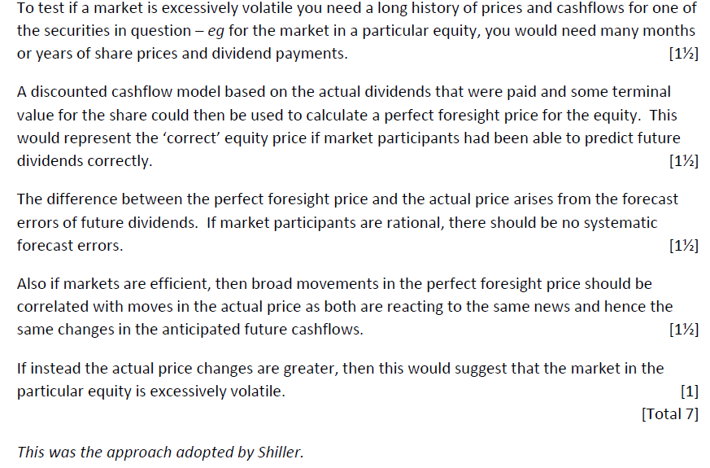

**Practical difficulties of such test –** 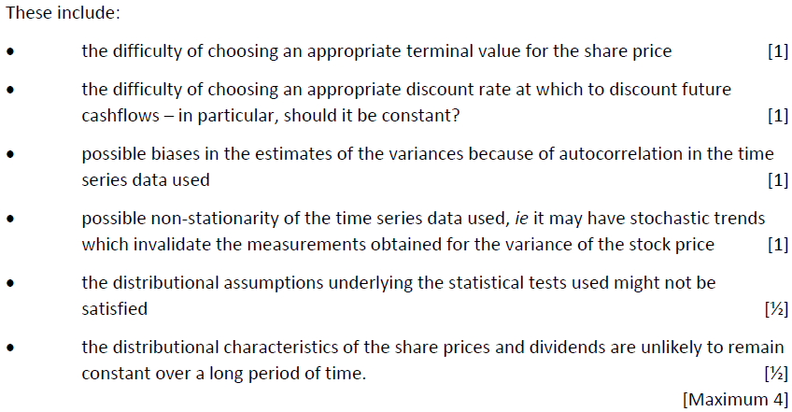

**2 e.g. of empirical evidence of the “under-reaction” of share prices to events.**

There are also well-documented examples of under-reaction to events (any two of these):

1. Stock prices continue to respond to earnings announcements up to a year after their announcement. An example of under-reaction to information which is slowly corrected.

2. Abnormal excess returns for both the parent and subsidiary firms following a de-merger. Another example of the market being slow to recognise the benefits of an event.

3. Abnormal negative returns following mergers (agreed takeovers leading to the poorest subsequent returns). The market appears to over-estimate the benefits from mergers, the stock price slowly reacts as its optimistic view is proved to be wrong.

**Explain the implications for investment management if a particular investment market is believed to be weak form inefficient. Technical analysis is the study of chart patterns of various asset prices. Explain whether this can be used to an investor’s advantage, if the Efficient Markets Hypothesis (EMH) holds**.

This is based purely on historical market data, ei prices and trading volumes. If the market is efficient in the weak sense, then technical analysis will be of no benefit.

Conversely, if it is possible to generate excess risk-adjusted returns based purely on historical market data, then this would suggest that the market is weak form inefficient (and hence also semi-strong and strong form inefficient).

**Insider trading is illegal in the UK stock market. Explain what this suggests about the EMH.**

Insider trading is based on information that is not publicly available and which will therefore not be built into the prices in a market that is only semi-strong form efficient. If the market is not efficient in the strong sense, then insider trading would enable the investor to generate excess risk-adjusted returns.

Making insider trading illegal aims to remove this advantage from those with access to inside information, and so suggests that some markets may not be strong form efficient.

**Fundamental analysis includes the analysis of balance sheets, consideration of company strategy, the environment in which the company operates etc. Explain how this relates to the EMH.**

The information mentioned here is publicly available.

So if the market is semi-strong form efficient, fundamental analysis will be of no benefit in helping the investor to identify mispriced securities, which can then be traded to generate excess risk-adjusted returns.

Fundamental analysis can add value only if the market is semi-strong form inefficient.

**How outperformance can be generated by – gaining superior information, processing information better and eliminating behavioural bias. (ST5 September 2008)**

* Super information about companies should give the investment manager superior insight into the success or otherwise of that company.
* An investment manager or analyst will need to invest time in research. Thus the manager may need to recruit additional analysts.
* This insight should enable the manager to identify mis-priced securities, which can then be traded to generate excess risk-adjusted returns.
* Many fund managers use quantitative models to help them better process information.
* Some information, such as management quality and company strategy is difficult to process numerically and must be processed by human judgment.
* Behavioural biases that are particularly relevant in investment markets include anchoring, over-confidence, status-quo and regret aversion.
* By eliminating such behavioural bias, it should be possible to enhance investments returns and generate out-performance. Methods include –
  + Training courses for investment management team
  + Implementation of mechanical trading rules
  + Making all investment decision subject to peer review

**Can target returns be generated via these?**

* Superior information : the investment manager will need to be careful not to breach regulations on insider trading. Also, as other investors will also be trying to gain superior information it may be difficult to achieve.
* Processing information and eliminating behavioural bias : many other market participants may be attempting to do the same things and so it may be difficult to achieve the target consistently.

**3% p.a. against Global Index year-on-year target reasonability –** quite difficult.

Patent comment – if the target is net of tax and management costs, the target would be even more demanding, particularly if more staff needs to be recruited.

**Implication of fund launch on structure and management**

* The current investment team will probably lack the required skills to successfully undertake active investment management. Recruitment will therefore be necessary.
* Access to much more information will be needed, so systems improvements may be needed to process the information.
* More analysts will be required to interpret the additional information, so an increase in the number of front office staff may be required.
* Experts in behavioural finance will also be required.
* The management will need people and processes to make final investment decisions and deal with conflicting investment recommendations.
* In addition, a more actively managed fund will lead to a much greater number of trades, so it is likely that the required number of back office staff will increase.
* The department may need to increase the size of its marketing and HR teams in order to cope with the additional fund and staff.
* The additional staff costs will need to be met by charges on the funds under management. Therefore, the manager will need to either levy high annual management charges or gain significant funds under management.

**Actions To Stop Behavioural Biases**

* Set rules that forces managers to sell underperforming stocks before they have underperformed for too long.
* Educate the managers so that they are aware of their own overconfidence and therefore place more weight on other people’s analysis and opinions.
* Have decisions peer-reviewed to ensure that one person’s biases are counteracted by another person’s.
* Design and use a model which determines which stocks should be bought and which sold.
* Change the remuneration policy such that analysts have a higher proportion of their pay based on performance. This should focus their attention on avoiding inefficient and biased processes.
* Set up a rule that all shares purchased must have a supporting piece of analyst research. This will avoid the danger that managers ignored research and back their own opinions.
* Introduce a mechanism that presents possible shares to purchase in the form of random scatter diagram. This avoids the danger of a list causing a bias towards the first item on the list.

**Shiller’s findings, approach adopted**

* The claim of “excessive volatility” was first formulated into a testable proposition by Shiller in 1981.
* He considered a discounted cashflow model of equities going back to 1870.
* By using the actual dividends that were paid and some terminal value for the stock he was able to calculate the perfect foresight price, the “correct equity” price if market participants had been able to predict future dividends correctly.
* The difference between the perfect foresight price and the actual price arise from the forecast errors of future dividends.
* If market participants are rational we would expect no systematic forecast errors.
* Also if markets are efficient broad movements in the perfect foresight price should be correlated with moves in the actual price as both react to the same news.
* Shiller found strong evidence that the observed level of volatility contradicted the EMH.

**Criticism with Shiller’s Finding (contradictory evidence)**

* However, subsequent studies using different formulations of the problem found that the violation of the EMH only had borderline statistical significance. Numerous criticisms were subsequently made of Shiller’s methodology, these criticisms covered.
* The choice of terminal value for the stock price
* The use of a constant discount rate
* Bias in estimates of the variances because of autocorrelation
* Possible non-stationarity of the series, i.e. the series may have stochastic trends which invalidate the measurements obtained for the variance of the stock price.
* Although subsequent studies by many authors have attempted to overcome the shortcomings in Shiller’s original work there still remains the problem that a model for dividends and distributional assumptions are required. Some equilibrium models now exist which calibrate both to observed price volatility and also observed dividend behaviour. However, the vast literature on volatility tests can at best be described as inconclusive.

**‘The efficient market hypothesis states that the market price is always correct and therefore it is not possible for investors to make money from investing in shares.’ (CT8 April 2010)**

***‘The efficient market hypothesis states that the market price is always correct.’***

* EMH states that prices react quickly and accurately to new information, which can be treated as saying that the prices are ‘correct’ in the sense that they factor in all the available information.
* However, it is important to distinguish between the different types of information that are factored into the prices. This could be just past price history (the weak form) or all publicly available information (semi-strong) or all information, including privileged information known only to company directors (strong form).
* If the relevant form of EMH applies, it is not possible to make a risk-adjusted profit based on that category of information. For e.g., if markets are weak-form efficient, then technical analysts should not be able to benefit from their analysis.

***‘It is not possible for investors to make money from investing in shares.’***

* This does not mean that it is not possible to make money by investing in shares. In the long-term shares are generally believed to offer a higher expected return than investing in a risk free asset. However, if the market is efficient, it should not be possible to outperform other investors who are working from the same information and within the same constraints.
* However, if additional information is available, higher returns may be possible e.g. if an investor in a semi strong form market has access to insider information (which may be illegal to make use of) this could provide an advantage.
* It may be also possible to pay for more detailed analysis that provides additional information not directly available to the public.
* It may also be possible to obtain information more quickly than other investors, which would give an advantage.
* Also, if an investor is prepared to accept a higher level of risk, he can obtain higher expected returns, even if the markets are efficient.
* There has been considerable research into testing whether the markets are indeed efficient and at what level, but there are difficulties with such testing.
* The weak form can be tested by retrospectively comparing the performance of strategies recommended by technical analysts with randomly selected portfolios. The problem here is that there will be a wise range of possible strategies and some are bound to do well purely by chance.
* The semi-strong form can be tested by looking for excessive volatility in price movements, as was done by Shiller in his analysis in 1981. This involved retrospectively comparing the actual price movements with the theoretical movements according to the model he used. He found evidence of excessive volatility, which would refute the semi-strong form of EMH. However, other economists have questioned his model and its assumptions.
* The strong form can be tested by comparing the returns obtained by directors who have access to privileged information. However, most markets do not allow insider trading and prevent directors trading during certain times, which is likely to remove this advantage.

**X assignment - X1.1**

1. **Technical analysis is the study of chart patterns of various asset prices. Explain whether this can be used to an investor’s advantage, if the EMH holds.**

This is based purely on historical market data, ei prices and trading volumes. If the market is efficient in the weak sense, then technical analysis will be of no benefit.

Conversely, if it is possible to generate excess risk-adjusted returns based purely on historical market data, then this would suggest that the market is weak form inefficient (and hence also semi-strong and strong form inefficient).

1. **Insider trading is illegal in UK Stock Market. Explain what this suggests about the EMH.**

Insider trading is based on information that is not publicly available and which will therefore not be built into the prices in a market that is only semi-strong form efficient. If the market is not efficient in the strong sense, then insider trading would enable the investor to generate excess risk-adjusted returns.

Making insider trading illegal aims to remove this advantage from those with access to inside information, and so suggests that some markets may not be strong form efficient.

1. **Fundamental analysis includes the analysis of balance sheets, consideration of company strategy, the environment in which the company operates etc. Explain how this relates to the EMH.**

The information mentioned here is publicly available.

So if the market is semi-strong form efficient, fundamental analysis will be of no benefit in helping the investor to identify mispriced securities, which can then be traded to generate excess risk-adjusted returns.

Fundamental analysis can add value only if the market is semi-strong form inefficient.

**Comment on market efficiency (April 2006)**

* **Necessary to ban management from trading their company stock during takeover talks**

If the market is strong form efficient then senior managers could not make abnormal profits.

The existence of a ban suggests that abnormal profits could be made, which suggests that markets are not strong form efficient.

## Ch 02: Utility Theory

The Expected Utility theorem states that a function U(w) can be constructed as representing an investor’s utility of wealth w, at some future date. Decisions are made in a manner to maximise the expected value of utility given the investor’s particular beliefs about the probability of different outcomes.

**4 Axioms –**

1. **Comparability –** An investor can state a preference between all available certain outcomes i.e. U(A) > U(B) or U(A) < U(B) or U(A) = U(B), where A and B are certain outcomes. E.g. if there is no earthquake, you make £1000 --- A, if there is an earthquake you make £10 ---- B. The investor can compare that U(A) > U(B).
2. **Transitivity –** if A is preferred to B and B is proffered to C, then A is preferred to C i.e. if U(A) > U(B) and U(B) > U(C) then U(A) > U(C). Similarly, if U(A)~U(B) (indifferent) and U(B)~U(C) then U(A)~U(C). This implies that investors are consistent with their rankings.
3. **Independence –** If an investor is indifferent between two certain outcomes A and B, then they are also indifferent between the following two gambles –
   1. A with probability p and C with probability (1-p)
   2. B with probability p and C with probability (1-p)

If U(A) = U(B), then you are indifferent between both gambles.

Thus, p*U(A) + (1-p)*U(C) = p*U(B) + (1-p)*U(C).

1. **Certainty Equivalence –** Suppose that A is preferred to B and B is preferred to C. Then there is an unique probability ‘p’ such that the investor is indifferent between B and a gamble giving A with probability ‘p’ and C with probability (1-p).

B is known as the ‘certainty equivalent’ of the above gamble.

Thus, p*U(A) + (1-p)*U(C) = U(B)

**Expected Utility Theorem’s Validity as an explanation of consumer behaviour (CT7 September 2008)**

* The expected utility theory is not required in conditions of certainty. In this context, consumers aim to maximise utility (not expected utility).
* However, the expected utility theory is useful in understanding decision making in uncertain situations e.g. investments and insurance
* Much experimental economic research has been devoted to determining whether or not individual do actually make choices in accordance with the predictions of the expected utility theorem. The results are mixed and suggest that individuals do not have always act exactly as expected utility maximisation would predict.
* As a result, other more complex theories and explanations of behaviour (e.g. behavioural finance) have been put forward. Nevertheless the expected utility theorem is relatively simple and intuitively appealing model that does capture the essence of decision making under uncertainty in many different circumstances. As such it remains one of the cornerstones of financial economics.

**Economic Characteristic of Utility Function -**

* **Principle of Non-Satiation**

This economic principle assumes that people prefer more wealth to less. The more the better. It can be expressed as $U^{'}\left(w\right)>0$.

* **Risk Aversion**

A risk averse investor values an incremental increase in wealth less highly than an incremental decrease and will reject a fair gamble. This means that increasing wealth is less valuable than any decrease in wealth. For a risk-averse investor, the utility function condition is: $U^{''}\left(w\right)<0$.

For a risk averse person, the utility function is increasing but at a decreasing rate thus having a concave shape.

**Risk Seeking Investor**

He values an incremental increase in wealth more highly than an incremental decrease and will seek a fair gamble. The utility function condition is: $U^{''}\left(w\right)>0$.

For a risk seeking investor, the utility function is increasing at an increasing rate thus having a convex shape.

**Risk Neutral Investor**

He is indifferent between a fair gamble and the status quo. In this case, the utility function condition is $U^{''}\left(w\right)=0$.

For a risk neutral investor, the utility function is a 45 degree straight line.



**Relationship between Risk Neutral and Real World Probability measure given investor type : (x3.7 assignment)**

* Under Risk Neutral Probability Measure Q, the fair price of derivative is the discounted value of the expected payoff of the derivative using the risk neutral probabilities q and continuously compounded risk free rate.
* Here, we assume that the investor is risk neutral and a risky asset grows at a risk free rate.
* Under Real World Probability Measure P, the fair price of derivative is the discounted value of the expected payoff of the derivative but using real world probabilities p and continuously compounded real world risk discount rate.
* The relationship between P and Q will depend on the investor preferences.
  + **Risk averse**

p > q

Reason : investors expect a higher return for their risk over and above the risk free rate.

* + **Risk neutral**

p = q

* + **Risk seeking**

p < q

**Risk Aversion and Certainty Equivalent**

Consider the certainty equivalent of a gamble. For a risk averse person this is higher than the actual likelihood of the outcome i.e. the individual would need to receive odds higher than expected to accept the gamble. The certainty equivalent is always negative for a risk averse person.

**Comment on utility function in case of increasing absolute risk aversion .**

Increasing absolute risk aversion means that an investor with this utility function will invest less, in absolute terms, in risky assets as they become wealthier.

This contradicts the usual assumption made that the typical , risk-averse investor will invest more in risky assets as they get wealthier.

Consequently , this utility function is not suitable for modelling the investment choices of the typical investor.

**Practise question 2.5 – comment on how to retain Jenny**

* Variable pay = $\left\{\begin{aligned}30,000 0.75 \\ 40,000 0.25\end{aligned}\right.$. Expected Salary = 37500. Minimum Fixed pay = 36771  
  Company X is risk neutral → irrelevant for them to opt for variable pay or fixed pay
* Jenny is risk neutral → her fixed salary option will be more beneficial (additional utility) because it reduced risk.
* How to retain her →Jenny would work for company X if her fixed salary is 36771 instead of expected salary of 37500.

**Fair Gamble?**

* Gamble outcome $\left\{\begin{aligned}1.3w 0.25 \\ 0.9w 0.75\end{aligned}\right.$ is it fair?
* Expectation = 0.25(1.3w) + 0.75(0.9w) = w
* Thus, the gamble is fair.

**Certainty Equivalents are Proportional given log utility function of 2 investors. Meaning? (Practise 2.6)**

* Cx = -1.334, initial wealth = 100 (for 1st investor) and Cx = - 2.668 initial wealth = 200 (for 2nd investor)
* Certainty equivalents are equal to the same proportion of each individual’s wealth. This is because ‘log utility’ function is consistent with preferences that exhibit constant RRA.
* This confirms that :

$$u\left(w\right)=\ln\left(w\right)$$

Or, u’(w) = 1/w and u’’(w) = $-1/w^{2}$

R(w) = 1 and R’(w) = 0

**Comment on whether policy is attractive to customers at this premium? (Sept 2020)**

* Premium of £11.81 is higher than the expected claim of 0.1*100 = £10
* Initially this does not seem attractive to customers
* However, customers buy insurance to reduce risk and increase certainty of cost
* So this might still be attractive
* If we knew customers utility function and initial wealth, we could determine whether this is attractive – by calculating the max premium the policyholder is ready to pay.

**Comment on whether U(w) = w + d*w2 is appropriate? (April 2021)**

* The quadratic utility function implies that the investor should be non-satiated (the more the better) and risk-averse.
* The investor in the question, bought vegetables for re-sale despite it having a lower expected utility
  + Expected utility of initial wealth = 64.813
  + Expected utility of wealth after purchase and re-sale = 50 (Lower)
* Thus, investor’s decision making is inconsistent with the quadratic utility function.
* He seems to be risk-seeking when it comes to buying the vegetables for re-sale
* Range of wealth under this utility function = -Inf to -1/2d i.e. -inf to 142.099
* The investor can exceed this upper limit easily in the highest payoff scenario (if sell all at 30*7 = 210).

**Absolute risk aversion and relative risk aversion**

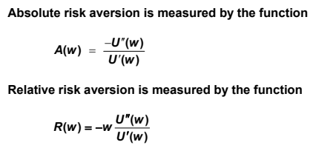

## Ch 03: Stochastic Dominance and Behavioural Finance

1. **Absolute Dominance –** is said to exist when one investment portfolio provides a higher return than another in all possible circumstances. Clearly, this situation will rarely occur so we usually need to consider the relative likelihood of out-performance i.e. stochastic dominance.
2. **Principal Theme Of Behavioural Finance**

* The field of behavioural finance looks at how a variety of mental biases and decision-making errors affect financial decisions. It relates to the psychology that underlies and drives financial decision-making behaviour.
* Behavioural finance challenges the assumption of expected utility theory that decisions are made on the basis of maximising the expected value of utility under the investor’s particular beliefs about the probability of different outcomes

**Critiques of Expected Utility Theory**

* **Friedman and Savage (1948)**

Argued than an individual can have different utility functions depending on initial wealth. This observation was motivated by people’s contrasting tendency to buy insurance and gamble. In the Friedman and Savage approach, individuals are risk-seeking at low levels of wealth, and risk-averse at high levels of wealth.

* **Markowitz (1952)**

Argued that utility should be measured relative to changes from a reference point rather than in absolute values of wealth. This reference point could be the current level of wealth.

* **Daniel Kahneman and Amos Tversky (1979)**

They detailed how human decision-making differs systematically from that predicted by Expected Utility theory and how human beings consistently violate the rationality axioms that form its basis. The model is descriptive: it tries to model real life choices, rather than optimal decisions.

1. **What is meant By Prospect Theory?**

* This is a theory of how individuals make decisions when faced with risk and uncertainty. It replaces the conventional risk-averse / decreasing marginal utility theory based on total wealth with a concept of value defined in terms of gains and losses relative to a reference point.
* Individuals are assumed to be risk-averse when facing gains relative to the reference point, but risk-seeking when facing losses relative to the reference point.
* This generates utility curves with a point of inflexion at the chosen reference point.

There are ***two phases of decision-making*** describe in prospect theory –

* **Editing /framing phases** – where outcomes of a decision are initially appraised and ordered.

Editing leads to a representation of the acts, outcomes and contingencies associated with a particular choice program. It involves a number of basic operations that simplify and provide context for choice. The two basic operations involved in the editing process are :

* + **Acceptance**: people are unlikely to alter the formulation of choices presented.
  + **Segregation**: people tend to focus on the most ‘relevant’ factors of a decision problem.

Within this process, **framing effects** refer to the way in which a choice can be affected by the order or manner in which it is presented. Standard economic theory considers such transformation to be innocuous with no substantive impact on decisions.

* **Evaluation phase** – choosing among the appraised options.

1. **Kahneman and Tversky observed a number of behavioural patterns in people when evaluating various alternatives :–** 
   1. **Reference Dependence** 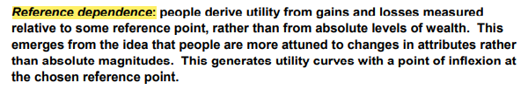
   2. **Loss Aversion** 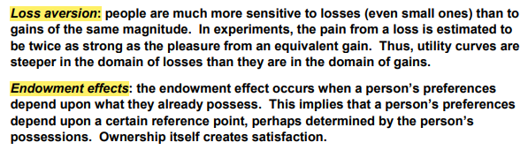
   3. **Endowment Effects **
   4. **Changing Risk Attitudes**
   5. **Diminishing Sensitivity**
   6. **Probability Weighing**
   7. **Certainty Effect**
   8. **Isolation Effect**

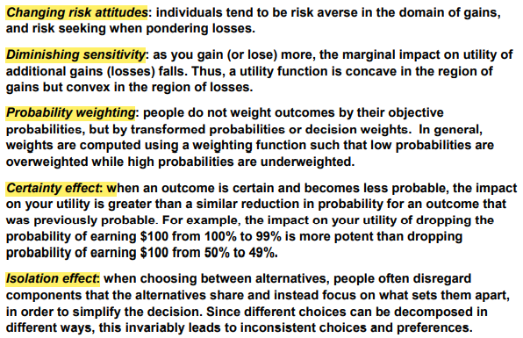

**Example**

* Alternative 1 : 80% chance of winning £4000 and 20% chance of winning nothing
* Alternative 2 : 100% chance of winning £3000

Here, 80% people chose alternative 2. Under expected utility theory, a risk averse person may prefer a more certain outcome, even if the expected gains are lower because the additional value derived from the extra certainty outweighs the additional value of higher possible return.

* Alternative 3 : 80% chance of losing £ 4000 and 20% chance of losing nothing
* Alternative 4 : 100% chance of losing £ 3000

Here, 92% people chose alternative 3, even though expected losses are greater. This evidence suggests that rather than being risk-averse, *people may actually become risk-seeking when facing losses*.

1. **Key findings of Prospect Theory**
2. Utility is based on gains and losses relative to some reference point
3. The reduction in utility from a loss is typically twice as much as the increase in utility form the same-sized monetary gain
4. People are typically risk-averse when considering gains relative to the reference point and risk-seeking when considering losses relative to the reference point.
5. People experience diminishing sensitivity to gains and losses, so, for e.g. an initial gain has a greater impact on utility than a subsequent gain of the same size.

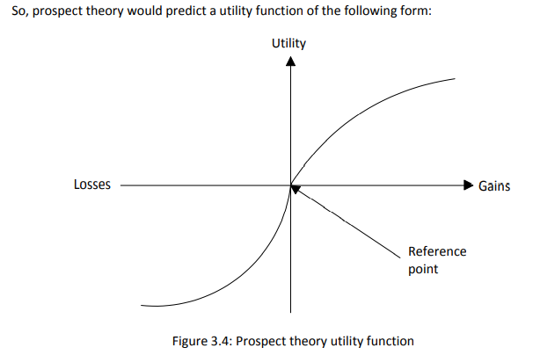

1. **Describe The Behavioural Finance Theory. (X1.10 assignment)**

* **Short-term interest rates have remained at historically low levels for several years now and there is no compelling reason for them to change. However, Saver A continues to expect them to increase anytime soon.**

This is an example of anchoring and adjustment. The saver’s expectations with regard to future short-term interest rates are anchored by past experience of higher interest rates. Consequently, they expect interest rates to rise back to average historical levels even when there is no evidence that they are likely to do so.

* **Investor B has been investing their cash with Bank X for the last five years and has received an annual interest rate of 5%. Bank Y has the same type of account with exactly the same interest rate, and is offering a £250 incentive for customers to switch accounts. Investor B is reluctant to switch banks.**

This is an example of status quo bias. The investor is preferring to stick with their current situation, even though the alternative is more favourable. This behaviour can be driven by the fear of incurring a loss when switching to a new bank, even though there’s no rational reason why Bank Y should be any more risky than Bank X.

1. **Describe The First Order Stochastic Dominance Theorem.**

The first order stochastic dominance theorem states that:

* Assuming an investor prefers more to less,
* A will dominate B (i.e. the investor will prefer portfolio A to portfolio B) if:
* FA(x) ≤ FB(x), for all x, and
* FA(x) < FB(x) for some value of x.
* where FY(x) represents the cumulative probability distribution EMH

1. **Describe The Second Order Stochastic Dominance Theorem.**

The second order stochastic dominance theorem applies when the investor is risk averse as well as preferring more to less. In this case, the condition for A to dominate B is that $\int_{a}^{x}{F_{A}\left(y\right)dy≤\int_{a}^{x}{F_{B}\left(y\right)dy}}$ for all values of x with the strict inequality holding for some value of x where a is the lowest return that the portfolios can possibly provide.

**Interpretation of this inequality →** a risk-averse investor will accept a lower probability of a given extra return at a low absolute level of return in preference to the same probability of extra return at a higher absolute level. In other words, a potential gain of a certain amount is not valued as highly as a loss of the same amount.

1. **Advantage of Stochastic Dominance –** does not require explicit formulation of the investor’s utility function, but can instead be used to make investment decisions for a wide range of utility function

**Disadvantage of Stochastic Dominance –** (1) may be unable to choose between two investments and (2) generally involves pair-wise comparisons of alternative investments, which may be problematic if there is a large number of investments between which to choose.

1. **Explain Overconfidence.**

Overconfidence occurs when people systematically overestimate their own capabilities, judgment and abilities.

Moreover, studies show that the discrepancy between accuracy and overconfidence increases (in all but the simplest tasks) as the respondent is more knowledgeable. (Accuracy increases to a modest degree but confidence increases to a much larger degree.)

This may be a result of:

* **Hindsight bias** – events that happen will be thought of as having been predictable prior to the event; events that did not happen will be thought of as having been unlikely ever to happen.
* **Confirmation bias** – people will tend to look for evidence that confirms their point of view (and will tend to dismiss evidence that does not justify it).

The discrepancy between accuracy and overconfidence increases as the respondent is more knowledgeable. Accuracy increases to modest degree but confidence increases to a much larger degree.

**E.g.** An individual investor claims that their stock-picking skills are very strong because 75% of their portfolio produced a 3% return. The other 25% of their portfolio produced a 50% loss.

* **Self-serving bias :** Closely related to overconfidence, self-serving bias occurs when people credit favourable or positive outcomes to their own capabilities or skills, while blaming external forces or others for any negative outcomes.

**E.g.** (April 2021) A portfolio manager says that 50% of their portfolio performed well because of their careful stock selection process, while 50% underperformed because of a global economic crash.

* **Status quo bias :** Status quo bias is the inherent tendency of people to stick with their current situation, even in the presence of more favourable alternatives and even when no transaction costs are involved.

**E.g.** A risk modelling team at an insurance company decides to continue to use a modelling technique for a risk because it is used by modelling teams at other similar companies. The team makes this decision despite academic research suggesting that a new approach is substantially better.

* **Herd behaviour :** Herd behaviour describes the tendency of people to follow or mimic the actions and decisions taken by others, as a mechanism to deal with uncertain situations. The underlying rationale may be that others must know better (safety in numbers), learning or conformity preferences. However such decisions may lead to mass hysteria or delusion if initial actions are themselves biased.

**(April 2021)**

**Case -** An actuary, with no knowledge of equity risk modelling, strongly opposes a new equity risk model that has suggested that the 1-in-50 value at risk of an equity is a 25% loss. The actuary’s rationale for their opposition is that the previous model suggested a 10% loss.

* The actuary is ***Anchoring And Adjusting*** - They have started with an idea of an answer (in this case the previous model output) [½] and are then adjusting away from this to arrive at their final judgement
* The actuary is also ***Overconfident*** - because they are offering strong critique of an area in which they have no expertise
* The actuary is arguably also following ***Status Quo Bias*** - again because they are seeking to stay with the current model output
* They may also be engaging in ***Familiarity Bias*** - where the ‘known’ model is preferred to the ‘new’ one.

**#Heuristics**

* **Availability Heuristics:** it’s based on ease of retrieval of any information. It suggest that the easier is to bring any information to mind, the greater its impact on subsequent judgements or decisions.
* **Representatives Heuristics:** we form a prototypical image on the basis of our first interaction with someone.
* **Anchoring & Adjustment Heuristics :** the heuristics involves the tendency to deal with uncertainty in many situations by using something we do know as a starting point and then making adjustments to it. We anchor of already existing schema & when new info comes, we tend to adjust it with our current schema.

1. **Possible Actions To Limit The Extent Of Overconfidence Bias**

* The board could require that all investment decisions made by the investment manager are reviewed by a second investment manager before being implemented.
* Alternatively, the management of the investment trust could be split equally between two investment managers.
* Either of these should reduce the impact of overconfidence bias, although the views of the second investment manager could be subject to similar overconfidence biases as those of the first manager.
* The investment manager could be sent on a training course about behavioural finance. This would make the manager aware of the possibility of overconfidence bias.
* However, providing training may have the opposite effect to that intended, making the investment manager feel more knowledgeable and aware of the issues and so even more confident.
* The board could place tighter constraints on the investment decisions taken by the investment manager, egg limits could be placed on the size of any transactions and/or on the size of holdings in individual companies or sectors.
* Limiting the manager’s actions should limit the scope for biases in investment decisions but will also reduce the manager’s scope for active investment management and possibly the returns achieved.

**Behavioural Finance Examples**

* **Property Investor**

Anchoring – the investor is basing the views on his experience of property prices. He is wedded to past experience, ignoring the recent negative experience.

Overconfidence – based on his historic success, the investor is overconfident about his ability to forecast future trends in property prices.

* **Economists**

Hindsight bias – the economist is commenting after the event that the house price falls could be seen prior to the event i.e. he is re-evaluating past evidence to prove that price falls were predictable.

* **Choosing Insurance policies**

Regret aversion, status quo bias, representative heuristics.

**A Behavioural Finance Approach To The Equity Premium Puzzle**

* The Equity-Premium Puzzle identified by Mehta and Prescott in 1985 is related to the gap in returns from risk-bearing stocks and Treasury bills. Mehta (2008) estimated that over 116 years the average return on US equities has been approx. 7.67% while on treasury bills only 1.31% i.e. an equity premium of 6.36%
* The standard explanation for the difference under mainstream financial economics (CAPM) relating to the level of risk associated is insufficient. The difference i.e. the equity premium is too large to be explained solely by risk aversion.
* Benartzi and Thaler in 1995, explained the abnormally large discrepancy in returns using the concept of ‘***myopic loss aversion***’

Myopic loss aversion suggests that investors are less risk averse when faced with a multi-period series of gambles and that the frequency of choice or length of reporting period will also be influential.

* So excess returns on stocks over bonds comprises :
  + Extra return to compensate investors for the higher risk of equity investment
  + Additional extra return to overcome investors’ loss aversion (i.e. the general unwillingness to expose themselves to potential losses of any kind).
* If an investor recognises that the investment strategy decision is in fact a series of repeated short-term gambles and consequently takes a long-term view when determining strategy, then they are likely to be less risk-averse than if they instead consider only the immediate short-term gamble and so take too short-term a view. In this latter case, they will tend to focus more on the short-term risk of loss than is necessarily in their best interests, the consequence being that their resulting portfolio ends up being overweight in less risky assets.

**Discuss the implications for a pension scheme’s investment strategy of requiring it to report its financial position annually rather than triennially (assuming that assets are valued using market values).**

If a pension fund has to report its financial position every year, it may be more averse to very short-term investment losses than if it had to report only every three years. The consequence of this might be to force the fund to invest in less volatile assets in order to reduce the risk of having to report a poor financial position. It might therefore result in the fund investing less heavily in equities, and possibly also less heavily in long-term bonds.

**Why Risk free asset must be 2nd order stochastically dominant over Risky asset in terms of investors and utility function. (X1.3 assignment)**

* Both assets have the same expected return of 1% (specific to this question)
* If an asset is 2nd order stochastically dominant over another asset, then every risk-averse investor will prefer that asset.
* This must be the case here, as every risk-averse investor will prefer the risk free asset.

**(April 2019) Which portfolio dominates?**

* Portfolio 1 N(μ1, σ21) and Portfolio 2 N(μ2, σ22)
* 
  + **μ1 < μ2 and σ1 = σ2**

Portfolio 2 1st order dominates portfolio 1 because cdf of 2 is greater than 1 for all x.

* + **μ1 = μ2 and σ1 < σ2**

Portfolio 1 2nd order dominates portfolio 2 because the integral of cdf 1 will always be less than equal to cdf 2.

But the cdf lines cross so neither portfolio is 1st order dominant.

* + **μ1 > μ2 and σ1 > σ2**

Neither portfolio dominates because the cdf will cross at some value of x and so will the integral of cdf.

OR, portfolio 1 might dominate portfolio 2 if μ1 is much greater than μ2 and σ1 is only little larger than σ2.

## Ch 04: Measurement of Investment Risk

1. **Variance of Return**
$$=\int_{-∞}^{∞}{{\left(μ-x\right)}^{2} f_{x}\left(x\right) dx}$$

2. **Downside Semi-Variance**
$$=\int_{-∞}^{μ}{{\left(μ-x\right)}^{2} f_{x}\left(x\right) dx}$$

3. **Shortfall Probability**
$$=\int_{-∞}^{L}{f_{x}\left(x\right) dx}$$

4. **Value at Risk (VaR)**

$P\left(X<t\right)=p find 't'$. VaR = - t

1. **Expected Shortfall**

$$=\int_{-∞}^{L}{\left(L-x\right)f_{x}\left(x\right) dx}$$

**Discrete**: E[max(L-x, 0)] = $\sum_{x<L}{\left(L-x\right)P(X=x)}$

1. **Shortfall Variance**
$$=\int_{-∞}^{L}{{\left(L-x\right)}^{2}f_{x}\left(x\right) dx}$$

2. **Tail VaR**
$$= \int_{-∞}^{t}{\left(t-x\right)f_{x}\left(x\right)dx}$$

3. **Conditional Tail VaR**

$$= \frac{Tail VaR}{P(X≤t)}$$

* **Expression for VaR and Tail VaR (given X ~ Normal) (Booklet 1, que18)**



* **Variance**

**Advantage**

* + It is mathematically tractable and easy to use, familiar, widely used and understood.
  + It leads to elegant solutions for optimal portfolio using MVPT
  + It provides a good approximation to other possible methodologies.

**Disadvantage**

* + Most investors do not dislike uncertainty of returns as such, rather they dislike the possibility of low returns. Variance accounts for all possibilities thus we need a measure which emphasises more on the lower returns side.
  + However, variance is a symmetric measure of risk about the mean return, whereas most investors are concurred with downside than upside risk.
  + It may therefore not be entirely suitable for a portfolio of bonds subject to credit risk, which will have a negatively skewed return distribution.
  + Also, as defaults are often co-dependent on economic downturns, portfolios returns can have fat tails. However, skewness and kurtosis of returns are not captured by a variance measure.
  + Variance also measures risk relative to the mean rather than some benchmark level of return chosen by the investor.
* **Downside Semi Variance**

**Advantage**

* + It focuses on downside risk below the mean.
  + Easy to handle mathematically.
  + It takes no account of variability above the mean.
  + If returns are symmetric, semi-variance is proportional to Variance.
* **Disadvantage**
  + Does not capture skewness or kurtosis
  + It is a measure of risk relative to the mean rather than some benchmark level of return chosen by the investor.

Note: Downside Semi Variance for mean symmetrical distributions is variance/2

* **Shortfall Probability**

**Advantage**

* + It gives indication of the possibility of loss below a certain level.
  + It is easy to understand and calculate
  + Choice of benchmark level can be chosen to reflect the risk preferences of the individual investor.

**Disadvantage**

* + Completely ignores returns above the benchmark level which may be relevance to the investor
  + Tells us nothing about the extent of potential downside of returns below the benchmark return.

**Benchmark** ‘L’ can be an index, a median fund or some level of inflation, level of surplus or fund solvency.

* **Value at Risk**

**2 key properties**

* + it is a statistical measure of downside risk
  + it assess the potential minimum loss over given time with given degree of confidence.

**Advantage**

* + It generalises the likelihood of underperforming by providing a statistical measure of downside risk. VaR represents the maximum potential loss on a portfolio over a given future time period with a given degree of confidence, where the latter is expressed as 1-p. VaR can be measured either in absolute terms or relative to a benchmark.
  + VaR provides a statistical measure of downside risk.
  + Subject to regulation, the timeframe and lower-tail probability can be chosen by the investor.
  + Bond portfolios subject to credit risk will have a negatively skewed and potentially fat-tailed returns and so the usefulness of VaR depends on accurately modelling such skewed or fat-tailed distributions of returns.
  + **(2005 April)** normal distribution is easy to manipulate to calculate VaR based on only 2 parameters.

**Disadvantage**

* + VaR is based on the assumption that investment returns are normally distributed. Portfolios exposed to credit risk, systematic bias or derivatives may exhibit non-normal distributions. The usefulness of VaR in these situations depends on modelling skewed or fat-tailed distributions of return, either in the form of statistical distributions (such as Gumbel, Frechet or Weibull) or via Monte Carlo Simulations. However, the further one gets out into the tails of the distribution, the more lacking the data and hence, the more arbitrary the choice of the underlying probability distribution becomes.
  + E.g. Hedge fund returns cannot be modelled using Normal distribution, the lower tail needs to be modelled differently based on the data available. This data may be lacking or include ***survivorship*** ***bias*** (i.e. hedge funds that do very badly may not be included).
  + VaR ignores all upside above the VaR return and also tells you nothing about the possible extent of the downside below the VaR return.
  + **Patent** – VaR doesn’t give a measure of how bad things could get if the level ‘t’ is breached – this doesn’t make it a very effective risk measure
  + **(2005 April)** results may be misleading with skewed or ‘fat tailed’ distribution.
  + **(2019 April) Difficult to apply VAR in real-world situations ↓**

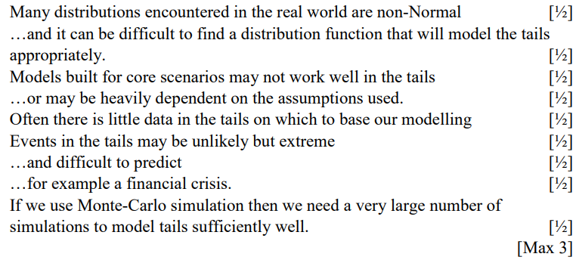 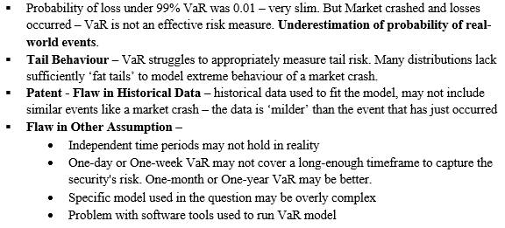

* + **Market Crash not predicted by VaR – Reasons (Sept 2021) ^**
* **Tail VaR** 
  + Tail VaR tells us something about how bad returns can be on average when the VaR benchmark level is exceeded.
  + Subject to regulation, the timeframe and lower-tail probability can be chosen by the investor.
  + It has the same modelling issuers as VaR in terms of sparse data, but captures more information on the tail of negatively skewed distribution.

**State Dependent Utility Function**

* Sometimes it may be inappropriate to model an investor’s behaviour over all possible levels of wealth with a single utility function. This problem can be overcome by using state-dependent utility functions, which model the situation where there is a discontinuous change in the state of the investor at a certain level of wealth.
* If expected return and semi-variance below the expected return are used as the basis of investment decisions, it can be shown that this is equivalent to a utility function that is quadratic below the expected return and linear above.
* Thus, this is equivalent to the investor being risk-averse below the expected return and risk neutral for investment return levels above the expected return. Hence, no weighting is given to variability of investment returns above the expected return.
* Use of a shortfall risk measure corresponds to a utility function that has a discontinuity at the minimum required return.

**Risk and Insurance Companies**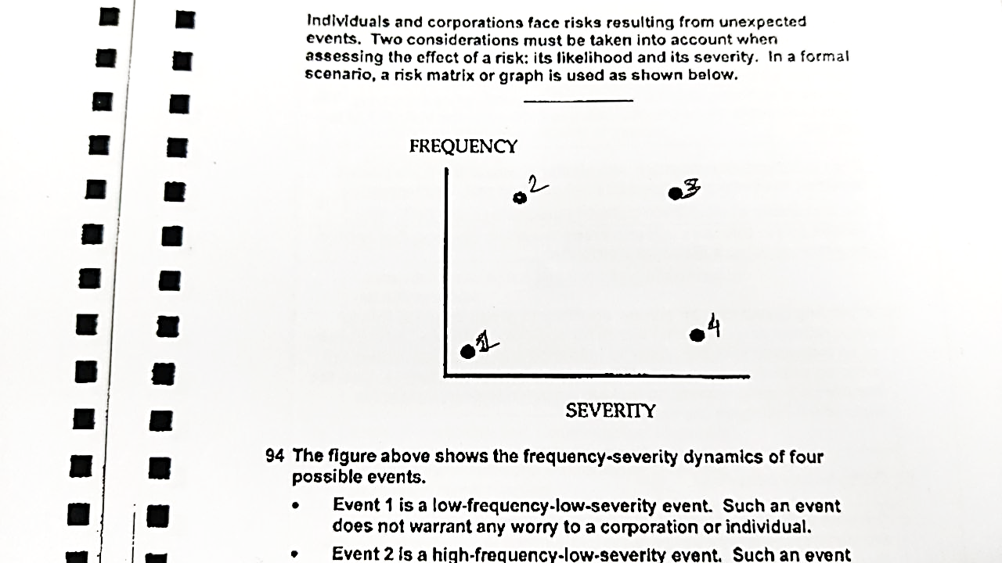

* **Event 1 – Low Frequency Low Severity –** does not warrant any worry to a corporation or individual. E.g. eye damage due to solar eclipse.
* **Event 2 - Low Frequency High Severity –** occurs many times but at a low cost each time. The overall cost due to high frequency maybe damaging. These types of events may need to be assessed on how they can be controlled. They can be covered via Micro Insurance contracts but in most cases it is difficult to insure because the claim investigation and policy administrations costs maybe high. E.g. mobile phone screen damage has a low severity but the frequency is high compared to car or life insurance.
* **Event 3 - High Frequency High Severity –** such events are to be avoided.
* **Event 4 - High Frequency Low Severity –** such events can be insured. E.g. natural calamities like earthquake, tsunami.

**Pooling –** Insurance companies reduce variability of losses due to adverse outcomes by pooling resources. If 10 independent properties with similar characteristics are pooled together, the average cost is still £100 but the probability of claims from all 10 is now down to 0.110. the VaR is 99.5%. In pooling resources, an insurer attempts to group insureds within homogenous groups.

**Adverse Selection** – people who know that they are particularly bad risks are more inclined to take out insurance than those who know that they are good risks. It is also called Self-selection or Anti Selection. **Overcome –** insurance companies need to find out lots of information about potential policyholders to put them in homogeneous pools and charge appropriate premiums.

**Moral Hazard** – a policyholder may, because they have insurance, act in a way which makes the insured event more likely. It makes insurance more expensive. It may even push the price of insurance above the maximum premium that a person is prepared to pay. **Overcome –** investigation team needs to improve in differentiating between true event and negligence. The NCD model is a means of moral hazard.

**Man coming to retirement age – 1% invested in shares of old respected bank, safe investment strategy of bank with steady returns – new management took risky decisions, share price declined - Man did not sell shares. Why? (ST5, April 2008)**

* Price might rebound
* Only 1% of portfolio
* Man does not follow share’s performance closely
* Maybe the portfolio is diversified enough
* Overconfidence – in his abilities to predict future prices
* Share might provide high dividend income
* Avoid creating tax liabilities
* **Regret Aversion** – to avoid regretting a decision to sell had the share price subsequently risen and/or avoid the regret arising when crystallising a loss.
* **Status quo bias** – the investor may have a preference for keeping things as they are
* **Anchoring** – the investor may be attached to a particular share price and reluctant to sell below specific price

**Suggest why it can be difficult to apply Value at Risk to real-world situations at higher percentage levels (for example at the 99% level).**

* Many distributions encountered in the real world are non-Normal …and it can be difficult to find a distribution function that will model the tails appropriately.
* Models built for core scenarios may not work well in the tails or may be heavily dependent on the assumptions used.
* Often there is little data in the tails on which to base our modelling Events in the tails may be unlikely but extreme and difficult to predict for example a financial crisis.
* If we use Monte-Carlo simulation then we need a very large number of simulations to model tails sufficiently well.

**Explain whether the investor may decide to split the investment in each of the following circumstances: (April 2021 Q3.)**

* 1. **If the assets are independent**

If the assets are independent then a combination of both assets will give a lower variance than either asset on its own. But with the same expected return. So the investor would prefer to invest partially in each asset.

* 1. **If the assets exhibit some positive correlation**

If the assets exhibit correlation and short selling is not allowed then the variance of a combined portfolio will be higher than if they were uncorrelated. But it will still be lower than investing in a single asset. So the investor would still prefer to invest partially in each asset. Or, if short selling is allowed, the investor could short one asset in order to achieve a lower portfolio variance.

**Benefits of Diversification -** As a portfolio is diversified, the return on the portfolio is less exposed to the specific risk of any one component. This means that as portfolios are diversified the correlation components become less important, therefore variance of return is minimised.

**Which Asset to choose A or B? Investment decision.**

|  |  |
| --- | --- |
| **Particulars** | **Figure and In favour of ?** |
| Expected Return | 1.435% in favour of B |
| Variance | 0.418%% in favour of B |
| Downside semi-variance | 0.414%% in favour of B |
| Shortfall Probability (L=0) | 1% in favour of B |
| Shortfall Probability (L=-2) | 0.1% in favour of A |

* Based on calculated results, 4:1 in favour of asset B.
* Calculate other factors like expected shortfall, VaR and Tail VaR
* Here we assume that the investor is rational and his investment decision is based on expected return and variance of return primarily and influenced by other assessments like downside semi-Variance and shortfall probabilities.
* **Patent** → He should consider the systematic and specific risks affecting assets A and B.
* **Patent** → The final decision will also be influenced by the following other factors –
  + Risk appetite of investor
  + Level of risk aversion of investor – if he is highly risk averse, he may lay more emphasis on the shortfall probability with the higher benchmark of -2, thus leaning more towards asset A.
  + Capital requirement and cashflow projections (if applicable)
  + He must consider his asset liability position and the aim of investment (achieve diversification or achieve higher return?)
  + Law and Regulations – complicated paper-work can make asset B difficult to acquire – thus making A look more attractive.
  + Consider opportunity cost – explore other available investment opportunities (if applicable)
* **Patent** → The investor must consider balance between risk and returns on any investment he makes.

**Appropriate Investment Decision – choice between gamble, risk-free and shares (Sept 2019)**

* **Investor** is a student who has £ 9000 and wants £10,000 at year end to buy a car.
* **Bank** offers a risk free investment with guaranteed return of 10% p.a. i.e. he has £ 9900 at the year end. He is only short £100 and thus should wait for some time (*if he can* defer the purchase of car by a few months, he should).
* **Shares** have a shortfall probability of close to 40% and Var at 75% equal to 439.4 (not profit more than this).
* **Gamble** has a shortfall probability of 35% and Var of 9000 (not profit more than this).
* As per shortfall probability, gamble seems most attractive. While as per 75% VAR shares seem attractive. However, they these 2 measures alone do not capture the entire picture.
* **Patent –** 
  + Different risk measurers end up suggesting different investment options to be suitable. (if applicable)
  + The investor should not invest entire wealth in one single investment option – diversify – invest some proportion in risk-free and some in risky assets.
  + Investor should seek out different investment options with different risk profiles in line with his/her risk appetite and investment attitude.
  + Consider other investment measures and whose insights might help better evaluate the options at hand.

**Appropriate investment decision – choice between Stocks and Derivative on this stock. (April 2021)**

* Initial investment = £800 for 1 year
* Expected return →
  + on stocks = 7% i.e. we are left with £856 at end of year 1 and on derivative = £855.89
  + expected returns are very similar, thus based on this, investor is indifferent
* Expected shortfall below L = 720 →
  + On stocks 0.1% and On derivative 0
  + Although there is a very small difference between the two – but the derivative is less risky than the stocks
  + ***Patent of shortfall probability*** – if the investor has a utility function with a discontinuity at the minimum required return then he may base his decision on this measure.
  + So based on Expected shortfall probability below L = 720, investor should choose derivatives
* 99.5% VaR →
  + for stocks is -742.66 and for derivative is -730
  + higher VaR for derivatives means higher loss. So based on VaR, investor should choose stocks

**##Comments On Choice Between Investment**

* **Systematic -vs- Specific Risk** → He should consider the systematic and specific risks affecting assets A & B.
* **Other factors** **affecting final decision** →
  + *Risk Appetite*
  + *Level of Risk Aversion* – if he is highly risk averse, he may lay more emphasis on the shortfall probability with the higher benchmark of -2, thus leaning more towards asset A.
  + *Capital Requirement & Cashflow Projections* (if applicable)
  + He must consider his *Asset-Liability Position* and the *Aim Of Investment* (achieve diversification or achieve higher return?)
  + *Laws & Regulations* – complicated paper-work can make asset B difficult to acquire – thus making A look more attractive.
  + *Consider Opportunity Cost* – explore other available investment opportunities (if applicable)
* **Balance** → The investor must consider *balance between risk and returns* on any investment he makes.
* **Different Risk Measurers** → end up suggesting different investment options to be suitable. (if applicable)
* The investor ***Should Not Invest Entire Wealth*** in one single investment option – diversify – invest some proportion in risk-free and some in risky assets.
* Investor should ***Seek Out Different Investment Options*** with different risk profiles in line with his/her risk appetite and investment attitude.
* Consider ***Other Investment Risk Measures*** and whose insights might help better evaluate the options at hand.
* ***Patent for Shortfall Probability*** → if the investor has a utility function with a discontinuity at the minimum required return then he may base his decision on this measure.

## Ch 05: Stochastic Model of Investment Returns

**#Single investment**

$S_{n}=\left(1+i_{1}\right)\left(1+i_{2}\right)…\left(1+i_{n}\right)=Π_{t=1}^{n}\left(1+i_{t}\right)$

* $E\left(i_{t}\right)=j$*and $V\left(i_{t}\right)=s^{2}$*

$E\left(S_{n}\right)={\left(1+j\right)}^{n}$

$E\left(S_{n}^{2}\right)={\left[{\left(1+j\right)}^{2}+s^{2}\right]}^{n}$

$V\left(S_{n}\right)={\left[{\left(1+j\right)}^{2}+s^{2}\right]}^{n}-{\left(1+j\right)}^{2n}$

**#Series of Annual Investment**

$A_{n}=S_{n}\left(1+\frac{1}{S_{1}}+\frac{1}{S_{2}}… +\frac{1}{S_{n-1}}\right)$

$A_{n}=\left(1+A_{n-1}\right)\left(1+i_{n}\right)$

$let μ=E\left(A_{n}\right) and M_{n}=E\left(A_{n}^{2}\right)$

$μ_{n}=\left(1+j\right)\left(1+μ_{n-1}\right) ∀ n≥2$

* *Or $μ_{n}={\ddot{s}}_{\overline{n|} @ j}$*

$M_{n}=\left[{\left(1+j\right)}^{2}+s^{2}\right]\left(1+2{\ddot{s}}_{\overline{n-1|} @ j}+m_{n-1}\right)$

$Var\left(A_{n}\right)=M_{n}- μ_{n}^{2}$

**#Investment Of Different Amount**

$F_{n}=(F_{n-1}+P_{n-1})(1+i_{n})$

**#Log Normal Model**

Due to compounding effect of investment returns, the accumulated value of an investment bond grows multiplicatively. This makes the lognormal distribution a natural choice for a modelling the annual growth factors (1+i), since a lognormal random variable can take any positive value and has the following multiplicative property: $If X_{1}\sim LogN\left(μ_{1}, σ_{1}^{2}\right)and X_{2}\sim logN\left(μ_{2},sigma_{2}^{2}\right) then, X_{1}X_{2} \sim LogN\left(μ_{1}+μ_{2},σ_{1}^{2}+σ_{2}^{2}\right) \left(independent\right).$

**#Log Normal Model – under Varying Interest Rate Model**

* $for \left(1+i_{t}\right)\sim logN\left(μ, σ^{2}\right)$ we have $S_{n}\sim logN\left(nμ, nσ^{2}\right)$

**#Log Normal Model – under Fixed Interest Rate Model**

* $for \left(1+i_{t}\right)\sim logN\left(μ, σ^{2}\right)$ we have $S_{n}\sim logN\left(nμ, n^{2}σ^{2}\right)$

**Comment on change in interest rate distribution from $i_{t}= \left\{\begin{aligned}2\% for 0.3 \\ 4\% for 0.4 \\ 6\% for 0.3\end{aligned}\right. to i_{t}= \left\{\begin{aligned}1\% for 0.3 \\ 4\% for 0.4 \\ 7\% for 0.3\end{aligned}\right.$.**

* The expected interest rate ‘*j*’ is still the same because the interest rate distribution is still symmetric about central value of 4%. Thus, expected accumulated value is still the same as it depends only on ‘*j*’.
* The variance of interest rate is now higher because the potential interest rates are more spread out (2% → 1% and 6% → 7%). Thus, variance of accumulated value increases + there will be greater range of possible final values.

***Accumulated Value Using The Mean Rate Will Not Be Equal To The Mean Accumulated Value*.**

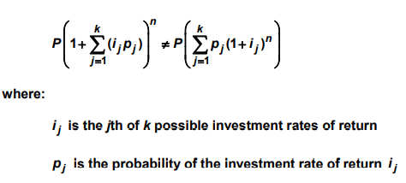core mat pg. 170.

**Why is there expected profit even when using expected rate of return? (CT8 September 2009)**

$E\left[{\left(1+i_{1}\right)}^{10}\right]E\left[{\left(1+i_{2}\right)}^{10}\right]≠{\left[1+E\left(i_{1}\right)\right]}^{10}{\left[1+E\left(i_{2}\right)\right]}^{10}$

* Expected profit is positive because there is a fairly high chance than the interest rate actually earned in first 10 years is greater than the mean rate.

**Comment – expected value of kitchen increases at 4% p.a. , should the customer continue investment. (Sept 2020)**

* Single investment of 5000 where j = 4% and s = 0.2 for 10 years.
* Because the increase in value of asset is equal to expected value of investment – there will always be an expected shortfall.
* The variance of investment will increase with time.
* So the probability of this investment meets asset purchase requirements will increase – but very slowly – with time.

## Ch 06: Portfolio Theory

**Possible types of risk relevant to investment –**

* Default/ credit risk – the other party to an investment deal fails to fulfil their obligations
* Inflation risk – higher than anticipated thus reducing real returns
* Exchange rate/ currency risk – unanticipated movements
* Reinvestment risk – stems from uncertainty concerning the terms on which investment income can be reinvested
* Marketability risk – the risk that you might be unable to realise the true value of an investment if it is difficult to find a buyer.

**Mean Variance Portfolio Theory aka Modern Portfolio Theory (MPT)** specifies a method for an investor to construct a portfolio that gives the maximum return for a specific risk, or the minimum risk for a specified return.

* **Efficient Frontier –** The efficient frontier is the line that joins the points in expected return-standard deviation space that represent efficient portfolios. A portfolio is efficient if the investor cannot find a better one in the sense that it has either a higher expected return and the same (or lower) level of risk (measured in terms of standard deviation of returns) or a lower level of risk and the same (or higher) expected return.
* **Indifference Curve -** Indifference curves in expected return-standard deviation space join together points representing all the portfolios that give the investor equal levels of expected utility, given the risk-return preferences of that particular investor. They slope upwards for a risk-averse investor.
* **Optimal Portfolio -** The investor’s optimal portfolio is the portfolio on the efficient frontier that gives the highest possible level of expected utility, given the investor’s particular indifference curves. It is represented by the point in expected return-standard deviation space where the efficient frontier is tangential to the highest attainable indifference curve.

**Assumptions of Mean Variance Theory**

* Expected Returns [$E\left(R_{1}\right), E\left(R_{2}\right), …E(R_{n})$], Return Variances [$V\left(R_{1}\right), V\left(R_{2}\right)…V\left(R_{n}\right)$] and all pairs Covariances [$Cov\left(R_{i}, R_{j}\right) where i≠j and i and j=1, 2, 3, …n$] are known.
* Investors are non-satiated
* Investors are risk averse
* No taxes or transaction cost
* Investment decision is purely based on expected return and Variance
* Assets may be held in any amount. Short selling is permitted. We can hold infinitely divisible holdings.
* No max investment limit
* Fixed single time step period

**Limitations of MPT –**

* Suitability of asset to investor’s liability – we want our asset cash flows to match liability cash flows. Under MPT, because investment decision is based purely on them and Variance of returns.
* Marketability (aka tradability or liquidity) of assets is ignored. E.g. marketability of bonds is greater than that of physical property.
* Higher moments like Kurtosis and Skewness are ignored. Only mean and Variance are considered.
* Taxes (also tax benefits) and other transaction costs are ignored.
* Legislation/ restrictions are not accounted for. E.g. foreign bonds might not be allowed to be traded in domestic markets or restrictions might be imposed by fund trustee or other stakeholders.

**Failure of Modern Portfolio Theory –**

* The definition of properties of the portfolios available to the investor – the opportunity set
* The determination of how the investor chooses one out of all feasible portfolios in the opportunity set.

**Other Key Factors that might influence investment decision besides expected return and variance –**

* Suitability of asset for an investor’s liabilities
* Marketability of assets
* Higher moments of the distribution of returns such as skewness and kurtosis
* Taxes and investment expenses
* Restrictions imposed by legislation
* Restrictions imposed by fund’s trustee

**Inefficient Portfolio** - A **portfolio is** **inefficient** if the investor can find another portfolio with (i) same/higher expected return with lower Variance and (ii) same/ lower variance with higher expected return. A **portfolio is efficient** if it isn’t inefficient. Note – the investor may be able to rank efficient portfolios using his utility function or level of risk aversion.

**2 Assumptions For Existence Of Efficient Portfolio** – (1) non-satiated – always prefer higher return to lower return at a given level of risk. (2) investors dislike risk i.e. risk-averse. For given level of return, they will always prefer a portfolio with lower variance to one with a higher variance.

**Lagrangian Function → $W=V-λ\left(E-E_{p}\right)-μ\left(Σ_{\left(i=1\right)}^{N}x_{i}-1\right)$**  here, μ and λ are called LaGrange's Multiplier.

**How To Find An Efficient Portfolio? (CT8 October 2012)**

* A portfolio is efficient if an investor cannot find a better one in the sense that it has either a higher expected return and the same (or lower) Variance or a lower Variance and the same (or higher) expected return.
* When N = 1 (i.e. one security) the security itself represents an efficient portfolio.
* When N = 2 (i.e. two security) all portfolios lying on the efficient frontier are efficient. The efficient frontier is the part of the opportunity set that lies above the minimum Variance portfolio in E – σ space.
* When N > 2, we can use the Lagrangian function to find the efficient portfolios.
* The aim is to minimise the Variance subject to the constraints:
  + $\sum_{i=1}^{N}{x_{i}E_{i}}=E_{P}$ (expected return on the portfolio is a given value EP)
  + (proportions held in each security sum to 1)
* To do this, we set up a Lagrangian function : $W=V-λ\left(\sum_{i}{E_{i}X_{i}}-E_{p}\right)-μ(∑x_{i}-1)$
* To find the minimum, we partially differentiate this with respect to each of the xi, λ and μ and set to 0. This gives a set of linear equations which can be solved.

**Investor With Quadratic Utility Function Would Select Portfolio**

* For quadratic utility functions the process described above produces optimal portfolios whatever the distribution of returns, because expected utility is uniquely determined if we know the mean and variance of the distribution.
* An investor with a quadratic utility function would select a portfolio from those along the efficient frontier by identifying the point at which one of his indifference curves is tangential to the efficient frontier. This would then be the portfolio that maximises his expected utility, as a function of portfolio expected return and variance.
* **Which Assumption Of MVT Can Be Relaxed Given Quadratic Utility Function →** the assumption that investors make their decisions purely based on expected return and Variance can be relaxed.

**Explain why an investor’s indifference curves slope upwards, and what determines their gradient.**

* An investor’s indifference curves slope upwards because we are assuming that the investor is risk-averse and prefers more to less. Consequently, additional expected return yields extra utility, whereas additional risk reduces utility. Thus, any increase (decrease) in risk/standard deviation must be offset by an increase (decrease) in expected return in order to maintain a constant level of expected utility.
* The gradient of the indifference curves is determined by the degree of the investor’s risk aversion. The more risk-averse the investor, the steeper the indifference curves – as the investor will require a greater increase in expected return in order to offset any extra risk.
* By combining the investor’s indifference curves with the efficient frontier of portfolios, we can determine the investor’s optimal portfolio, i.e. the portfolio that maximises the investor’s expected utility.
* Utility is maximised by choosing the portfolio on the efficient frontier at the point where the frontier is at a tangent to an indifference curve.
* 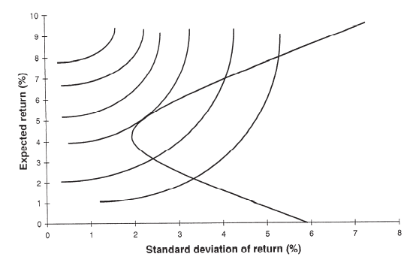

**Explain why the optimal portfolio on the efficient frontier is at the point where the frontier is at a tangent to an indifference curve.**

* The optimal portfolio occurs at the point where the indifference curve is tangential to the efficient frontier for the following two reasons:
  + The indifference curves that correspond to a higher level of expected utility are unattainable as they lie strictly above the efficient frontier.
  + Conversely, lower indifference curves that cut the efficient frontier are attainable, but correspond to a lower level of expected utility.
* The highest attainable indifference curve, and corresponding highest level of expected utility, is therefore the one that is tangential to the efficient frontier. The optimal portfolio occurs at the tangency point, which is in fact the only attainable point on this indifference curve, which is why it is optimal.

## Ch 07: Model of Asset Returns

**Multi Factor Model**

* **Structure**
$R_{i}=α_{i}+ β_{i, 1}I_{1}+ β_{i, 2}I_{2}+…+ β_{i, k}I_{k}+c_{i}$

* **‘αi’** is the expected value of investment return which is independent of other factors
* **‘αi +ci ’** is the specific return to the security
* $β_{i, 1}I_{1}+ β_{i, 2}I_{2}+…+ β_{i, k}I_{k}$ is the systematic return to security ­*i*.
* $I_{1}, I_{2}…I_{k}$ are general factors affecting a security’s return – systematic factors explaining variations in Ri.
* **Assumptions**
* Expected error is zero. $E(c_{i}) = 0$
* Uncorrelated errors $Cov\left(c_{i}, c_{j}\right)=0 ∀ i≠j$
* Errors and factor terms are independent i.e. $Cov\left(c_{i}, I_{k}\right)=0$

**Note –**

* Factors can be non-linear functions of the underlying variables, e.g. log of inflation
* αi + ci can be a single parameter with non-zero expectation.
* **Main Uses** **of Multi factor Model**
* Determination of the investor’s efficient frontier, as part of the derivation of the investor’s optimal portfolio.
* Risk control – by enabling the investor to forecast the variability of portfolio returns both absolutely and relative to some benchmark. For example, by constructing a portfolio whose sensitivities to the relevant factors are the same as the benchmark, it is possible to reduce the risk of under- or over-performance compared to that benchmark.
* Performance analysis – by comparing the actual performance of the portfolio to that predicted by the model and based on the portfolio’s actual exposure to the relevant factors over the period considered.
* Categorisation of investment styles – according to the extent of the exposure to particular factors.
* **Main Limitation**
* The construction of factor models is based on historical data that reflect conditions that may not be replicated in the future. Moreover, a model that does produce good predictions in one time period, may not produce good predictions in subsequent time periods.
* **Note** that this particular limitation applies equally to many of the other investment models in common use, including the capital asset pricing model discussed in the next chapter, whose parameters are typically estimated using past data.
* **How multi factor model can be used to form an Asset Pricing Theory when combined with principle of no arbitrage? (April 2007)**
* 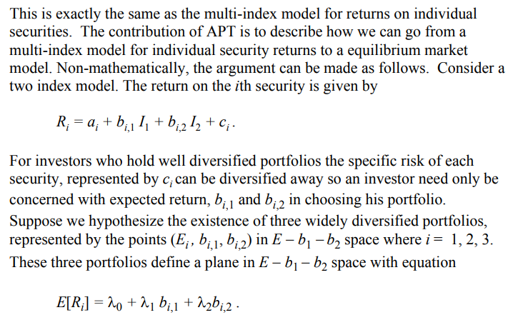 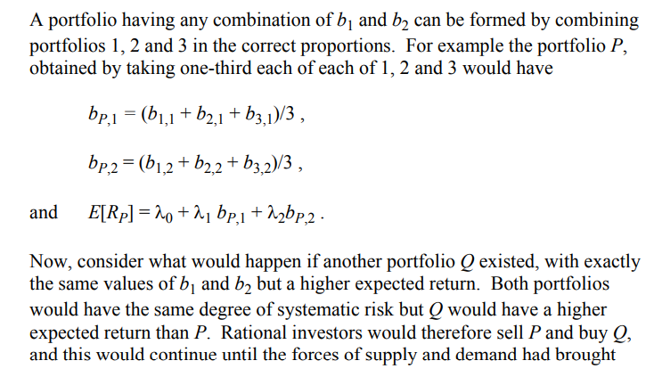 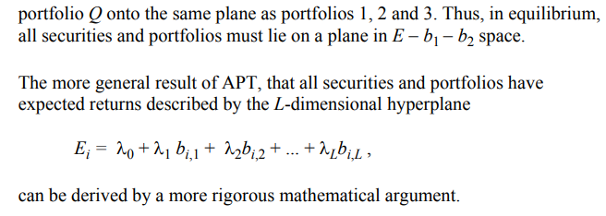

**Macroeconomic Factor Models** use observable economic time series as the factors. They could include factors such as the annual rates of inflation and economic growth, short-term interest rates, the yields on long term government bonds, and the yield margin on corporate bonds over government bonds. Once the set of factors has been decided on, a time series regression is performed to determine the sensitivities for each security in the sample.

**Fundamental Factor Models** use macroeconomic variables that are company-specific like level of gearing, price earnings ratios, level of RnD, industry group to which company belongs and so on. Then, the models are constructed using regression techniques.

**Statistical Factor Models** do not rely on specifying the factors independently of the historical returns data. Instead a technique called PCA can be used to determine a set of indices which explain as much as possible of the observed Variance. However, these indices are unlikely to have any meaningful economic interpretation and may vary considerably between different data sets.

**Principal Component Analysis –** technique used to investigate the relationship between a set of endogenous variables. It can be used to –

* determine the relative significance of the various factors by analysing the variance-covariance matrix (between them) to determine which factors have the most influence upon the total variance of security returns
* combine groups of highly correlated factors into single factors or *principal components* that are much less highly correlated with each other – thereby reducing the number of factors in the model and improving the efficiency of the model.

For applications of multi-index models to portfolio selection problems, it is *convenient if the factors used are uncorrelated* (or orthogonal). Principal components analysis automatically produces a set of uncorrelated factors.

**Why should factors be uncorrelated ideally?**

* The less correlated the factors are, the easier it is to disentangle the influences of each upon security returns. If they are highly correlated, then they act in unison and have insufficient independent variation to enable the model to isolate their separate influences.
* Within a regression context, this problem is known as *multicollinearity* and it has the effect of making the coefficient estimates less efficient.

**Single Index Model**

This model expresses the return on a security as $R_{i}= α_{i}+β_{i}R_{M}+e_{i}$

Where, (interpretation of αi and βi)

* **αi** can be interpreted as the expected value of the component of security i’s return that is independent of the market’s performance and specific to that particular security.
* **βi** quantifies the component of the security return that is directly related to movements in the market – so that if βi = x, then security i’s return is expected to increase (decrease) by x% when the market return increases (decreases) by 1%.

**Assumptions**

$E\left(e_{i}\right)=0$

$Cov\left(e_{i}, e_{j}\right)=0 ∀i ≠j$

$Cov\left(e_{i}, R_{M}\right)=0 ∀ i$

**Results of the model -** 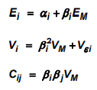

**Question – what happens if βi doubles?**

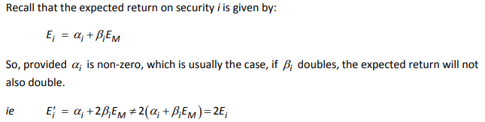

**Implication of not allowing Short-Selling**

**(CT8 September 2017)**

* Holdings : 1.2889 units of Asset A and – 0.2889 units of Asset B (i.e. short sell Asset B).
* If short selling is not allowed, then it will not be possible to attain this particular portfolio.
* Consequently, the only attainable point where the efficient portfolio and indifference curve intersect is the other one found, which has a weight of 0.1497 in A and 0.8503 in B.

**(CT8 April 2015)**

* If short-selling is not allowed, then the minimum-variance portfolio deduced is no longer available because $x_{1}< 0$.
* Asset 2 has the highest individual expected return, therefore any positive combination of the 3 assets cannot exceed this.
* Furthermore, E2 = 4% so without short-selling the only way to achieve a portfolio return of 4% is to invest wholly in Asset 2.

## Ch 08: CAPM

**Assumptions of Mean Variance Theory**

* Expected Returns [$E\left(R_{1}\right), E\left(R_{2}\right), …E(R_{n})$], Return Variances [$V\left(R_{1}\right), V\left(R_{2}\right)…V\left(R_{n}\right)$] and all pairs Covariances [$Cov\left(R_{i}, R_{j}\right) where i≠j and i and j=1, 2, 3, …n$] are known.
* Investors are non-satiated
* Investors are risk averse
* No taxes or transaction cost
* Investment decision is purely based on expected return and Variance
* Assets may be held in any amount. Short selling is permitted. We can hold infinitely divisible holdings.
* No max investment limit
* Fixed single time step period

**Extra Assumptions under CAPM**

* All investors have the **same one-period horizon.**
* All investors can borrow/ lend unlimited amounts at the **same risk free rate.**

**Consequence →** if investors are faced with the same risk free interest rate, the efficient frontier collapses to the straight line in E-σ space which passes through the risk free rate of return on the E-axis and is tangent to the efficient frontier for risky securities.

* **Perfect market** for risky assets. Information is freely and instantly available to all investors and no investor believes that they can affect the price of a security by their own actions.
* **Investors have same estimates** of expected returns, standard deviations and covariances of securities over the one-period horizon.

**Consequence →** if investors have homogeneous expectations, then they are all faced with the same efficient frontier or risky securities.

* All investors **measure in same ‘currency’** e.g. pounds or dollars or in real or nominal terms.

**Requirements of Perfect Market**

* Infinitely many buyers and seller – no single buyer or seller can influence prices by his own actions.
* Perfect information
* Rational behaviour – all rational investors will hold a combination of risk free asset and risky assets, at the point where the straight line through the risk free return (on E-axis) touches the original efficient frontier.
* Perfect divisibility – we can hold/sell assets in any amounts.
* No taxes or transaction costs.

**Market Portfolio –** portfolio (of risky and risk free assets held in proportion to their market capitalisation) held in different quantities by all investors is commonly called the market portfolio. The proportion of particular investor’s portfolio consisting of the market portfolio will be determined by their risk-return preference.

**Separation Theorem**

* The separation theorem states that, under the assumptions of CAPM, the optimal combination of risky assets for an investor can be determined without any knowledge of their preferences towards risk and return.
* This combination is the market portfolio, which consists of all risky assets held in proportion to their market capitalisation.

**## Extra**

**Sharpe’s Ratio** is one the most commonly used risk-adjusted return measure for alternative investments given by:

$$sharpe^{'}s ratio=\frac{return-rfr}{sd of return}$$

The biggest issue with using this statistic is that the standard deviation may not be appropriate measure of risk. Returns on alternative investments might not be normally distributed. When return skewness is significantly different from 0 or return kurtosis is significantly different from 3, standard deviation is not the most appropriate measure of risk. Additionally, if values used to calculate mean returns are based on model pricing (rather than market values), returns are smoothed relative to market-based return measures, so estimated standard deviation will underestimate the actual volatility of returns (uncertain about actual asset values over time).

**Sortino Ratio** substitutes downside deviation, which is based on only deviations below the mean return, for standard deviation in the Sharpe Ratio. On limitation of both Sharpe and Sortino ratios is that they do not take into account the diversification benefits from low correlations with returns to traditional investments.

**Treynor Ratio** uses β (a measure of systematic risk based on return correlations) as the denominator. A lower β (resulting from low correlation of returns) results in higher Treynor ratio. A higher Sharpe, Sortino and Treynor ratio indicates greater excess returns per unit of risk taken.

**##**

**Specific Risk and Systematic Risk –**

The fluctuation of returns (both up and down) from a security can be broken into 2 components according to the extent to which :

* Company/ industry specific events cause the returns to vary independently of movements in the investment market as a whole i.e. ***specific risk***
* The returns from the security move with the market as a whole i.e. ***systematic risk***

Specific risk is the risk unique to a particular security that can be eliminated from a portfolio if the portfolio is suitably diversified. In terms of portfolio theory, it is unrewarded risk.

Systematic risk cannot be diversified away.

**Issue faced by a Young Investor under CAPM (CT8 April 2009)**

* A young investor should also consider their human capital (i.e. value of future earnings) which is likely to be large and variable.

**Why in CAPM all investors should hold all risky assets in proportion to the market capitalisation of those assets. (CT8 April 2008)**

* If all investors have homogenous expectations, then they are all faced with the same efficient frontier of risky securities.
* If in addition they are all subject to the same risk free rate of interest, the efficient frontier collapse to the straight line in E-σ space which passes through the risk free rate of return on the E-axis and is tangential to the efficient frontier for risky securities.
* All rational investors will hold a combination of the risk free asset and M, the portfolio of risky assets, at the point where the straight line thought rfr on E-axis touches the original efficient frontier.
* Because this is the portfolio held in different quantities by all investors, it must consist all risky assets in proportion to their market capitalisation. It is commonly called the ‘market portfolio’. The proportion of a particular investor’s portfolio consisting of the market portfolio will be determined by their risk-return preference.

**Beta of Share**

* A share’s beta is a measure of its systematic risk. It is a coefficient that measures the extent to which the return from the security covaries with the return from the market of risky assets as a whole. It also indicates how the risk premium on the share compares to that for the market of risky assets as a whole.
* If the returns on a particular share move more aggressively than the market, the share has a high beta (greater than 1). A defensive share that does not fluctuate as much as the market would have a coefficient below 1.

**Calculating β of share for a company**

* Calculate the return on the share over a suitably large set of periods (say each month for 5 years) and also for the whole market.

Plot these values with market returns on the horizontal axis, and the corresponding share returns on the vertical axis, and find the gradient of the line of best fit (by least-squares regression). The beta is estimated as the gradient of the line.

We do, however, need to be wary of company- or industry-specific events that may have caused the historical beta of the company to change over the period of estimation. The estimate of the prospective beta may need to be adjusted accordingly.

**Calculate β Of Share For A Portfolio**

* The beta is the weighted average of the betas for the individual shares, weighted by the value of the holding for each of the shares. So to calculate it, we would calculate the weighted average using the betas as worked out above. Alternatively, repeat (a) using the returns on the portfolio.

**How β Of Portfolio Can Be Used To Determine Expected Return For The Portfolio** 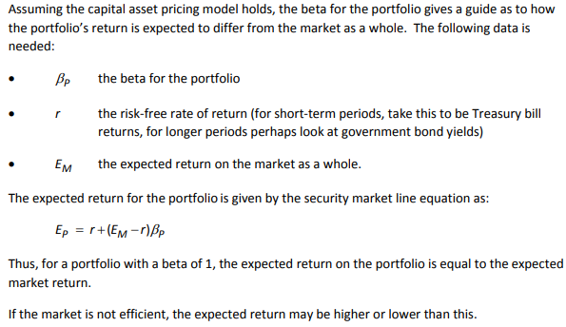

**Why is β Of A Company Inappropriate?**

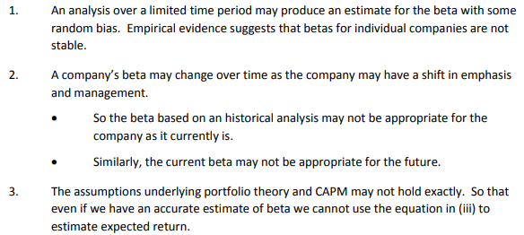

**Limitations of CAPM (based on Sept 2021)**

* There are basic problems in testing the model since, in theory, account has to be taken of the entire investment universe open to investors, not just capital markets.
* An important asset of most investors, for example, is their human capital (i.e. the value of their future earnings). Models have been developed which allow for decisions over multiple periods and for the optimisation of consumption over time to take account of this.
* Other versions of the basic CAPM have been produced which allow for taxes, inflation, and also for a situation where there is no riskless asset.
* In the international situation there is no asset which is riskless for all investors (due to currency risks) so a model has been developed which allows for groups of investors in different countries, each of which considers their domestic currency to be risk-free.
* There is a discrepancy between the values obtained for the expected return on the market using the security market line and the weightings by market capitalisation.
* Some other assumptions of CAPM are unrealistic, e.g. everyone has the same estimates for the means/variances/covariances, everyone has the same single time horizon.

**Equation for Market Security Line**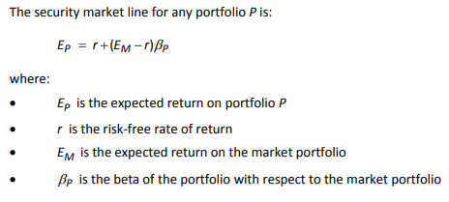

**Security Market Line and Market Portfolio**

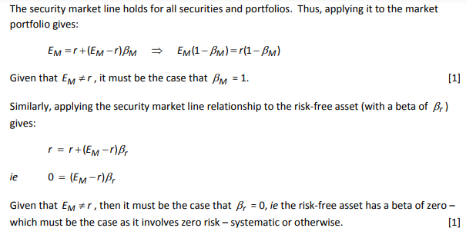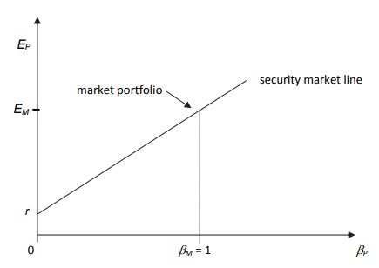

**What Does Security Line Indicate?**

The security market line relationship is of interest because:

* It enables us to determine the expected return on any asset or portfolio. This can be done if we can estimate the risk free rate, the expected return on the market portfolio and the beta of the individual asset or portfolio.
* It tells us that the expected return on any asset is equal to the risk free rate plus a risk premium, which is a linear function of the systematic risk of the asset as measured by the beta factor.
* It tells us that expected return does not depend on any other factors and in particular it is independent of the specific risk of an asset, which can be eliminated by diversification.

The above results do of course depend upon the appropriateness or otherwise of the capital asset pricing model.

**Capital Market Line**

* The capital market line is the equation of the efficient frontier in (E, σ) space, which is a straight line.
* It passes through the risk free asset with coordinates (0, rfr) and the market portfolio, which has coordinates (σM, EM).
* Thus, the **Gradient** of the capital market line is equal to: $\frac{E_{M}-rfr}{σ_{M}}$
* It has an intercept on the vertical axis at the risk free rate r and consequently, for any efficient portfolio P , its equation must be: $E_{P}=rfr+\left(\frac{E_{M}-rfr}{σ_{M}}\right)σ_{P}$
* The capital market line relationship only holds for efficient portfolios – those for which there is other portfolio that offers either a higher expected return for a given risk or a lower risk for a given expected return – assuming that the capital asset pricing model itself applies. Efficient portfolios are always combinations of the risk free asset and the market portfolio.
* **Market Price of Risk = $\frac{E_{M}-rfr}{σ_{M}}$**  can be interpreted as the extra expected return that can be gained by increasing the level of risk of an efficient portfolio by one unit. In this context, risk strictly means the standard deviation of investment returns.
* **Risk premium = $\left(\frac{E_{M}-rfr}{σ_{M}}\right)σ_{P}$**  represents the additional return over and above the risk free rate that can be obtained on a portfolio P by accepting risk, i.e. a non-zero portfolio standard deviation.

**Number of Parameters to be Estimated –**

|  |  |
| --- | --- |
| **Using Mean-Variance Portfolio Theory** | **Using CAPM** |
| * N means * N Variances $\frac{N(N-1)}{2}$* Covariances | * N betas * Expected market return EM * Variance of market return VM |
| TOTAL = $\frac{N\left(N+3\right)}{2}$ | TOTAL = $N+2$ |

**Number of Parameters to be estimated –**

|  |  |
| --- | --- |
| **Single factor model** | **Multi-factor model** |
| Requires the return on market plus, for each security : αi, βi and σi.  Therefore, 3N+1 data items are required. | * L : means of indices (we can assume 0 mean as well) * 05*L(L+1) : covariances * N : αi’s * NL : sensitivities (βi’s) * N : standard deviations of ci   Therefore, 0.5*L(L+3) + N(L+2) data items are required. |

**Why are outliers important in an investment context?**

* Outliers are defined as observations that have a large residual. They can be influential, though they don’t necessarily have to be.
* The outliers are important because this is where the major financial risks lie. It is very low investment returns – i.e. returns in the lower tail of the distribution – that will lead to a fall in asset values and possible difficulties with regard to financial solvency.

**Why an investor would not hold market portfolio in practise? (X2.2 assignment)**

* It is impossible to identify exactly the constituents of the market portfolio, as in principle it contains all risky assets including shares, property, bonds, commodities and human capital, many of which are never traded and have no market values.
* Even if it were possible to identify exactly the constituents of the market portfolio, many of the different risky assets required (e.g. human capital) cannot be invested in, in practice.

**Proof that ∑πi*βi = 1. (Sept 2019)**

* Here, $β_{i}=\frac{Cov\left(R_{i}, R_{M}\right)}{V\left(R_{M}\right)}$
$E_{i}=rfr+β_{i}\left(E_{M}-rfr\right)$

$R_{M}=\sum_{i=1}^{n}{π_{i}R_{i}} where π_{i} is proportion of investment$

$V\left(R_{M}\right)=\sum_{i=1}^{n}{π_{i} Cov\left(R_{i}, R_{M}\right)} or \sum_{i=1}^{n}{π_{i}}=\frac{V\left(R_{M}\right)}{Cov\left(R_{i}, R_{M}\right)}=\frac{1}{β_{i}}$

* Thus, $\sum_{i=1}^{n}{π_{i}}β_{i}=1$
* Proved.

## Ch 09: Brownian Motion and Martingales

**Brownian Motion** is a continuous time analogue of simple symmetric random walk.

**Standard Brownian Motion or Wiener Process**

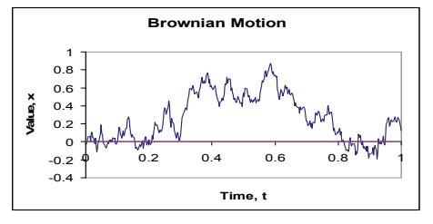

is defined as a stochastic process Wt, t ≥ 0 where,

* W0 = 0
* Wt has continuous sample path i.e. there are no jump anomaly or finite discontinuity.
* Wt has independent increments over non-overlapping time periods

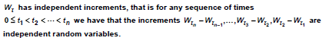

* Wt has Gaussian Increments i.e. Wt – Ws ~ N(0, t-s) for 0 ≤ s < t
* Wt has Stationary Increments i.e. Bt – Bs ~ N(0, t-s) and

Bt+k – Bs+k ~ N(0, t-s).

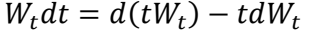 simple diferentiation by parts.

* Wiener Process has independent increments implies it is Markov.

Deep insight into [wiener process](Support%20files/Wiener%20process.pdf)

**Other Properties of Simple Brownian Motion**

* Cov (Wt, Ws) = min (t, s)
* Wt is a Markov Process i.e. E(Bt | Bs = a) = a
* Wt is a Martingale
* Wt returns infinitely to 0.
* Scaling Property: (1/√c)*Bct ~ N(0, t) is also a SBM
* Time Inverse Property: t*B1/t ~ N(0, t) is also a SBM

**General Brownian Motion**

$W_{t} = W_{0} + μt + σB_{t} \sim N (W_{0}+μt, σ^{2}t)$

* Process = Origin + drift + volatility/diffusion

$W_{t} –W_{s}= μ(t - s) + σ(B_{t}-B_{s}) \sim N (μ(t - s), σ^{2}(t-s))$

**Properties**

* W0 may/ may not be equal to zero.
* Wt has independent increments over non-overlapping time period.
* Wt has Gaussian increments which are stationary.
* Wt has a continuous sample path.

**Correlated Wiener Process**

Zt is a Wiener process such that Wtα and Wtβ are SBM and they are independent of each other and ‘ρ’ is the correlation coefficient between Wt α and Zt and -1 ≤ ρ ≤ 1

$Z_{t}=ρW_{t}^{α} +\sqrt{1- ρ^{2}} W_{t}^{β}$

* E(Zt) = 0 and V(Zt) = t
* $Cov(Z_{t},W_{t}^{α})=ρt$ Where t implies, wiener process that evolves with time.

**Time inverted Wiener Process**

* $X_{t}=t*W_{1/t}$ It flips the process( i.e. the x axis of the graph flips.)

**Scaled Wiener Process**

* $X_{t}=\sqrt{c} W_{t/c}$ C works as a scaling factor.

**Filtration**

Ft is a process which contains the entire past history of the stochastic process. (Learn more about [filtration and sigma algebra](Support%20files/Filtration%20and%20sigma%20algebra.pdf))

* If s < t, then Fs is a subset of Ft
* If Xt is adapted to Ft then Xt is Ft-measurable
* If t < u, then for any Standard Brownian Motion Bt, Bu-Bt is independent of Ft

**Martingale**

Stochastic Process which is expected to stay where it is and does not blow towards infinity.

* If Xt is a martingale then Xt is Ft-measurable
* E (|Xt|) < ∞ ∀ t
* E (Xt |Fs) = Xs for all s ≤ t
* Super-Martingale: E (Xt |Fs) ≤ Xs. Expected to stay same or move down
* Sub-Martingale: E (Xt |Fs) ≥ Xs. Expected to stay same or move up

**Bachelier Model**

$S_{t}=S_{0}+ σB_{t}$

There are 2 major defects of this model:

* It returns negative share prices
* Range of St given by: $S_{0}–3σ\sqrt{t}<S_{t}<S_{0}+3σ\sqrt{t}$ (Means excluding outliers as for 99.7% values lie inside this range for a normal distribution)
* Absolute returns are independent of initial investment

**Log-Normal Model**

The continuous time log-normal model of security prices assumes that log prices form a random walk in continuous-time. If St denotes the market price of an investment, then the model states for T > t, the log returns are modelled by the following distribution →



$S_{t}=S_{0}e^{μt+σB_{t}} \sim LogN (lnS_{0}+μt, σ^{2}t)$

$St/Ss = e^{μ\left(t-s\right)+ σ\left(B_{t}-B_{s}\right)} \sim LogN \left(μ\left(t-s\right), σ^{2}\left(t-s\right)\right)$

Where, μ is drift parameter and σ2 is volatility parameter. As share prices are expected to grow exponentially, this model tries to capture that along with the jagged nature of Brownian motion.

**Log-Normal Model and Market Efficiency →** As the model incorporates independent returns over disjoint intervals, it is impossible to use history to deduce that prices are cheap or dear at any time**.**

**SDE under Geometric Brownian Motion $dS_{t} = S_{t}\left\{μ dt +σdW_{t}\right\}$. Discuss the Assumptions behind this equation.**

* This process is very similar to log normal model, as it is just log transform version of the later equation.(To linearise)
* This model is a **continuous-time random walk**. Graphs of share prices do appear to have this form, with the price changing by a small ‘random’ amount from day to day.
* The RHS contains an ***St* factor**, which implies that prices changes are proportional to the current price. This is plausible since we would expect price movements to be based on percentage changes, not absolute changes.
* However, the Empirical Evidence suggests that the **volatility parameter *σ*2** may not be constant over time, as estimates of volatility from past data are critically dependent on the time period chosen for the data and how often the estimate is re-parameterised.
* It can also be argued that the **drift parameter *μ*** may not be constant over time, as it is likely to vary with the level of bond yields.
* The underlying Brownian motion has **Gaussian Increments**. However, studies have shown that the distribution of log-share price increments has fatter tails and is more peaked than a normal distribution.
* Brownian motion also assumes **Continuous Sample Paths**. However, share prices often exhibit sudden jumps both upwards and downwards.
* Brownian motion assumes **Independent Increments**. However, the empirical evidence suggests a degree of dependence between the increments.
* In particular, there is some evidence of **Mean Reversion**, i.e., negative serial correlation, in the long term, although this is based largely on a small number of market crashes.
* In addition, daily movements appear to be subject to **“Momentum” Effects**, i.e., they are positively correlated.

**Interesting Joint distribution math**

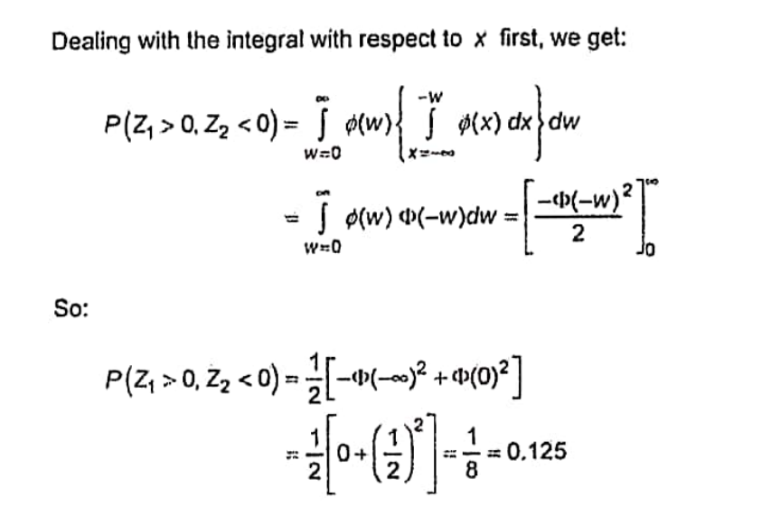

## Ch 10: Stochastic Calculus and ITO Processes

Stochastic calculus is utilized when traditional calculus is not suitable for analysing functions that exhibit randomness. Unlike ordinary calculus, which provides the derivative dy/dx to represent the slope of a function at a point, stochastic calculus deals with processes where this approach does not apply due to their random nature. In stochastic calculus, the differential 𝑑𝑊𝑡 is used to represent the change in a stochastic process 𝑊(𝑡) over an interval 𝑑𝑡, specifically 𝑊(𝑡+𝑑𝑡) −𝑊(𝑡). This represents the evolution of the process over time, highlighting changes rather than instantaneous rates of change.

**ITO Integrals**

**For deterministic process**

constant

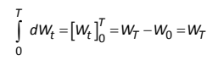

Function of t:

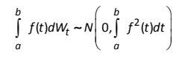

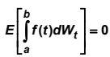

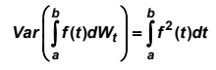

**For stochastic process**

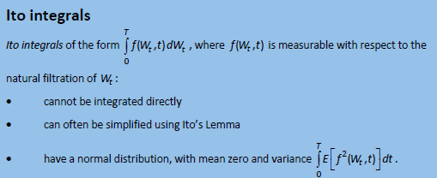

**Stochastic Integral Equation of Process Value Equation – (ITO process)**

$$X_{T}=X_{0}+\int_{0}^{T}{μ\left(X_{t}, t\right)dt}+\int_{0}^{T}{σ\left(X_{t}, t\right)dW_{t}}$$

To prevent the process from ‘exploding’ (hitting ± ∞ in finite times) we impose restrictions on μ and σ –

$\left|μ\left(x\right)\right|+\left|σ\left(x\right)\right|≤ K \left(1+\left|x\right|\right)$

* Absolute sum of μ and σ ≤ constant*(1 + mod X)

**Geometric Brownian Motion (Exponential Process)**

The rate of change of Xt i.e., dXt is proportional to Xt implies that the GBM never hits 0 or ∞ by time inversion.

$dXt​=μXt​dt+σXt​dWt$ ​ Where:

* 𝜇 is the drift coefficient (rate of return),
* 𝜎 is the volatility (standard deviation of returns),
* 𝑋𝑡​ is the stock price at time 𝑡*t*,
* 𝑊𝑡​ is a standard Brownian motion.

Solution of GBM: 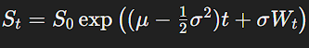

The corresponding PDE, derived from the above SDE using Itô's Lemma, is:

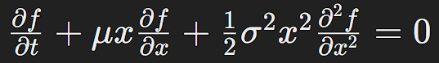

Derivation in Ito’s lemma section.

**Ornstein-Uhlenbeck Process (OUP)**

Drift term will push the process to zero, while the volatility term is random.

$dXt​=θ(μ-Xt​)dt+σdWt​$ Where:

* 𝜃 is the rate of reversion to the mean,
* 𝜇 is the long-term mean,
* 𝜎 is the volatility,
* 𝑊𝑡​ is a standard Brownian motion.

Solution of OUP: 

The PDE for the OUP is:

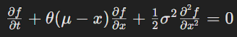

**Long Term OUP variance = σ2/2γ** is unsurprisingly close to zero for large value of (T-t). (T-t) is the length of time over which the process is being observed. When this quantity is small it means that there is little opportunity for the process value Xt to deviate far from Xt. This behaviour is captured by having a variance close to zero.

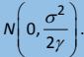

**Mean Reverting Process** is based on OUP, here, the process is pulled back to some equilibrium level μ at a rate determined by γ >0. Note that the process can go negative.

Mean-reverting process is ideal for modelling interest rates where one would expect the rate to fluctuate around a particular value rather than tending to grow indefinitely.

**Square Root Mean Reverting Process/ Feller process/ Cox-Ingersoll-Ross Process (CIR).**

* Parameters γ, σ, and μ >0.
* However, for the choice of parameters σ2 ≤ 2γμ the process is positive.
* ***If the process hits zero***, its volatility disappears, and its drift is positive, the process deterministically moves away from zero and spends “no time” at 0 (i.e., the time spent at zero has measure zero).
* This is a very useful property in modelling asset prices and interest rates, which are required to remain positive.
* The CIR process extends the OUP by ensuring that the process remains positive, making it suitable for modeling quantities that cannot go negative, like interest rates. The SDE for the CIR process is: 𝑑𝑋𝑡=𝜅(𝜃−𝑋𝑡)𝑑𝑡+𝜎𝑋𝑡𝑑𝑊𝑡 Where:
* 𝜅 is the rate of mean reversion,
* 𝜃 is the long-term mean,
* 𝜎 is the volatility coefficient.

The PDE for the CIR process is:

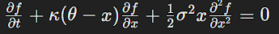

**Taylor’s series**

The Taylor series is a mathematical representation of a function as an infinite sum of terms that are calculated from the values of its derivatives at a single point.



Watch this video for better understanding of [taylor series](https://www.youtube.com/watch?v=3d6DsjIBzJ4&ab_channel=3Blue1Brown) #out of scope.

**ITO’s Lemma**

It is often thought of as the stochastic counterpart to the classical chain rule from differential calculus.

For derivation using taylor series,watch this [video](https://www.youtube.com/watch?v=Devm4ElEhGc&ab_channel=QuantPy) and for a better concept clarity, watch this [video](https://www.youtube.com/watch?v=IRhF4RBhi8o&ab_channel=MJtheFellowActuary)

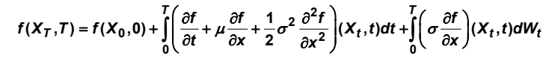

**This same formula can be written as a single time stamp dt.**

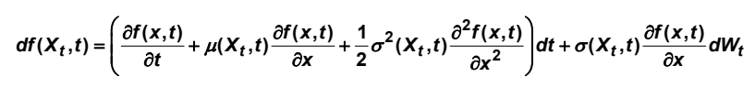

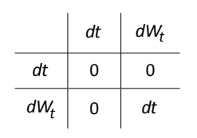

For finding the PDE of a stochastic process, we first use ito lemma to get the ito function and then take the part and equate it to 0 as financial instruments have a zero drift to proof martingale property.

Example for GBM:



**Multi- dimensional ITO formula**

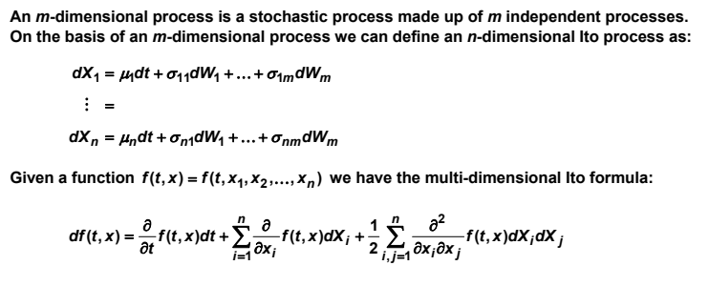

## Ch 11: Log Normal Model

Consider a continuous-time log-normal model for security price.

* **Formula for log-returns (for T > t)**
$log⁡(S_{T}/S_{t}) \sim N\left(μ\left(T-t\right), σ^{2}\left(T-t\right)\right)$

* 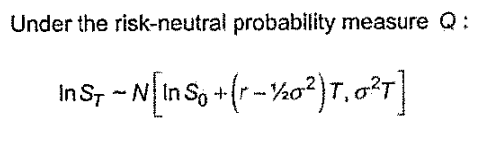
* **Solution for St =** 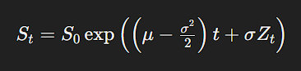
* **Formula for *Expected Value* of investment at specified future time**
* $E\left(S_{T} | F_{t}\right)=S_{t}e^{\left(\left(μ+\frac{1}{2}σ^{2}\right)\left(T-t\right)\right)}$.
* ***Variance* of value of investment at specified future time**
* $V\left(S_{T} | F_{t}\right)=S_{t}^{2}e^{\left[\left(2μ+σ^{2}\right)\left(T-t\right)\right]}\left[e^{σ^{2}\left(T-t\right)}-1\right]$.
* ***Market Efficiency***
* The model assumes independent increments over non-overlapping time intervals. This is consistent with the weak-form efficient market hypothesis, which claims that it is impossible to use the past history to generate excess risk-adjusted returns.

***Empirical Evidence ‘For’ the model***

* The model is consistent with weak-form EMH. No credible challenge has arisen to weak form EMH.
* The model prevents negative values and generates share prices that drift upwards through time.
* The model implies that movements in share prices are proportional to the current share price.

***Empirical Evidence ‘Against’ the model***

* Empirical evidence suggests that the volatility varies according to the time period considered and the frequency of the sample taken. The model's assumption that volatility is constant is contradicted by empirical evidence that shows volatility tends to cluster in time and varies significantly across different periods.

Additionally, an examination of historic option prices and calculations of implied volatility suggest that volatility fluctuates markedly over time.

* The assumption of independent increments is inconsistent with empirical evidence that, following market crashes, share prices have a tendency to mean revert. It is also inconsistent with observed momentum effects, which implies that a rise one day is more likely to be followed by another rise the next day.
* Expected Value of Returns – this is a contentious area. However, theoretically, equities should yield a risk premium over bonds, the yields of which vary over time. There is some evidence for mean-reversion, but the evidence relies heavily on the aftermath of a small of dramatic crashes.
* Statistical Distribution of Returns - Empirical evidence suggests a more peaked distribution (since days with little or no movement in share prices occur more frequently than normal distribution suggests) with fatter tails (as market crashes occur more frequently than normality suggests) than is consistent with normality.
* In reality, share prices can do jump, rather than following continuous sample paths.
* One measure of these non-normal features is the **Hausdorff Fractal Dimension(**[**Video**](https://www.youtube.com/watch?v=gB9n2gHsHN4&ab_channel=3Blue1Brown)**)** of the price process. A pure jump process (such as a Poisson process) has a fractal dimension of 1. Random walks have a fractal dimension of 1½. Empirical investigations of market return often reveal a fractal dimension around 1.4. Real-life stock prices exhibit jumps and discontinuities, which are not captured by the continuous paths assumed in the log-normal model. The Hausdorff Fractal Dimension being around 1.4 suggests a more complex, fractal structure in price movements than can be modeled by either purely continuous or simple discontinuous processes.

**Continuous-Time Log Normal Model and Other Possible Processes**

The Log Normal model assumes constant drift and volatility. An alternative to constant volatility would be to model it as a process in its own right, e.g. using an ARCH Model.

There are no mean reversion or momentum effects with the Log Normal Model.

Changes in log stock prices are assumed to have a normal distribution. To incorporate jumps, a Levy Process could be used.

**Mean Reverting Behaviour** – A mean-reverting market is one where rises are more likely following a market fall, and falls are more likely following a rise.

**Momentum Effect** - there also appear to be some evidence of momentum effects, which imply that a rise one day is more likely to be followed by another rise the next day.

**Wiener Process**

**Why is Standard Brownian Motion less suitable than Geometric Brownian Motion as a model of stock prices?**

* **Starts at zero**

Asset prices do not start at zero. they are listed at some positive price representing the initial capital. It can end at zero but not start at zero.

* **Sample path is continuous**

Asset Prices are not continuous. Trades are made at discrete points in time.

* **Independent Increments**

The evidence shows us the assets are not Markovian over shorter timeframes. Two phenomena over shorter timeframes are observed:

1. Momentum effect
2. Mean Reverting behaviour

This gives us an idea that future evolution of process is dependent on recent past over shorter timeframes, thus, defying the Markovian assumption.

Similarly, if the increments were stationary, it would be practically impossible to identify them.

* **Normally Distributed**

The evidence suggests existence of more extreme events than captured by Normal distribution.

**Continuous Time Log Normal Model (Geometric Brownian Motion)**

**Advantages –**

* **The Mean and Variance of log returns are proportional to Time Lag.** This allows the standard deviation of log returns to increase with the square root of the time lag.
* **Independent Returns over non-overlapping intervals.** This is applicable in real life most of the times. This is because the normal variables generating the random variation in the log of security prices are assumed to be independent.
* **Consistent with Weak Form Market Efficiency.** It implies that technical analysis and charting will not produce Supernormal Profits as there is no relative mispricing of securities.

Weak Form efficient market hypothesis claims that it is important to use the past history to generate excess risk-adjusted returns.

* **Mathematically tractable.** As we work with log of returns, it is mathematically tractable.
* **Realistic to an extent, avoids negative values.**

**Disadvantages –**

* **Actual σ is not constant over time.** It varies widely according to time period and how frequently samples are taken. e.g. volatility increases during periods of financial crisis and recessions. σ can be estimated on daily, monthly or annual share price records, even if the data covers the same time period, numerical estimates of σ are different.
* **Actual μ is not constant over time.** It varies over time. E.g. there are abnormal profits on a share, the drift might increase.
* **Mean Reverting Behaviour and Momentum Effect.** This makes us question Independent Increments and Markov assumption in the short run.
* **Distribution of ln(St/Ss) ~ Normal i.e. Normality Assumption.** In reality, there are more extreme events than what is captured by Normal Distribution. In particular, market crashes appear more often than one would expect from a Normal (or lognormal) distribution. Further, days with no change, or very small change also happen often than suggested by the normal distribution. Distribution of security returns has taller peak and fatter tails in reality.
* **Continuous Sample Paths or No jump anomalies**. The lognormal model produces continuous price paths but jumps anomalies and discontinuities seem to be an important feature of real markets.

**Alternatives to Log Normal Model**

* ARCH Model/GARCH model (eliminates constant volatility assumption)
* Levy Process (incorporates jumps)

**Examination of Past Option Prices**

* Taking an individual option, volatility is the only parameter that isn’t directly observable and so needs an assumption. Looking at the actual option price in the market, we can back solve to find the implied volatility, if we repeat this exercise on different days, the implied volatility is likely to change, perhaps quite considerably in volatile markets.
* Calculating the implied volatility for options with different strike prices or different terms to maturity, but on the same underlying, is likely to give different figures. This tells us that traders are not happy with the geometric Brownian motion assumption underlying Black-Scholes theory and so make adjustments to the volatility input, to allow for non-normality of log returns.
* If we can’t find a set of parameters that will reproduce simultaneously the various option prices observed in the market on the same underlying, then either there are arbitrage opportunities present or it indicates that traders are using a different model for option pricing.

**Arguments Against Gaussian Random Walk**

* Market crashes appear more often than under normal distribution (real world events require fatter tails than normal)
* Real world share prices can have jump anomalies and discontinuities not permitted under gaussian random walk
* Real world distribution is more peaked because – days with very little change happen more often than the normal distribution.
* Assumption of independent increments is contradicted by empirical evidence of mean-reversion and momentum effects
* Assumption of constant volatility is contracted by empirical evidence
* It can be argued that expected returns on shares are likely to vary with bond yields, which contradicts the assumption of a constant mean.
* Market returns are often negatively skewed.

**Arguments Against Modelling Market Returns Using Gaussian Random Walk**

* **Market Crashes** appear more often than one would expect from a normal distribution. The real world distribution has “fat tails”.
* While the random walk produces continuous price paths, **Jumps Or Discontinuities** seem to be an important feature of real markets.
* Days with no change, or very small change, also happen more often than the normal distribution suggests. The real world distribution is “**More Peaked**”.
* The assumption of **Independent Increments** is contradicted by empirical evidence of mean reversion and momentum effects.
* The assumption of a **Constant Volatility** is contradicted by empirical evidence.
* It can be argued that expected returns on shares are likely to vary with bond yields, which contradicts the assumption of a **Constant Mean**.
* Random walks have a **Fractal Dimension** of 1½, (whereas) empirical investigations of market returns often reveal a fractal dimension around 1.4.
* Market returns are often (negatively) **Skewed**.

**Empirical Investigations of stock market returns have revealed a fractal dimension of 1.4.**

* **What does this mean about the distribution of returns.**

One measure of these non-normal features is the Hausdorff fractal dimension of the price process. A pure jump process (such as a Poisson process) has a fractal dimension of 1. Random walks have a fractal dimension of 1½. Empirical investigations of market returns often reveal a fractal dimension around 1.4.

* **How mean-reversion in the stock market can be consistent with an efficient market?**

Even mean reversion can be consistent with efficient markets. After a crash, many investors may have lost a significant proportion of their total wealth; it is not irrational for them to be more averse to the risk of losing what remains. As a result, the prospective equity risk premium could be expected to rise.

**Log share price Model -vs- Log Dividend Yield Model**

$lnS_{t+1}=lnS_{t}+μ+σZ_{t+1}$

$lnD_{t+1}=lnδ+α\left(lnD_{t}-lnδ\right)+ηW_{t+1}$

Where, Wt and Zt are serially uncorrelated N(0,1) random variables but are correlated to each other and μ, σ, 𝛿, η are positive parameters and 0< α<.1.

1. **Explain magnitude and sign of the correlation coefficient between Zt and Wt.**

We expect a strong negative correlation.

Dividend yield = dividend/price

So if there is a strong price rise it’s likely to be accompanied by a decrease in yield.

1. **2 properties of dividend yield model and comment on their realism.**

Mean-reverting: this is in line with historical evidence in most markets.

Non-negative: dividend yield cannot be negative.

1. **3 properties of share price model and comment on the relative and empirical evidence and the EMH.**

Not mean-reverting: consistent with weak form EMH. Empirical evidence is mixed.

Constant volatility: this is inconsistent with empirical evidence.

Normal distribution: markets jump and returns have fat tails, so inconsistent with empirical evidence.

**Why Log Normal distribution may be preferred to exponential distribution for modelling security price. (Sept 2021)**

* ***Tail behaviour*** – log normal distribution has higher 99th percentile – making it more appropriate than exponential distribution. Having a heavier upper tail allows for a better fit for security prices.
* ***No. of parameters*** – log normal distribution has more parameters – more flexible when fitting to historic data
* ***Better Established*** – log normal distribution is a more well-established in financial modelling and can lead to useful frameworks like Black-Scholes model. Exponential distribution does not have such frameworks in place.
* ***Security Prices Cluster About The Mean*** – exponential distribution is the largest for smallest values, which does not fit this observation. Log normal distribution captures this fact.

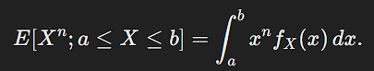

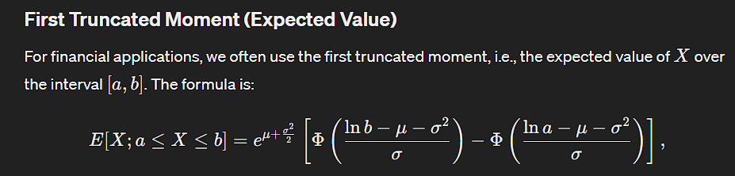Here we normalize the upper and lower limits.

## Ch 12: Derivative Securities

* **Derivatives** are financial contracts which derive their value from some of the underlying assets, commodities, index, share, interest rate or exchange rate.

Derivative is a security or contract that promises to make a payment at a specified time in the future, the amount of which depends upon the behaviour of underlying security up to and including the time of payment.

* **Call** and **put** options are a typical derivative or contract that provides rights to the buyer. However, there’s no obligation to purchase or sell the underlying asset within a specific date or at a specified price.
* **European** can only be exercisedon expiry whereas **American** can be exercised at anytime before expiry**.**
* **Forward contract** is an agreement made at some time t =0, say, between two parties under which one agrees to buy from the other a “specified amount” of an asset (denoted S) at a “specified price” on a “specified future date”. The investor agreeing to sell the asset is said to hold a “short forward position” in the asset, and the buyer is said to hold a “long forward position”.
* **Speculators** are people who speculate if the price in future will rise or fall. They are either Bullish (price will rise) or Bearish (price will fall).
* **Arbitrageur** is someone who spots relative mispricing of securities.
* **Algo-traders** are companies with software dealing with continuous time prices aimed at spotting relative mispricing i.e. they exploit arbitrage opportunities.
* **Arbitrage opportunity** arises when there is zero probability of making a loss (zero initial cost) and a non-zero probability of making a profit.
* **Principle Of No Arbitrage -** The *principle of no arbitrage* states simply that arbitrage opportunities do not exist. This principle is vital to the pricing of derivative securities.
* **Law of One Price**says that any two portfolios that behave in exactly the same way must have the same price. If this were not true, we could buy the ‘cheap’ one and sell the ‘expensive’ one to make an arbitrage (risk free) profit.
* **Hedgers** are risk-averse players of markets who find ways to minimise their risk. The act of minimising risk is called Hedging.
* **Short Position** indicates Seller’s duration of holding the underlying asset which is smaller than that of the buyer. **Long Position** indicates Buyer’s duration of holding the underlying asset which is longer than that of the seller.

A *long* position on a contract is when the contract has been purchased, while a *short* position is when the contract is sold.

* **Over the Counter (OTC)** refers to a situation where the parties involved in the transaction meet each other. Here there is no much regulation and liquidity.
* **Exchange Traded** refers to a situation where the parties are not in contact of each other, they rather trade through an institution. The buyers buy from the institution and the sellers sell to the institution. This institution provides regulation and liquidity.

**Notations**

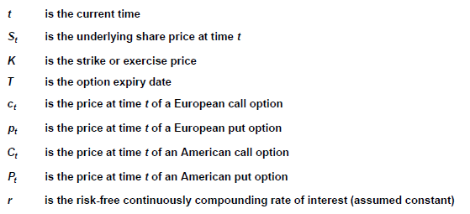

**Price = Time Value + Intrinsic Value**

**Intrinsic value**

The *intrinsic value* of a derivative is the value assuming expiry of the contract immediately rather than at some time in the future.

**Time value**

The *time value* or *option value* of a derivative is defined as the excess (or the shortfall) of an option’s current price over its intrinsic value.

It primarily represents the value of the *choice* that the option provides to its holder.

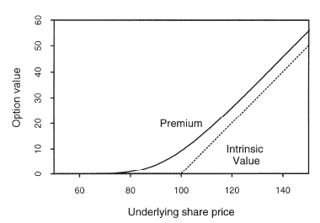

**Time Value of European Call Option**

* Time value = Price/ Premium – Intrinsic Value

$Time value = c_{t} –\max\left(S_{t}-K,0\right)$

**Non-Negative Time Value**

* Consider a portfolio consisting of a call option and cash equal to the discounted value of the strike price. At time ‘t’ the value of this portfolio is :

$c_{t}+Ke^{-r\left(T-t\right)}$

* At maturity, the portfolio is worth :
$$\max\left(S_{T}-K,0\right)+K=\max\left(S_{T},K\right)≥S_{T}$$

* Therefore, by principle of No Arbitrage, at time t,
$$c_{t}+Ke^{-r\left(T-t\right)}≥S_{t} or c_{t}≥S_{t}-Ke^{-r\left(T-t\right)}$$

* In addition, the option price cannot be negative. This gives us the lower bound for the price of the call option: $c_{t}≥\max\left(S_{t}-Ke^{-r\left(T-t\right)},0\right)$
* So, the time value of the call option is :

$c_{t}-\max\left(S_{t}-K, 0\right)≥\max\left\{S_{t}-Ke^{-r\left(T-t\right)},0\right\}-\max\left\{S_{t}-K, 0\right\}≥0$

**Notional Portfolio Proofs – Forward Price Derivation**

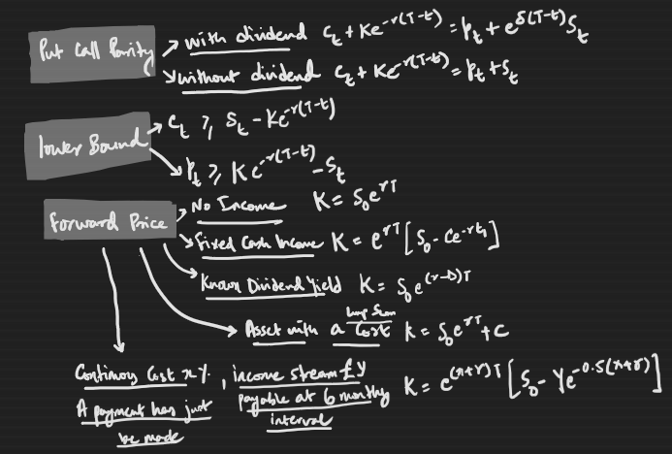

Here, we assume that there are no arbitrage opportunities in the market. This implies that if payoffs at maturity are equal then the cost of setting up the portfolio is equal.

1. **No Income:** **K = S0*er*T**

|  |  |  |
| --- | --- | --- |
| **Time** | **Portfolio A** | **Portfolio B** |
| **At t=0** | >enter into long forward position (*K+*)  >invest $Ke^{-rT}$ in RFR | >buy a security at *S0* |
| **At t=T** | >contract: $S_{T}- K$ >cash investment: *K* | >security price: *ST* |
| **Cost of set up** | *K*e-r*T* | *S0* |

As the payoffs of both the portfolios are equal (*ST*) thus, the cost of setting up the portfolios must be equal.

Thus, *K = S0*er*T*

Value at a **later time ‘t’** = $V_{t}=e^{-r\left(T-t\right)}E_{Q}\left[X|F_{t}\right]= e^{-r\left(T-t\right)}E_{Q}\left[S_{T}-K|F_{t}\right]= e^{-r\left(T-t\right)}\left[S_{t}e^{r\left(T-t\right)}-K|F_{t}\right]$

$$=S_{t}-Ke^{-r(T-t)}$$

1. **Fixed Cash Income: K = (S0 – C*e-r*t1) *er*T**

Here, we assume that we reinvest the Cash Income immediately at Risk free Rate received at time t1.

|  |  |  |
| --- | --- | --- |
| **Time** | **Portfolio A** | **Portfolio B** |
| **At t=0** | >enter into long forward contract (K+)  >invest *K*e-r*T + C*e-r*t1* in RFR | >buy security at *S0* |
| **At t= t1** | >investment = *C+K*exp(-r*(T-t1))* | >security price: *St1*  >fixed cash income: *C* |
| **At t=T** | >investment = *K + C*exp (r*(T-t1))*  >Forward contract = *ST – K* | >security price: *ST*  >income reinvested: *C*er*(T-t1)* |
| **Cost of set up** | *K*e-r*T + C*e-r*t1* | *S0* |

As payoffs of both the portfolios are equal (*ST + C*er*(T-t1)*) thus, the cost of setting up the portfolios must be equal. Thus, *K = (S0 – C*e-r*t1) *er*T*

1. **Known Dividend Yield: K = S0*e(r-D) *T**

Here, we also assume that partial holding of securities is allowed and the dividend income is reinvested immediately to buy portions of the same security.

* Dividend Yield = Dividend per share / Price per share

|  |  |  |
| --- | --- | --- |
| **Time** | **Portfolio A** | **Portfolio B** |
| **At t=0** | >Buy *e-D*T* units of security priced *S0* | >enter into long forward position (*K+*)  >invest *K*e-r*T* at RFR |
| **At t=T** | >security price: *ST* | >Forward Contract: *ST-K*  >investment: *K* |
| **Cost of set up** | *S0*e-D*T* | *K*e-r*T* |

As payoffs of both portfolios are equal thus, the cost of setting up the portfolios must be equal.

Thus, *K = S0*e(r-D) *T*

1. **ASSET WITH A COST: K = S0*er*T + C**

|  |  |  |
| --- | --- | --- |
| **Time** | **Portfolio A** | **Portfolio B** |
| **At t=0** | >enter into long forward position (K+)  >invest *K*e-r*T* at RFR | >buy security: *S0*  >invest *C*e-r*T* in RFR |
| **At t=T** | >Forward Contract: *ST – K*  >investment: K | >security price: *ST – C*  >investment: *C* |
| **Setup Cost** | *K*e-r*T* | *S0+ C*e-r*T* |

As payoffs of both portfolios are equal (ST) thus, the cost of setting up the portfolios must be equal.

Thus, *K = S0*er*T + C*

1. **PUT CALL PARITY (Without Dividend)**

Assumptions-

* Non-dividend paying security
* Equation holds true only for European style options

|  |  |  |
| --- | --- | --- |
| **Notional Portfolio (Without Dividend Asset)** | | |
|  | **Portfolio A** | **Portfolio B** |
| **Time t** | >Call option: ct  >investment: K*e-r(T-t) | >Put option: pt  >security: St |
| **At maturity T,**   1. **ST = K** 2. **ST > K** 3. **ST < K** | 1. 0 + K 2. (ST –K) + K 3. 0 + K | 1. 0 + ST 2. 0 + ST 3. (K- ST) + ST |

When ST > K, then the Put Option will not be exercised and for ST < K the Call Option will not be exercised.

As, as payoff at maturity are equal then initial cost of setting up portfolios must also be equal. Thus, we have the following relationship:

* K*e-r(T-t) + ct =St+pt

**Utility**- Helps us to find value of corresponding put given we know the value of call option and vice-versa.

1. **PUT CALL PARITY (WITH DIVIDEND at time T1)**

|  |  |  |
| --- | --- | --- |
| **Time** | **Portfolio A** | **Portfolio B** |
| **At t = 0** | Buy 1 call and 1 put | Buy 1 share  Borrow cash : $Ke^{-rT}+De^{-rT1}$ |
| **At t = T (Maturity)** | $S_{T}-K$ (under all states) | $$S_{T}+De^{-r(T-T1)}-K-De^{-r\left(T-T1\right)}=S_{T}-K$$ |

As payoffs of both portfolios are equal (ST-K) thus, the cost of setting up the portfolio must be equal.

Thus, $c_{t}-p_{t}=S_{t}-Ke^{-r\left(T-t\right)}-De^{-r\left(T1-T\right)}$

1. **ASSET with Continuous cost x%**

**+ income stream of £y payable at 6-monthly intervals**

**+ A payment has just been made (Q20 - CT8 Sept 2011 q4)**

|  |  |  |
| --- | --- | --- |
| **Time** | **Portfolio A** | **Portfolio B** |
| t = 0 | Long Position in Forward Contract K+  Cash investment $Ke^{-rT}$ | Asset : $e^{xT}S_{0}$ Cash borrowing: $-Ye^{-0.5r}e^{x(T-0.5)}$ |
| t = 0.5 |  | $$e^{x\left(T-0.5\right)}S_{0.5}+Ye^{x\left(T-0.5\right)}-Ye^{x\left(T-0.5\right)}$$ |
| t = T | ST - K + K | ST |

As payoffs of both portfolios are equal thus, the cost of setting up the portfolio must be equal.

Thus, $Ke^{-rT}=e^{xT}S_{0}-Ye^{-0.5r}e^{x\left(T-0.5\right)}=e^{\left(x+r\right)T}\left[S_{0}-Ye^{-0.5(x+r)}\right]$

1. **Upper Bound and Lower Bound of Call and Put Options**

|  |  |  |
| --- | --- | --- |
|  | **CALL** | **PUT** |
| **European** | Lower: St – K*e-r(T-t)  Upper: St | Lower: max {K*e-r(T-t) – St, 0}  Upper: K* e-r(T-t) |
| **American** | Lower: St – K*e-r(T-t)  Upper: St | Lower: max {K– St, 0}  Upper: K |

**Condition necessary for American put option price to approach the upper bound (Sept 2019)**

The value of put option will be maximised if the underlying asset is worthless at expiry which will happen if it is worthless now and has zero volatility. The option will also approach the bound if the underlying Geometric Brownian Motion has negative drift.

* **European Call** gives the holder the right (not obligation) to buy one share from the writer/issuer of contract at time T at the strike price K.
* **European Put** gives the holder the right (not obligation) to sell one share to the writer/issuer of contract at time T at the strike price K.
* **American Call and Put options** are the same as European ones, but they can be exercised at any time ‘t’ up to expiry T.

|  |  |  |
| --- | --- | --- |
|  | **Call Option** | **Put Option** |
| **At the Money** | St = K | St = K |
| **Out of Money** | St < K | K < St |
| **In the Money** | St > K | K > St |
|  | | |
| **Payoff to Holder** | Max (ST-K, 0) | Max (K-ST,0) |
| **Accounting Profit to Holder** | Max (ST-K, 0) - Ct | Max (K-ST,0) - Pt |

**Payoff and Accounting Profit Position Diagram**



**“Never Optimal to exercise an American Call Option before Maturity of non-dividend paying asset.” Proof**

* If American Call Option is exercised early say at time ‘t’, we receive St-K
* We know that European Call Option is worth more than its intrinsic value i.e. $c_{t}≥S_{t} –Ke^{-r\left(T-t\right)}> S_{t}-K$...(1)
* We know that American Call Option is valued more than or equal to European Call Option (as it provides additional right of exercising before maturity) i.e. $C_{t}≥c_{t}$…(2)
* From (1) and (2), we can say that Ct > St-K
* Thus, it is never optimal to exercise American Call option before maturity of non-dividend paying asset.

**Exercise American Put Option early? (CT8 October 2012)**

|  |  |  |  |  |
| --- | --- | --- | --- | --- |
| u = 1.06 | d=0.95 | Payoff if exercised at t=0.25 | r = 5% | Payoff if exercised at t=0.5 |
|  | **84.8** | 0 | **89.88** | 0 |
| **80** |  |  | **80.56** | 1.44 |
|  | **76.0** | 6 | **72.20** | 9.80 |
| **t=0** | **t=0.25** |  | **t=0.5** |  |

* Price of European Call = £2.49 (as calculated)
* Price of European Put = £2.47 (as calculated)
* **Patent** → To ascertain whether it is optimal to exercise an American Put Option early, we must compare the values of the derivatives at each node with what could be obtained on early exercise at that node.
* **At t=0.25(Present)**,

Value of derivative = £ 2.47

Payoff if exercised = K - S0 = 82 – 80 = £ 2

Value of derivative > Payoff if exercised at t = 0. Thus, *not optimal* to exercise at t = 0.

* **At t = 0.5**,

Note → if share price moves up, payoff is zero because put option will not be exercised.

Value of derivative = expected future payoff = $e^{-0.25r}\left(1.44q+\left(1-q\right)*9.8\right)$ = £ 4.98

Payoff if exercised = K - S1 = 82 – 76 = £ 6

Value of derivative < Payoff if exercised at t = 0.25. Thus, *it is optimal* to exercise at t = 0.25.

**Position Diagram)**

Portfolio: One European Call and Put Options each – same expiry date and strike price – same underlying security – cost: c and p respectively.

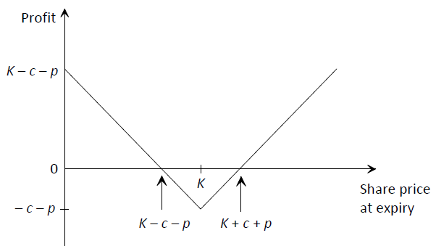

**Speculator’s Opinion -** The speculator would have set up this portfolio in the belief that the share price at the expiry date would have moved a long way from the strike price K, where this movement could be in either direction. This situation can arise when the market is waiting for news (e.g. an announcement of the company’s latest results or a court ruling) that will have a definite effect on the share price, but no one knows which way it will go.

**Factors Affecting Option Prices**

|  |  |  |
| --- | --- | --- |
| **Factors** | **Call Option** | **Put Option** |
| **Underlying Share Price (St)** | (+) | Negative |
| **Strike Price (K)** | Negative | (+) |
| **Risk free rate (r)** | (+) | Negative |
| **Time to Expiry (T-t)** | (+) | (+) *** |
| **Volatility (σ)** | (+) | (+) |
| **Dividends (q)** | Negative | (+) |

***Exception: for a deeply-in-the-money Put Option, relationship is Negative.

Deep out of the money call option, delta and gamma will be close to zero which implies that theta will equal the risk free rate of return.

**Share price**: higher share price means higher intrinsic value i.e. a higher premium/ price of Call option. But, under a put option, higher share price means lower intrinsic value of put option i.e. lower price.

* **Strike Price**: for a call option, higher strike price implies lower intrinsic value i.e. a lower premium. For a put option, higher strike price implies higher intrinsic value i.e. a higher premium.
* **Time to expiry**: longer the time to expiry, greater the chance of underlying share price to move in favour of the holder. Thus, value of option increases with increasing time to expiry. Here, the holder of the option faces an asymmetric risk i.e. lots of upside profit potential and limited downside risk.
* **Volatility**: higher volatility of underlying share, greater the chances of underlying share price to move significantly in favour of holder. Thus, direct relation.
* **Interest rate:** if interest rates rise, the holder of put will lose out on interest he/she could have earned on cash. While the holder of call as cash in the bank earning interest till the expiry date. Thus, it is positive for Call and negative for Put option.
* **Dividend rate:** if dividend rates increase then the holder of call option loses out while the holder of put option receives those dividends. Thus, it is negative for call and positive for put.

**How Option Prices Changes If Share Were Dividend-Paying?**

* If the share was dividend-paying the call option would be worth less because by holding the call option instead of the share you miss out on receiving dividends.
* The put option would be worth more because by holding the share and a put option instead of cash you receive dividends.

**American and European Call pricing on Dividend-paying share?**

* It could be optimal to exercise the American call option before maturity in order to capture the dividend.
* This is because ***you have to own the stock on the ex-dividend date in order to receive the dividend.***
* The ability to exercise represents an additional benefit of holding the American-style call option compared to the European-style call option.
* Therefore, the value of an American-style call option will be higher than the equivalent European-style call option

**How Forward Price Might Change As A Result Of an unexpected One-Off Dividend?**

* The dividend will not affect the forward price directly because the forward price only depends on future expected dividends.
* The dividend will not directly affect the share price because it was not expected hence not priced in already.
* The dividend might still affect the share price in the real world either negatively because cash has been transferred out of the business or positively because it suggests confidence in the business.

|  |  |  |
| --- | --- | --- |
|  | **Forward** | **Futures** |
| **Definition** | Forwards contracts are special-purpose instruments designed to fulfil the specific needs of counter parties. Thus, they are non-standardised contracts. | Standardised contracts |
| **Trading** | OTC | Stock exchanges like NSE, BSE etc |
| **Regulation** | Not regulated by any specific regulatory authority. | Regulated by SEBI, RBI and other regulatory authorities. |
| **Margin** | There is no possibility for payment margins by any of the parties to the other | There is a scope for margin requirements and daily settlements. |
| **Settlement** | Most of the forward contracts are settled through actual delivery of underlying assets | Most of the future contracts are settled through cash settlement instead of actual delivery of underlying assets. |

**Why is the option price falling even though analysts expect increasing returns in future. (April 2005)**

* **Given**: daily share price fell from £3 to £2 and option price from £0.9 to £0.6. Analysts expect share price to be £4 in 6 months.
* **Reason:** options are priced by “relative valuation techniques” (i.e. using risk neutral valuation). This approach is equivalent to building a hedging strategy for the option and does not take account of the expected return on the share. Since the hedging strategy involves holding some shares, the drop in price will result in a drop of the value of the option even though the expected future share price has remained the same.

**State any requirements for the option price to have fallen to its level on 2nd November. (April 2005)**

* Unless the option is deep in the money, the drop in price of the option will be less than proportional to the share price and hence some combination of the following must also have occurred:

(a) dividends increased (b) share price volatility decreased (c) risk free interest rate decreased

## Ch 13: The Greeks

**Hedging** is strategy by which we build a single portfolio by combining various derivatives and the underlying assets to eliminate almost all of the market risk facing our portfolio (though other risks such as lack of marketability or credit risk will remain).

**Delta Hedging** involves the construction of a portfolio who’s overall ‘𝛿’ is equal to zero.

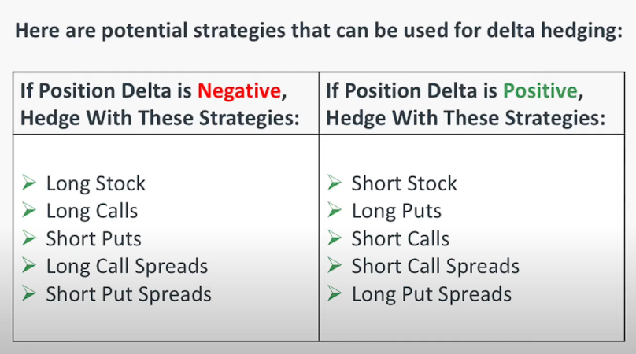

**Greeks** are a group of mathematical derivatives that can be used to help us to manage or understand the risk in our portfolio.

**6 Greeks –**

1. **Delta (Δ)**

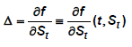



Delta is defined as the rate of change of the derivative price with respect to changes in the underlying asset price (assuming all other parameters remain unchanged). It therefore tells us the (approximate) change in the derivative price when the underlying asset price changes.

When we consider delta hedging, we add up the deltas for the individual assets and derivatives (taking account, of course, of the number of units held of each). If this sum is zero and if the underlying asset prices follow a diffusion then the portfolio is **instantaneously risk free**.

A portfolio for which the weighted sum of the deltas of the individual assets is equal to zero is described as **delta-hedged** or **delta-neutral**.

The process of simply constructing an initial portfolio with a total delta of zero without rebalancing it in future to reflect changes in delta is known as **static Delta Hedging**.

Delta changes continuously through time. The process of continuously rebalancing the portfolio in order to maintain a constant total portfolio delta of zero is known as **dynamic Delta Hedging.**

**Why Delta of Call is Positively Correlated with St**

Delta determines how the value of the option changes when the underlying share price changes. Therefore increases in the share price lead to increases in the option value under all circumstances. We can also see that the payoff function of the call options is an increasing function of St.

**Using ITO’s lemma show that  (X3.10 assignment)**



**Reason for discrepancy between estimated (based on delta) and actual value of Zero coupon bonds? (x4.1)**

* Reason for discrepancy is the fact that delta is not constant but varies with the change in value of underlying (here company’s assets).
* Other reason : change in values of other parameters like volatility.

1. **Gamma (Γ)**

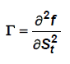



Gamma is the rate of change of  with the price of the underlying asset.

It therefore measures the curvature or convexity of the relationship between the derivative price and the price of the underlying asset. This is because a high value of Γ means that  is more sensitive to changes in the share price St.

For practical hedging purposes, a portfolio with a low  is preferable, as costly

rebalancing will be required less frequently in order to keep the portfolio approximately Delta Hedged.

**Low-Value of Gamma is Desirable for Delta-Hedging -**

Gamma describes how delta changes when the share price changes. A low value of gamma therefore implies that delta is not very sensitive to changes in the share price. So the portfolio is likely to require less rebalancing as the share price changes. This is desirable because rebalancing costs time and money and introduces risk.

1. **Vega ()**

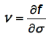



This is the rate of change of the price of the derivative with respect to a change in the “assumed” level of volatility of St.

The volatility cannot be observed directly in the market, and so its value must be ‘estimated’ or ‘assumed’.

The value of a portfolio with a low value of vega will be relatively insensitive to changes in volatility. It is less important to have an accurate estimate of  if vega is low. Since  is not directly observable, a low value of vega is important as a risk management tool. Also, if vega is small, approximating σ will be better.

**Why low value of vega is desirable ?**

$Vega =\frac{d}{dσ}$ of the share price.

The value of a portfolio with a low value of vega will be relatively insensitive to changes in volatility.

Put another way: it is less important to have an accurate estimate of σ if vega is low.

Since vega is not directly observable, a low value of vega is important as a risk management tool.

Furthermore, it is recognised that vega can vary over time.

Since many derivative pricing models assume that volatility is constant through time the resulting approximation will be better if vega is small.

1. **Rho (ρ)**

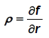



Rho tells us about the sensitivity of the derivative price to changes in the risk free rate of interest. The risk free rate of interest can be determined with a reasonable degree of certainty, but it can vary by a small amount over the (usually) short term of a derivative contract. As a result, a low value of  reduces risk relative to uncertainty in the risk free rate of interest.

1. **Lambda (λ)**

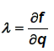



where *q* is the assumed, continuous dividend yield on the underlying security.

**Why is Lambda of a long forward position in a dividend-paying share is negative?**

* We buy the share at a future data instead of buying the share now, thus we are not entitled to receive the dividends paid by the share over the lifetime of the forward contract.
* The greater the value of these dividends, the more income we miss out.
* Consequently, lambda is negative for a forward contract

1. **Theta (θ)**

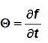

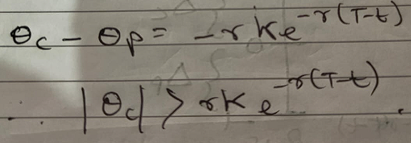

Since time is a variable which advances with certainty, it does not make sense to hedge against changes in t in the same way as we do for unexpected changes in the price of the underlying asset.

**Why is Theta negative for an option –**

Theta determines how the value of the option changes with the passage of time. As we move closer to the expiry date it becomes more certain whether or not the option will be exercised. So the value of the optionality reduces. $θ=\frac{df}{dt}$

|  |  |  |
| --- | --- | --- |
| **Greeks** | **Call Option** | **Put Option** |
| **𝛿** | Positive (+) | Negative |
| **Vega** | Positive (+) | Positive (+) |
| **ρ** | Positive (+) | Negative |
| **λ** | Negative | Positive (+) |
| **Theta** | Positive (+) | Negative |

**Reasoning –**

* **Delta and Call/Put** – Increasing share price will push out of money option towards in the money. Thus, positive. Increasing share price will push in the money option towards out of money. Thus, negative.
* **Vega and Call/Put** – higher vega implies greater volatility i.e. more uncertainty about movement of price. Thus, it is positive for both and equal as well.
* **Rho and Call/Put** – if interest rates rise, the holder of put will lose out on interest he/she could have earned on cash. While the holder of call as cash in the bank earning interest till the expiry date. Thus, it is positive for Call and negative for Put option.
* **Lambda and Call/Put –** if dividend rates increase then the holder of call option loses out while the holder of put option receives those dividends. Thus, it is negative for call and positive for put.
* **Theta and Call/Put** – Theta is a measure of current time. And (T-t) is the remaining time to expiry. Higher the value of theta, Lower is the time to expiry, lower is the price of the option as certainty increases. Thus, it is negative for both.

**#Management Role of Greeks**

**Hedge Fund Manager**

* 𝛿-neutral position i.e. 𝛿 = 0
* To minimise rebalancing to maintain 𝛿-neutral position, Γ = 0

**Derivatives Trader**

* Lower volatility i.e. Vega = 0

**Pension Fund Trustee**

* Concerned about the effect of calendar time on the value of options. To avoid value falling, the trustee will prefer to have a *non-negative theta*.

**Explain how Γ and Vega can be used in the risk management of a portfolio that is delta-hedged. (Sept 2005)**

* Assuming that the portfolio under management is delta hedged at discrete times, the two most important Greeks are gamma and vega. Between rebalancing at the trading times, delta will drift away from zero as the underlying asset prices move. If the portfolio is gamma-hedged at the discrete trading times then the amount of such drift will be small (comparable to the square of the change in underlying price).
* The underlying volatilities used in hedging calculations are all estimates. If these are incorrect then delta hedging may be incorrect, consequently it is appropriate to attempt to immunise a portfolio against (small) errors in volatility estimates. Just as in delta hedging, achieving a portfolio vega of zero achieves this. Consequently, good risk managers will seek to achieve a (close to) zero vega for the bank’s portfolio.

**Explain by comparing the cash flows of an option holder and a shareholder, why the value of this option would be lower if the share was dividend-paying. (2020 Sept)**

* Dividend income is not passed onto the holder of an option.
* By buying the option instead of the underlying share the investor therefore foregoes this income.
* The dividend also removes value from the company which therefore removes value from the shareholder.

## Ch 14: The Binomial Model

**Assumptions**

* No trading costs
* No taxes
* No minimum or maximum units of trading – i.e. non-integer number of shares can be held and short selling is permitted.
* Trading occurs only at discrete times
* Principle of no arbitrage holds i.e. d < exp (r) < u

Where, d is decreasing factor and u is increasing factor

**Principle of No Arbitrage under Binomial Model, Proof**

1. **If we assume exp (r) < d < u holds.**

* At t=0, take a loan of £1 at risk free-rate and Buy a £1 share.
* At t=1, Share price = u or d and payoff = u-er >0 or d-er >0
* In both cases, we have a net profit without any initial cost of set-up. Thus, arbitrage exists.

1. **If we assume d < u < exp (r) holds.**

* If this holds, then no one would consider investing in securities and payoff is higher in risk free assets.

**One-Period Binomial Tree**

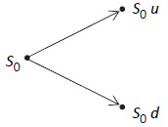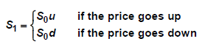

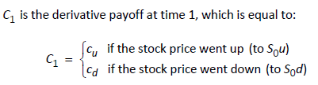

**Define Risk Neutral Probability Measure for the model**

* The pricing measure Q must satisfy $E_{Q}\left[e^{-r(t+1)}S_{t+1}|F_{t}\right]=S_{t}$
* So if we set risk neutral probability of up-step ‘q’ = $Q\left(S_{t+1}=u*S_{t}|F_{t}\right)$
* Then, $V_{0}=e^{-r}\left[C_{u}q+C_{d}\left(1-q\right)\right]$
* Thus, the unique pricing measure makes St a multiplicative random walk with up-jump probability of ‘q’
* At t=0, hold **φ** units of securities and **ψ** units of cash
* Value of portfolio at t=0 **V0 =** **φ*S0 + ψ**
* At t=1, the same portfolio has the value

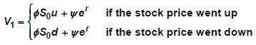

* Thus, we have two equations –

**Cu = φ*S0*u + ψ*er and Cd = φ*S0*d + ψ*er**

* Solving the two equations, we get
  + **φ = (Cu – Cd) / S0*(u-d)**
  + **ψ = er *(u*Cu – d*Cd) / (u-d)**
  + **V0 = e-r *[Cu*(****er-d / u-d) + Cd*(u-er /u-d)]**
  + Risk neutral probability of up-step q = **er-d / u-d**
  + Risk neutral probability of down-step (1-q) = **u**-**er / u-d**
  + **V0 = e-r *[Cu*q + Cd*(1-q)]**
* Payoff of the derivative at t=1 is given by
  + V0 = e-r *EQ[C1] = S0*er
  + Where, q is the risk neutral probability measure
  + Under Q we see that the expected return on the risky stock is the same as that on a risk free investment in cash. investors are neutral with regard to risk: they require no additional return for taking on more risk.
  + Under the real-world measure P, the expected return on the stock will not normally be equal to the return on risk free cash. Under normal circumstances, investors demand higher expected returns in return for accepting the risk in the stock price. So, p > q.
  + 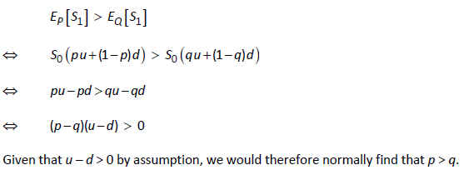

**Two-Period Binomial Tree**

A **Re-Combining binomial tree** (or binomial lattice) is one in which values of u and d, and consequently the risk neutral probabilities, are the same in all states.

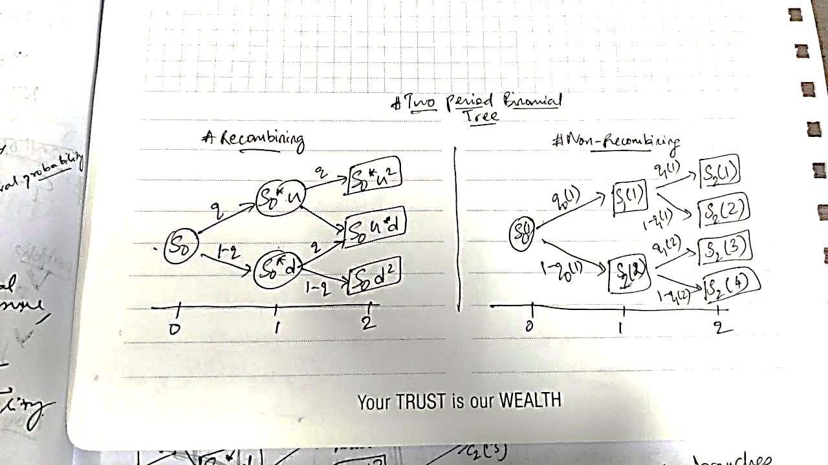

**For a Recombining Binomial Tree**

* Value at time 1
  + C1(1) = e-r *[q*C2(1) + (1-q)*C2(2)]
  + C1(2) = e-r *[q*C2(2) + (1-q)*C2(3)]
* Value at time 0
  + C0 = e-r *[q*C1(1) + (1-q)*C1(2)]

**Replicating Portfolio Method –**

**Definition :**

* A replicating portfolio is one that produces the payoffs of a derivative for all possible outcomes of the value of the underlying asset.
* It is usually constructed out of a suitable combination of the underlying asset and risk free cash.
* In an arbitrage free world, it must have the same value as the derivative it replicates.
* At t=0, hold **φ0(1)** number of shares **ψ0(1)** cash
  + **V0 = S0*φ0(1) + ψ0(1)**
* At t=1, the value of current holding is given by
  + **V1 = S1(1)*φ0(1) + ψ0(1)*er……..(1)**
* At t=1, the market value of rebalanced portfolio to be held
  + **V1 = S1(1)*φ1(1) + ψ1(1) ………..(2)**
* For a self-financing portfolio, (1) and (2) are equal
  + **S1(1)*[φ1(1) - φ0(1)] + [ψ1(1) - ψ0(1)*er] = 0**
  + if shares (first part of equation) is positive, then cash (second part of equation) will be negative, i.e. cash invested will be used to buy more shares.
  + If shares part is negative, then cash part will be positive i.e. shares will be sold and that cash inflow will be invested.

**Non-Recombining Two-period Binomial Tree**

* Value of portfolio at t =0
  + V0(1) = e-r[ q0(1)*V1(1) + (1-q0(1))*V1(2)]
* Value of C0 is given by
  + C0 = e-2r[ q0(1)*q1(1)*C2(1) + q0(1)*(1-q1(1))*C2(2)

+ (1-q0(1))*q1(2)*C2(3) + (1-q0(1))* (1-q1(1))*C2(4) ]

Generalising,

 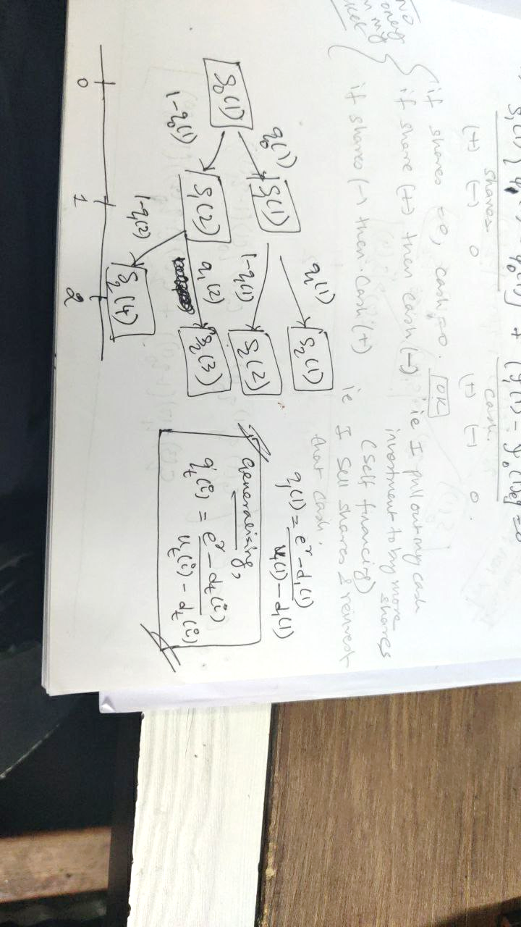

**Explain the difference between a recombining and a non-recombining binomial tree. (Practise Question 14.8)**

* In a recombining binomial tree u and d, the proportionate increase and decrease in the underlying security price at each step, are assumed constant throughout the tree. As a result, the security price after a specified number of up- and down- movements is the same, irrespective of the order in which the movements occurred.
* In a non-recombining binomial tree, the values of u and d can change at each stage. As a result, each node in the tree will in general generate two new nodes, making the tree much larger than a recombining tree. Consequently, an n-period tree will have 2*n, rather than just n +1, possible states at time n.

**N-Period Binomial Tree**

I: random variable for number of Up steps

I ~ Bin (n, q) where I = 0,1,2 …n

**V0 = e-r*n sum:(k=0, n): f(S0*uk*dn-k) * nCk qk (1-q) n-k**

**Vt = e-r*(n-t) sum:(k=0, n-t): f(S0*uk*dn-t-k) * n-tCk qk (1-q) n-t-k**

**Calibrating Binomial Models**

For recombining binomial models, an additional condition that leads to a **unique** solution is: **u = 1/d i.e. u*d = 1**

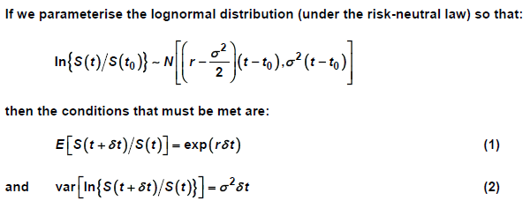

𝛿t: time interval of each step, 𝛿t tends to 0

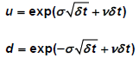 where, v is the rate of dividend

**Advantage & Disadvantage of *subdividing the option term into months* and suggest an alternative model based on months which is more efficient numerically.**

* Sub-diving the option term into months or smaller time periods will make the model less crude and capable of producing more accurate valuation.
* However, it will require a lot more parameters to be specified and appropritate values of ‘u’ and ‘d’ would be required for each branch of the tree and values of ‘r’ for each month.
* The size of the tree will increase. We will thus required program on a computer to perform the calculations.
* Alternative: Black-Scholes Model

**Difference between Real-World and Risk neutral probability measure in context of valuation of derivatives using a binomial tree.**

* Real world probability measure can be interpreted in the following way. Let A be some event contained in F (for example, suppose that A is the event that S1 is greater than or equal to 100). Then P (A) is the actual probability that the event A will occur.
* On a more intuitive level with m independent realisations of the future instead of one we would find that the event A occurs on approximately a proportion P (A) occasions (with the approximation getting better as m gets larger and larger).
* Two measures P and Q which apply to the same sigma-algebra F are said to be equivalent if for any event E in F:
  + P (E) >0 if and only if Q (E) >0, where P (E) and Q (E) are the probabilities of E under P and Q respectively.
* In the context of the binomial model and using the above definition of equivalence the only constraint on the real-world measure P is that at any point in the binomial tree the probability of an up move lies strictly between 0 and 1. The only constraint on Q is the same but this can be equated to the requirement that the risk free return must lie strictly between the return on a down move and the return on an up move. This gives us considerable flexibility in the range of possible equivalent measures.

**Comment on relationship between Price of standard and special Call option.**

* The price of standard call option calculated under Binomial tree method = 16.7216, and
* The price of special call option calculated under Binomial tree method = 16.7216 i.e. equal.
* The special call option can only be exercised when price goes above specified limit (here, 130). Thus, it provides lesser possibilities to exercise the option. Thus, the price of special call should be lower than that of the standard call option.
* But, under binomial tree method, we get the same price. Thus, we need to reconsider our method of valuation.

**Limitations Of Using A Binomial Tree to set up a Replicating Portfolio**

* A Binomial tree assumes that the stock price can only move to one of two values in a single time step.
* We can therefore only check the option value at these points.
* The Binomial tree also only allows us to model discrete step changes in stock prices when real stocks will move continuously.
* So there will be intermediate points in time when we cannot use the Binomial tree to calculate an option price.
* This will limit the usefulness of a replicating strategy derived using a Binomial tree.
* Although we could introduce more time steps, which would help.

**Change in the value of down-step d from 0.8 to 0.7, What is the impact on the portfolio?**

* The portfolio consists of a short position in European call option and long position in European put option. The value of the call option was evaluated using the Binomial tree approach based on the risk neutral probability measure.
* For d = 0.8, call option payoffs = (76.82, 26.12, 0, 0) and put option payoffs = (0, 0, 5.08, 24.28) and price of call is £12.87 and put option is £7.05.
* For d = 0.7, call option payoffs = (76.82, 15.98, 0, 0) and put option payoffs = (0, 0, 16.78, 34.42) and price of call is £15.94 and put option is £10.12.
* Ignoring the Binomial tree dynamics and solely based on the Put Call Parity, the value would not change as it is independent of expected movements of the stock (i.e. its volatility) $c_{0}+Ke^{-rT}=p_{0}+S_{0}$.

**Why is it difficult to apply Black Scholes model on Binomial Tree (April 2021)**

* Because the assumption are different :
  + Under Black Scholes,
    - share price St ~ logN
    - dividends are continuous
  + Under Binomial tree,
    - share price St ~ Binomial
    - dividends are one-off at a set time
  + The Black-Scholes constant volatility assumption is flawed here as well because of the dividend.

## Ch 15: Black Scholes Model

**Assumptions**

1. Underlying share price follows Geometric Brownian Motion or Log Normal Model.
$dS_{t} = S_{t} (μ dt + σ dW_{t})$

2. Principle of no arbitrage holds
3. Risk free rate is constant and it is same for borrowing and lending.
4. *Unlimited short selling* i.e. we are allowed to sell unlimited amounts of securities that we do not own. This is necessary because, in order to hedge a derivative whose price is positively correlated with that of the underlying asset (e.g. a call option with positive 𝛿) we need to hold a negative quantity of underlying asset.
5. No taxes and transactional costs.
6. The underlying asset can be traded continuously and in infinitesimally small numbers of units.

**Comment on how realistic these assumptions are in practice. OR Defects in assumptions.**

It is clear that each of these assumptions is unrealistic to some degree, for example:

* Share prices can jump. This invalidates assumption 1. since geometric Brownian motion has continuous sample paths. It also invalidates assumption 2. However, hedging strategies can still be constructed which substantially reduce the level of risk.
* The risk free rate of interest does vary and in a unpredictable way. However, over the short term of a typical derivative the assumption of a constant risk free rate of interest is not far from reality. (More specifically the model can be adapted in a simple way to allow for a stochastic risk free rate, provided this is a predictable process.)
* Unlimited short selling may not be allowed except perhaps at penal rates of interest. These problems can be mitigated by holding mixtures of derivatives which reduce the need for short selling. This is part of a suitable risk management strategy as discussed in Section 2 below.
* Shares can normally only be dealt in integer multiples of one unit, not continuously and dealings attract transaction costs: invalidating assumptions 2., 5., 6. and 7. Again we are still able to construct suitable hedging strategies which substantially reduce risk.
* Distributions of share returns tend to have fatter tails than suggested by the log-normal model, invalidating assumption 1.

**Defects**

1. All defects of continuous time log normal model.
   1. Volatility parameter σ may not be constant over time.
   2. Drift parameter μ may not be constant over time. In particular, interest rates will impact the drift.
   3. There is evidence in real markets of mean-reverting behaviour, which is inconsistent with the independent increment assumption.
   4. There is evidence in real markets of momentum effects, which is inconsistent with the independent increment assumption.
   5. Distribution of ln(St/Ss) ~ Normal i.e. Normality Assumption. In reality, there are more extreme events than what is captured by Normal distribution. In particular, market crashes appear more often than one would expect from a Normal (or lognormal) distribution. Further, days with no change, or very small change also happen often than suggested by the normal distribution. Distribution of security returns has taller peak and fatter tails in reality.
   6. The sample paths of security prices are not continuous, but instead appear to jump occasionally.
2. Unlimited short selling may not be allowed
3. Shares can normally only be dealt in integer multiples of one unit
4. Trading is not done continuously rather it is discrete
5. Transaction costs and taxes exist.
6. The risk free rate of interest does vary and in an unpredictable way.

**Explain what is meant by a ‘complete market’**

A financial market is said to be complete if any contingent claim (ei derivative payoff) can be replicated using the underlying asset and cash. For example, we can replicate the payoff from a call option on a share using a long holding in the underlying share and a short holding of cash.

**Tradeable Asset –** asset whose total returns are realised at the point of sale. E.g. zero-coupon bond, non-dividend paying share.

**Convert Non-tradeable asset to tradeable asset –** if income from non-tradeable asset is *reinvested* in buying additional units of the underlying asset. $Dividend Yield = \frac{dividend per share}{market price per share}$

**Give two reasons why in practice financial markets may not be complete**

A replicating strategy will typically involve holding fractions of shares and fractions of units of cash. Since these are indivisible it will not be possible to replicate exactly. A replicating strategy for a put option will require a short holding of the underlying security. If the financial markets do not allow short selling (or if there are restrictions on it), then replication may not be possible.

**State the relevance of the concept of complete markets in derivative pricing.**

Although it is usually just a technicality, the concept of a complete market is important because, without it, we could not be sure that we could replicate the payoff from a derivative. This means that the steps in the derivation of the risk neutral pricing formula cannot be applied. So we could not use this formula to price the derivative.

**Explain how delta and self-financing are used in the martingale approach to valuing derivatives.**

* In the martingale approach we showed that there exists a portfolio strategy $\left(ϕ_{t},ψ_{t}\right)$ which would replicate the derivative payoff. We did not say what $ψ_{t}$ actually is or how we work it out. In fact this is quite straightforward.
* First we can evaluate directly the price of the derivative $V_{t}=e^{-r\left(T-t\right)}E_{Q}\left[X | F_{t}\right]$ either analytically (as in the Black-Scholes formula) or using numerical techniques.
* In general, if $S_{t}$, represents the price of a tradeable asset $ϕ_{t}=\frac{∂V}{∂s}\left(t,S_{t}\right).$ $ψ_{t}$ is usually called the Delta of the derivative.
* The martingale approach tells us that provided:
  + We start at time 0 with V0 invested in cash and shares.
  + We follow a self-financing portfolio strategy.
  + We continually rebalance the portfolio to hold exactly $ψ_{t}$ units of St with the rest in cash then we will precisely replicate the derivative payoff.

**Describe how the no-arbitrage condition and a self-financing strategy can be used to value the derivative.**

An initial investment of $V_{0}$ at time 0, if we follow the self-financing portfolio strategy will reproduce the derivative payment without risk. Hence, by no arbitrage the value of the derivative at time 0 must be V0.

**Explain what is meant by a “risk neutral probability measure” and state mathematically what it implies about the pricing of derivatives relative to the price of the underlying asset. (X3.4 assignment)**

A risk neutral probability measure is a synthetic set of probabilities under which the expected values of the relevant assets accumulate at the risk free rate of interest, ei at the rate of return that would apply if all investors were risk neutral. If the risk neutral probability measure for the underlying asset is Q and the risk free interest rate (continuously compounded) is r , then the value at time t of a derivative with payoff T X at time T is

$V_{t}=e^{-r\left(T-t\right)}E_{Q}\left[X_{T} | F_{t}\right]$

This can be used to calculate a derivative price in an arbitrage-free world.

**Derive Distribution of St –**

* SDE of St is given by : $dS_{t}=S_{t}\left(μ dt+σ dW_{t}\right)$ where, Wt is Standard Brownian Motion
* Now, $dS_{t}^{2}= σ^{2}S_{t}^{2}dt$ (Using ITO’s Lemma)
* We define $f\left(S_{t}\right)=\ln\left(S_{t}\right)$
* First order derivative with respect to St : $f^{'}\left(S_{t}\right)=\frac{1}{S_{t}}$
* Second order derivative with respect to St : $f^{''}\left(S_{t}\right)=\frac{-1}{S_{t}^{2}}$
* Thus, $d\left(logS_{t}\right)=f^{'}\left(S_{t}\right)dS_{t}+0.5*f^{''}\left(S_{t}\right)dS_{t}^{2}$ (Using Taylor Series)
* Or, $d\left(logS_{t}\right)=\left(μ-0.5σ^{2}\right)dt+σdW_{t}$
* Integrating both sides, from 0 to t, we get –

$\int_{0}^{t}{d\left(logS_{t}\right)}=\int_{0}^{t}{\left(μ-0.5σ^{2}\right)dt}+σ\int_{0}^{t}{dW_{t}}$

$\log\left(S_{t}\right)=\log\left(S_{0}\right)+\left(μ-0.5σ^{2}\right)t+σW_{t}$

$S_{t}=S_{0}e^{\left(μ-0.5σ^{2}\right)t+σW_{t}}$

$S_{t}\sim LogN \left(lnS_{0}+(μ-0.5σ^{2}\right)t , σ^{2}t)$

**The Black Scholes Formula**

$c_{t}=S_{t}Φ\left(d_{1}\right)-Ke^{-r\left(T-t\right)}Φ\left(d_{2}\right)$ where, $d_{1}=\frac{\ln\left(\frac{S_{t}}{K}\right)+\left(r+0.5σ^{2}\right)(T-t)}{σ\sqrt{T-t}} and d_{2}= d_{1}-σ\sqrt{T-t} or \frac{\ln\left(\frac{S_{t}}{K}\right)+\left(r-0.5σ^{2}\right)(T-t)}{σ\sqrt{T-t}}$

**When σ → 0,**

1. **Behaviour of d1 and d2**

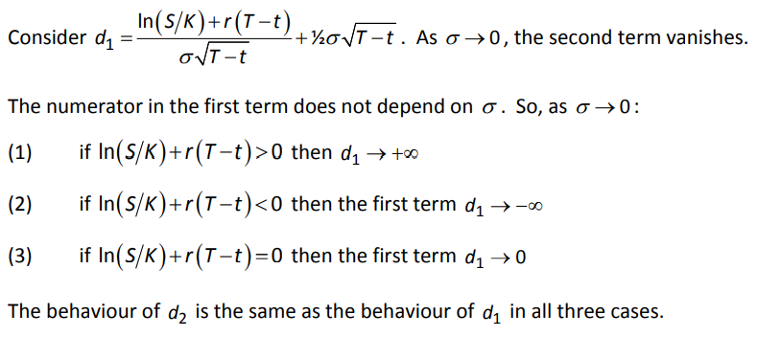

1. **Behaviour of Φ(d1) and Φ(d2)**

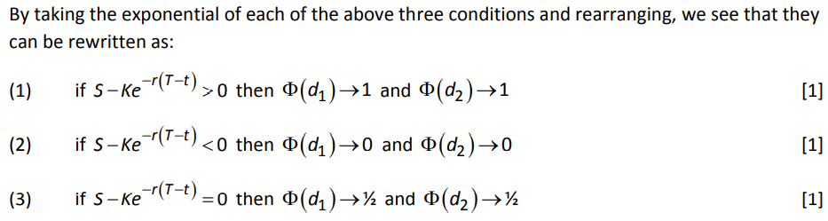

1. **Behaviour of entire formula**

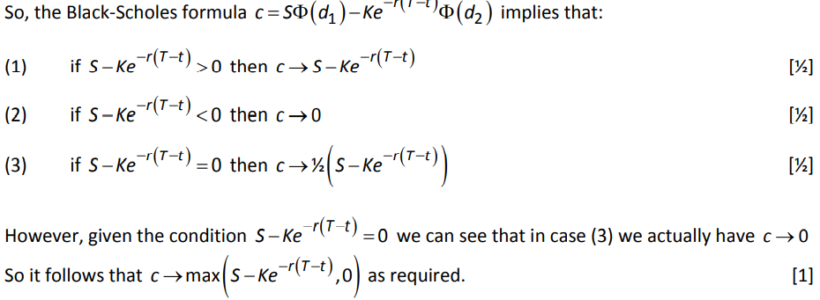

Analysing each component of the formula:

Here we are understanding individually how d1 and d2 behaves.

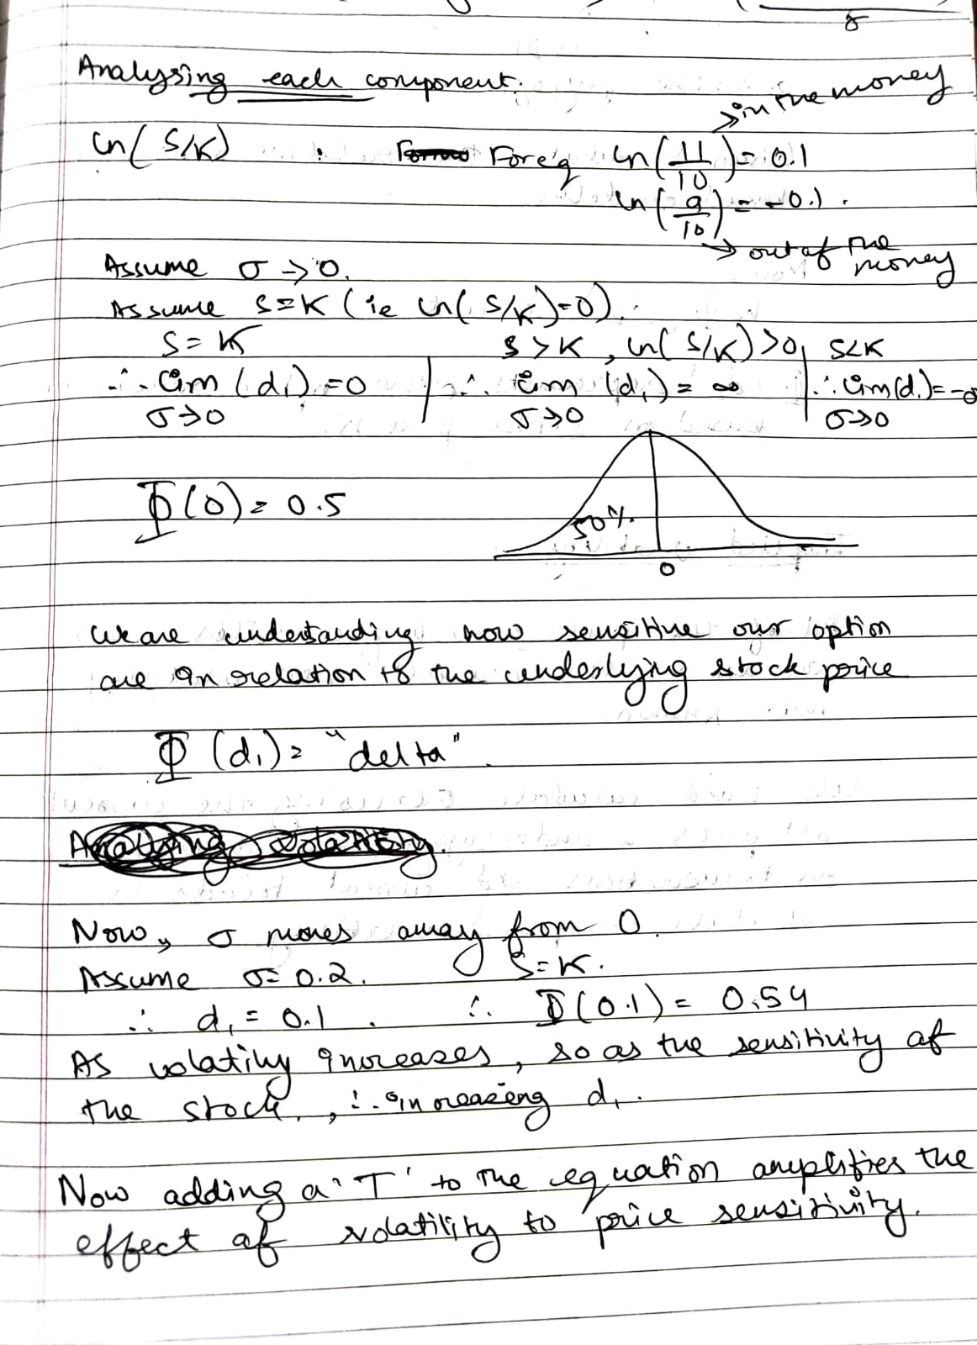

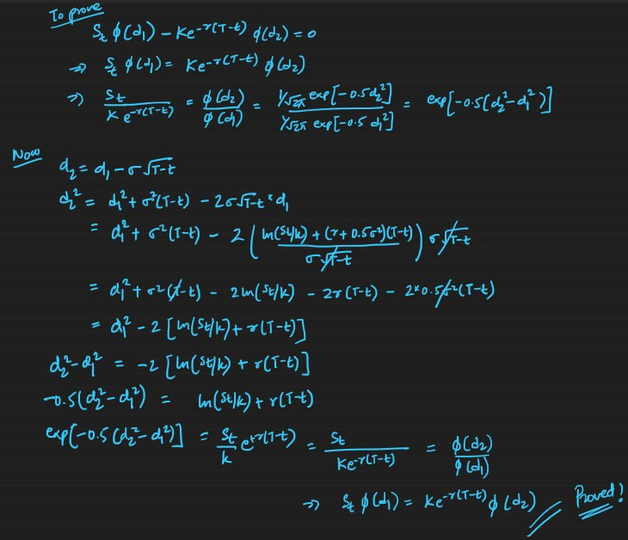Here its comparing the PDF

**Black Scholes PDE:**

The derivation of the Black-Scholes PDE assumes that the underlying asset follows a geometric Brownian motion and that there are no arbitrage opportunities. It reflects how the value of an option is sensitive to changes in the financial and time variables that describe the system.

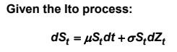 ie GBM.

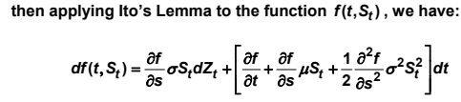

The drift term should be constant and represent the risk free gain.

**The black scholes PDE**

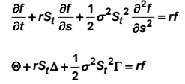

The risk free portfolio method.

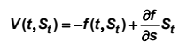 where V is the value of the portfolio, f is price of a option.

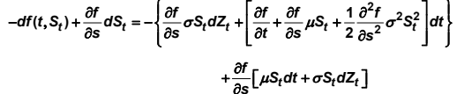

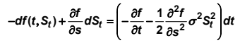



Alternative equation:

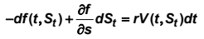 Since market is assumed to be arbitrage free.

Now equating both the equations, we get our black scholes pde.

**Que14 – CT8 September 2011 Question 8 -** Given → payoff = $\left\{\begin{aligned}1000 if t=2, S_{2}<2 \\ 500 if t=1, S_{1}>2\end{aligned}\right.$**If option is not exercised at time 1 then how should it be priced?**

* If option is not exercised then it becomes an European Put option with
  + Strike Price = K = £2.00
  + Remaining Term = 2 – t where 1≤ t ≤ 2
  + Fixed-Cash Payoff = 1000 when St < K

**Put options to hedge risk (Sept 2020)**

* Whether put options can be bought on these shares.
* Whether a put option can be bought on these shares with the right term…
* … or whether a dynamic hedging strategy will be needed.
* Whether the put option is believed to be reasonably priced.
* The executive’s utility function.
* Whether the executive has expertise in the use of derivatives.
* Any tax or regulatory concerns about using derivatives
* Dealing costs or access to the market
* Restrictions on CEOs trading company shares
* The hedge would reduce the upside potential of the benefits
* Reputational damage caused by the CEO effectively betting against their own company

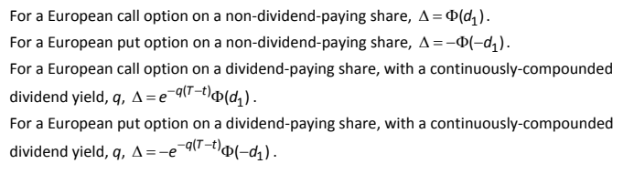

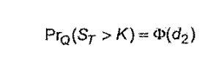

**All greeks derivation and formula for black scholes

## Ch 16-17: 5 Step Method

This chapter centres on the development of a derivative pricing approach based on the use of replicating strategies.

5 Step Method

This chapter focuses on developing proofs for the formula 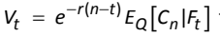

1. Establish an unique equivalent measure Q under which the discounted asset price process given by

$D_{t}=e^{-rt}S_{t}$ is a martingale.

$$E_{Q}\left[S_{t}e^{-rt} |F_{s}\right]$$

$S_{t}\sim LogN\left(lnS_{0}+rt , σ^{2}t\right)$ (Under Q, μ → r)

$$=e^{-rt}S_{s}*E_{Q}\left[e^{\left(r-0.5σ^{2}\right)\left(t-s\right)+σ\left(Z_{t}-Z_{s}\right)}\right]$$

$$= e^{-rt}S_{s} e^{\left(r-0.5σ^{2}\right)\left(t-s\right)+{0.5σ}^{2}(t-s)}$$

Because $\exp\left[σ\left(Z_{t}-Z_{s}\right)\right]\sim LogN\left(0, σ^{2}\left(t-s\right)\right), mean=e^{0.5σ^{2}(t-s)}$

$$=S_{s}e^{-rt + rt-rs-0.5σ^{2}\left(t-s\right)+{0.5σ}^{2}(t-s)}$$

$=S_{s}e^{-rs}$ Thus, a Martingale under Q. (because we changed drift μ → r)

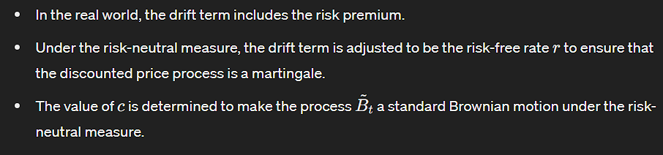

**Addition under continuous →**

1. It can show that that this measure exists, is unique, and that under Q:

$D_{t}=D_{0}\left(σ{z̃}_{t}-0.5σ^{2}t\right)$ where ${z̃}_{t}$ is a standard Brownian Motion under Q.

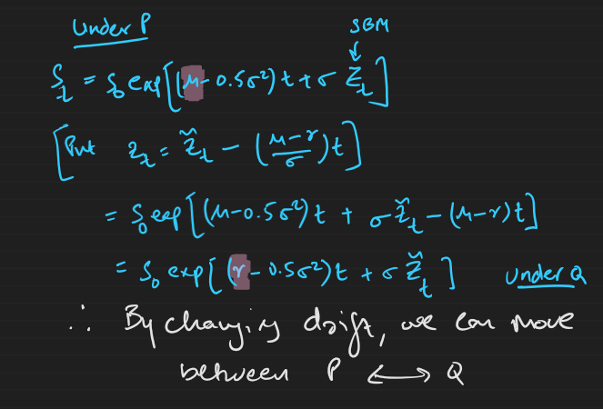

1. We define $V_{t}=e^{-r(T-t)}E_{Q}\left[X_{T}|F_{t}\right]$ where the random variable XT is the derivative payoff at time T. It is proposed that this is the fair price of the derivative.
2. Let $E_{t}=e^{-rt}V_{t}$ be a martingale under Q

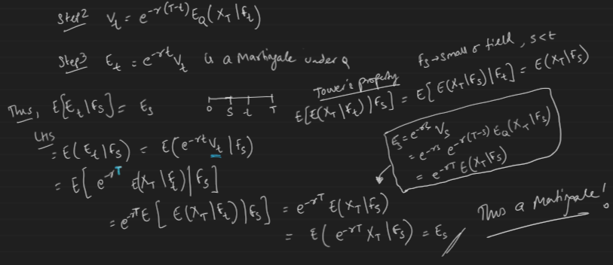

1. (Martingale Representation Theorem) As Et and Dt both are martingales under Q, then there exists an unique previsible process φh such that $dE_{t}=ϕ dD_{t}$.

**(Discrete)**



**(Continuous)**

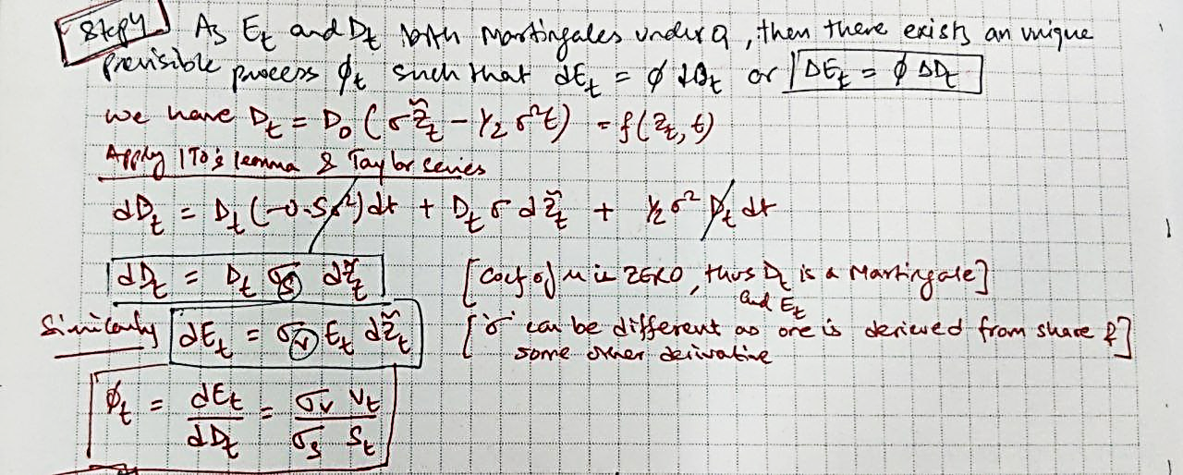

1. Let the hedging strategy of holding φh shares/asset and bt cash bonds be self-financing.

(Discrete)

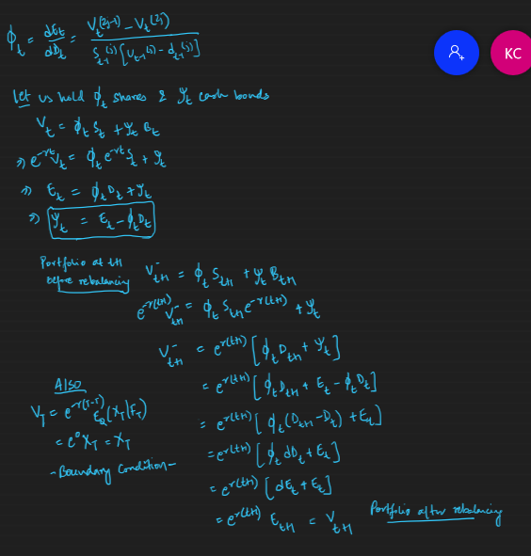

(Continuous) 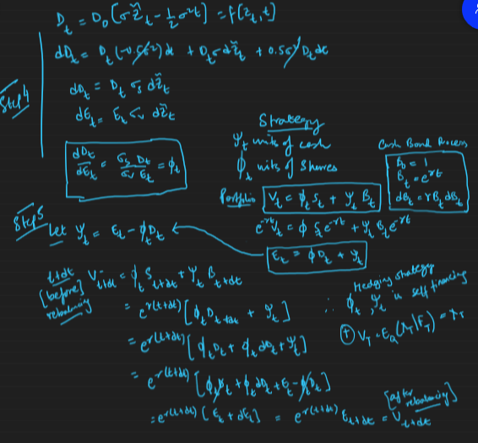

Because portfolio before rebalancing and after rebalancing is the same i.e. it does not need topping up or siphoning off, we can say that the hedging strategy (φh, bt) is self-financing.

Also, Vt satisfies the Boundary Conditions $V_{T}=e^{T-T}E_{Q}\left[X_{T}|F_{T}\right]=X_{T}$.

Therefore, $V_{t}=e^{-r(T-t)}E_{Q}\left[X_{T}|F_{t}\right]$ is the fair price at time ‘t’ for this derivative contract.

**Cameron – Martin – Girsanov CMG Theorem**

1. Wt is a SBM defined on the probability space $(Ω, F, P)$ where $F$ is a filtration associated with the Brownian motion and P is the real-world probability measure.
2. P and Q are equivalent probability measures.
3. W̃t is a SBM under Q (Risk Neutral Probability Measure)

Where, ${\tilde{W}}_{t}=W_{t}+\int_{0}^{t}{γ_{s}ds}$

Here, γ is a pre-visible process such that $\frac{dP}{dQ}=e^{γ \tilde{W}t - 0.5γ^{2}t}$

The CMG theorem states that if (A) and (B) hold true, then (C) holds true as well and vice-versa.

The CMG Theorem implies that we can shift from one probability measure to another by simply changing the drift term of a Brownian Motion.

**Martingale Representation Theorem**

1. Suppose that Xt is a martingale under probability measure P i.e. $E_{p}\left(X_{t}\right|F_{s})=X_{s}$ for s < t

And volatility of Xt is always non-zero

1. Suppose that Yt is a martingale under probability measure P i.e. $E_{p}\left(Y_{t}\right|F_{s})=Y_{s}$ for s < t then,

MRT states that there exists a unique pre-visible process $ϕ_{t}$ such that $Y_{t}=Y_{0}+\int_{0}^{t}{ϕ_{s}dX_{s}}$ or $dY_{t}= ϕ_{t}X_{t}$ if and only if there is no other probability measure equivalent to P under which Xt is a martingale. This integral is the key part of the representation. It says that the changes in 𝑌𝑡​ can be expressed as the integral of another process 𝜙𝑠 with respect to the increments of a martingale 𝑋𝑡.

Under Discrete-time Binomial Model, $Y_{t}=Y_{0}+Σ_{s=1}^{t}ϕ_{s}∆X_{s}$ or $∆Y_{t}= ϕ_{t}∆X_{t}$ (Refer to Booklet 6, page 22).

**Advantage Of Martingale Approach –**

It gives us much more clarity in the process of pricing derivative. Under the PDE approach we derived a PDE and had to guess the solution for a given set of boundary conditions. Under the martingale approach we have an expectation which can be evaluated in some cases and in a straightforward numerical way in other cases. Furthermore, the martingale approach also gives us the replicating strategy for the derivative. Finally, the martingale approach can be applied to any $F_{T}-$ measurable derivative payment, including path-dependent options (for e.g. Asian Options) whereas the PDE approach in general cannot.

This Martingale Approach is often referred to as Risk neutral Pricing. The probability measure Q is commonly called the risk neutral measure. However, Q is also referred to as the equivalent martingale measure because the discounted price processes Ste-rt and Vte-rt are both martingales under Q.

**Risk Neutral Pricing Approach – Advantage**: **(April 2021)**

* The risk neutral approaches offers a convenient computational tool
* Investors are assumed to be indifferent to risk
* All assets are assumed to earn a risk-free return
* No assumptions need to be made about an asset’s expected return
* The price produced is the no-arbitrage price
* A wide range of derivatives can be priced in this way

**Sample Path Problem**

* In the Binomial Model, up to a given finite time horizon each sample path has a probability greater than zero – so equivalence is straight forward to prove.
* In many continuous time models, all individual sample paths have zero probability. This makes it difficult to prove equivalence because to prove we require either both equal to zero or strictly positive together.

|  |  |  |
| --- | --- | --- |
| **Martingale Approach** | **PDE Approach** | **State Price Deflator** |
| More clarity | Need to guess the solution | Deflators values the derivative in a real world probability measure with a stochastic adjustment factor.  The approach is the same as risk-neutral pricing, the only difference is that calculations are presented using the real world measure and a stochastic adjustment factor versus a risk neutral measure. Intuitively the deflator approach can also give information about real world expected outcomes. |
| Based on a replicating portfolio | Based on a risk free strategy |
| Explicitly constructs the replicating strategy | Precise strategy is not specified (because $\frac{∂f}{∂S_{t}}$ unknown) |
| Can be applied to derivatives where the payoff depends on the entire history of the underlying asset prices | Can only be applied to derivatives whose payoff depends on the underlying asset price at time T |

**Define State Price Deflator in Continuous Time**

A corollary to the CMG Theorem states that there exists a process ηt (It is the Z we saw in girsanov theorm) to such that for any FT-measurable derivative payoff X at time T, we have: $E_{Q}\left[X|F_{T}\right]=E_{P}\left[\frac{η_{T}}{η_{t}}X|F_{t}\right]$.

The state price deflator A is defined by $A_{t}=e^{-rt}η_{t}$

Under the Black Scholes Model, we define $η_{t}=e^{-γZ_{t}-0.5γ^{2}t}$ and $γ=\frac{μ-rfr}{σ}$ is the market price of risk.

**Note –** We can see that At is the discounting factor which is dependent on whether the share price goes up or down. This means that the new discounting factor is RANDOM and hence we also call it ***stochastic discounting factor***.

**How would value of State Price Deflators change if real world probability changes?**

* A1 (top-most node) has the real-world probabilities in its denominator, so a decrease in the up-probability will cause an increase in A1.
* A3 (bottom-most node) has the real-world probabilities in the denominator, so a decrease in the up-probabilities will cause an increase in the down probability i.e. a decrease in A3.
* A2 (middle node) has both the up and down probabilities in the denominator – so the effect will be much smaller than above two cases.

**How would value of option change if real world probability changes?**

* When using state price deflator, the real-world probabilities cancel out while calculating the fair price.
* The final answer depends only on the risk neutral probabilities. So, if we change the assumption about real-world probabilities, the answer for the fair price would not change.

**Garman-Kohlhagen Formula**

The payoff for an option on a dividend paying share is based on the quoted price ST, not the price of the tradable asset ${\tilde{S}}_{t}=S_{T}e^{qT}$ (which includes the accumulated past dividends). The Garman-Kohlhagen formula for a call option on a dividend paying share: $X=\max\left(S_{T}-K, 0\right)=e^{-qt}max⁡(\tilde{S_{T}}-\tilde{K}, 0)$ and applying the basic Black-Scholes Formula.

**Tower’s Property of Conditional Expectation**

$E_{Q}\left(X_{2} | F_{0}\right)=E_{Q}\left(E_{Q}\left(X_{2} | F_{1}\right) | F_{0}\right)=E_{Q}\left(E_{Q}\left(X_{2} | F_{0}\right) | F_{1}\right)$

* Usefulness in case of Binomial Tree : helps us work backwards through the binomial tree to calculate value of derivative from time ‘t to (t-1)’.
* 

Working backwards in Binomial tree (up prob = 0.4) (Practise Question 16.4)

**Real-World Quantities Modelled Using Geometric Brownian Motion** → currency exchange rate, share prices.

**(Practise Question 17.3) Relevance of result in Financial Mathematics given :**

$$S_{T}=S_{0}e^{\left(r-0.5σ^{2}\right)T+σ{\tilde{Z}}_{T}} under Q, X=\max\left(S_{T}-K\right) we have$$

* X is the payoff of European call option with strike K and maturity T
* The formula gives us the fair price of the underlying call option by calculating the discounted share price process
* This matches the Black-Scholes formula for valuing a call option on a non-dividend paying share.

**Self-financing**

* A portfolio strategy $\left(a_{t},b_{t}\right)$ is described as *self-financing* if the value of the portfolio
* $V_{t}=a_{t}S_{t}+b_{t}C_{t}$ is such that its instantaneous change is ${dV}_{t}=a_{t}{dS}_{t}+b_{t}{dC}_{t}$.
* That is, at *t + dt* there is no inflow or outflow of money necessary to make the value of the portfolio back up to *V(t + dt)*.
* Equations satisfied by portfolio which replicates Dt (call option)
  + *at $S_{t}+b_{t}C_{t}$* = *Dt*
  + *at ${dS}_{t}+b_{t}{dC}_{t}$* = d*Dt*

## Ch 18: Interest Rate Model

**Desirable Characteristic of interest rate models**

* The model should be arbitrage-free.
* Interest rates should ideally be positive.
* Interest rates should be mean-reverting over the long term.
* Bonds and derivative contracts should be easy to price.
* The model should produce realistic interest rate dynamics.
* It should fit historical interest rate data adequately.
* It should be easy to calibrate to current market data.
* It should be flexible enough to cope with a range of derivatives.

**Use of Term Structure Models**

• by bond traders looking to identify and exploit price inconsistencies

• for calculating the price of interest rate derivatives

• by investors with a portfolio involving bonds or loans who want to set up a hedged position

• for asset-liability modelling.

**Define the following notations –**

|  |  |
| --- | --- |
| **Notation** | **Meaning** |
| **P(t, T)** | Price at time ‘t’ of unit zero-coupon bond maturing at time ‘T’ |
| **r(t)** | Instantaneous risk free rate applicable from t to t + dt |
| : instantaneous forward rate | |
| **F(t, T, s)** | Forward Rate decided at time ‘t’ for a derivative contract from ‘T’ to ‘s’ |
| $$F\left(0, t, T\right)={\left(\frac{P\left(0,t\right)}{P\left(0,T\right)}\right)}^{\frac{1}{T-t}}-1$$ | |
| **R(t, T)** | Weighted average of interest applicable from ‘t’ to ‘T’ |
| $$R\left(t,T\right)= -\frac{1}{T-t}\ln\left(P\left(t,T\right)\right)$$ Or, $P\left(t,T\right)=\frac{1}{{\left(1+R\left(t,T\right)\right)}^{T-t}}$ | |
| $f\left(t, T\right)=\lim_{s→T^{+}}{F\left(t, T, s\right)}=-\frac{d}{dt}lnP(t,T)$ is the instantaneous forward rate from T → T + dT | |
| **Boundary Condition** | * P(T,T) = 1 * For all t < T, P(t, T) < P(T,T) = 1 |

* **The Expectations Theory** argues that the long-term rate is determined purely by current and future expected short-term rates, so that the expected by current and future expected short-term rates, so that the expected final value of investing in a sequence of short-term bonds equal the final value of wealth from investing in long-term bonds.
* **The Market Segmentation** theory argues that different agents in the market have different objectives: pension funds determine longer-term rates, market makers determine short-term rates, and businesses determine medium-term rates, which are all determined by the supply and demand of debt for these different market segments.
* **The Liquidity Preference** theory argues that lenders want to lend short term while borrowers wish to borrow long term, and so forward rates are higher than expected future rates (and yield curve are upward sloping).

**Short Rate Model Of Interest Rate : (a) Meaning (b) How To Use It To Price Derivatives?**

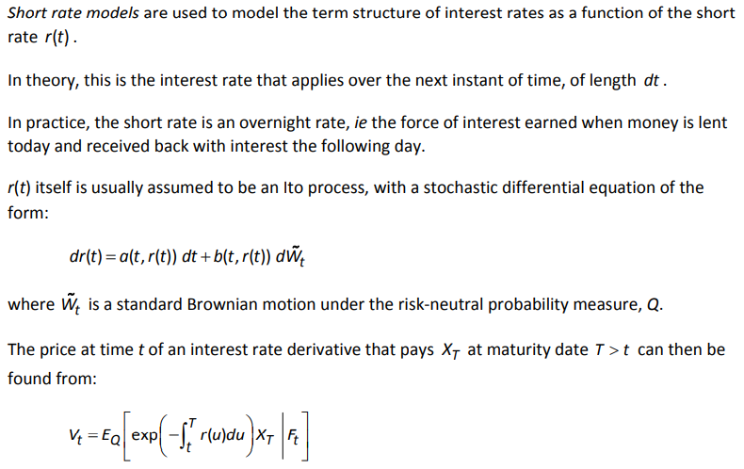 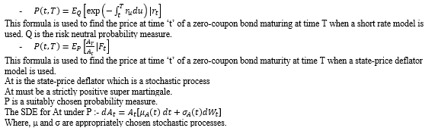

**(c) Drawback of short rate models**

* Single factor short rate models mean that all maturities behave in the same way – there is no independence. This essentially means they are useless for pricing swap options but ok for caps/ floor
* There is little consistency in valuation between the models
* They are difficult to calibrate.

**Equilibrium Models** start with a theory about the economy, such that interest rates revert to some long-run average, are positive or their volatility is constant or geometric. Based on the model for the short rate, the implications for the pricing of assets is worked out. examples of equilibrium models are Rendleman and Bartter, Vasicek and CIR Model. Being based on ‘economic fundamentals’, equilibrium models rarely reproduce observed term structures. This is unsatisfactory.

**No-Arbitrage Models** use the term structure as an input and are formulated to adhere to the no-arbitrage principle. An example of non-arbitrage model is Hull-White (one- and two-factor).

**One Factor Models**

* 1. **Definition**

A one-factor short rate model is one in which the short rate, and hence the term structure as a whole, is assumed to be influenced by a single source of randomness. The prices of all bonds (of all maturities) and interest-rate derivatives must therefore move together. The single source of randomness is typically assumed to be a standard Brownian motion process. The short rate is therefore usually modelled as an Ito process..

* 1. **Limitation**
* A result of one-factor models is that yields on bonds of different durations are perfectly correlated. This is not realistic.
* In fact, they need not even be positively correlated. Sometimes we see, for example, that short-dated bonds fall in price while long-dated bonds increase in price.
* If we look at the long run of historical data we find that there have been sustained periods of both high and low interest rates with periods of both high and low volatility. These are features that are difficult to capture in one-factor models.
* This issue is especially important for two types of problem in insurance: • the pricing and hedging of long-dated insurance contracts with interest rate guarantees • asset-liability modelling and long-term risk management.
* One-factor models struggle to cope with valuing derivative contracts. We need more complex models to deal effectively with these. For example, any contract that makes reference to more than one interest rate should allow these rates to be less than perfectly correlated.

**Multi-Factor Models** are models with more than one source of randomness. Hull White is not really a multi-factor model, the μ and α parameters are deterministic and aid fitting. A multi-factor version of Vasicek would involve a multi-dimensional driving Weiner Process and possibly stochastic μ.

**Market Models** have superseded short-rate models for situations where the correlation between different maturity rates is critical, such as the pricing of swap options. These treat each maturity instrument as a distinct object, correlated to other similar assets using a multi-dimensional Weiner Process in a no-arbitrage set-up based on the ‘state-price deflator’ approach.

**2 Problems in Insurance** – the pricing and hedging of long-dated insurance contracts with interest rate guarantees, and asset-liability modelling and long-term risk management.

**#Vasicek Model**

* **Statistical Property of Vasicek**

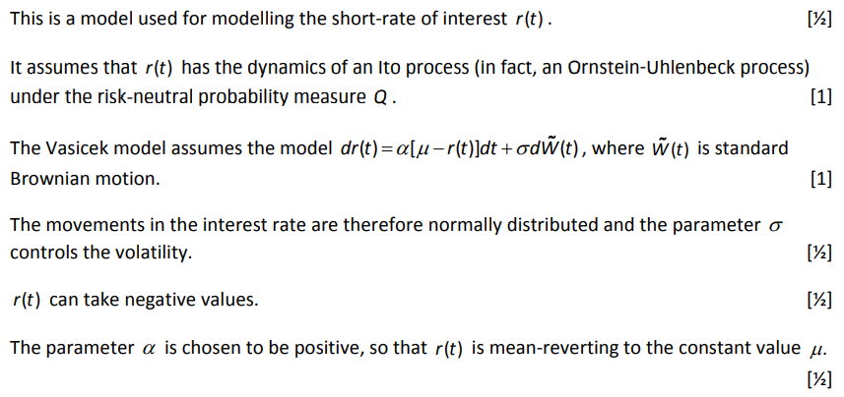

* **Advantage of Vasicek**

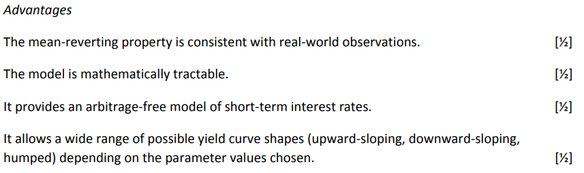

* **Limitations of Vasicek**

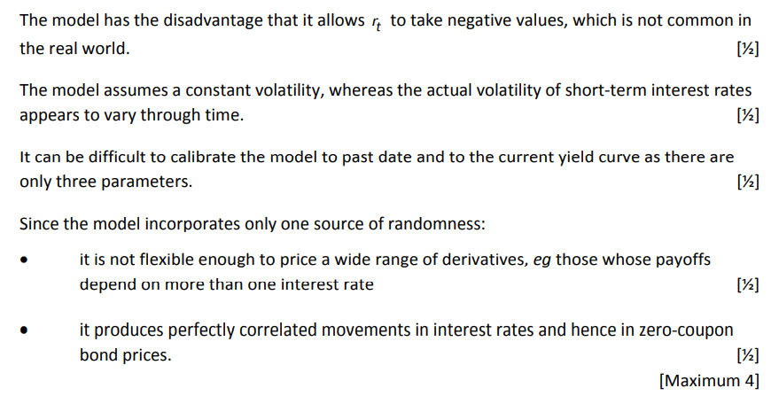

* Due to the normal distribution of increments of rt its possible for the model to output negative interest rates, which goes against one of the desirable features of nominal interest rate models (although negative interest rates have been seen in some countries in recent years).
* **Extent to which the drawbacks are a problem**
* This depends largely on how negative the interest rates generated using the model might of and also how often they might go negative, both of which will depend on the parameter values used.
* It also depends on the likelihood that actual interest rates may go negative in whichever economy is being modelled.
* For e.g., it has been less of a problem in recent years, as nominal interest rates have been historically low levels, often very close to zero in many developed economies and actually below zero in a handful of countries.
* **Type of Process of which Vasicek is an example**

Vasicek is an example of OUP Process.

* **How CIR model avoids this problem?**
* The CIR model avoids the problem of negative interest rates by inserting √rt into the volatile term in the SDE for rt.
* This makes the volatility term vary in direct proportion to √rt .
* Thus the volatility term will be lower when rt is lower and will tend to zero if rt → zero.
* This means that if rt → 0, the volatility term will be very close to zero and will be outweighed by the mean-reverting term pulling back rt back upwards, so ensuring that rt cannot go negative.

**#Vasicek Model**

1. Incorporates Mean Reversion: Interest rates tend to revert to a long-term average.
2. Arbitrage-Free: Consistent with no arbitrage opportunities in the market.
3. Constant Volatility: Volatility is constant and independent of the interest rate level.
4. Allows Negative Interest Rates: The model's structure allows for interest rates to become negative.
5. Easier to Implement: Simpler dynamics and linear nature make it more straightforward to use.

PDE of Vasicek model

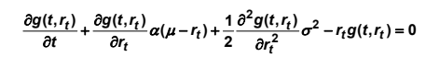 The explanation defining the PDE is given.

Solution to PDE: 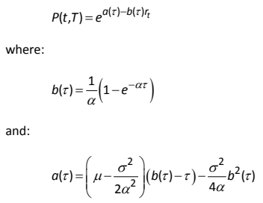 The explanation is given.

**#Cox Ingersoll Ross CIR Model**

1. **Properties**

* Incorporates mean reversion.
* Arbitrage free.
* Volatility high/low when rates high/low.
* Does not allow negative interest rates.
* More difficult to implement than Vasicek model.

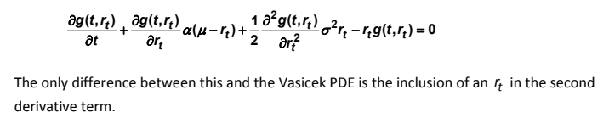

Solution :

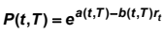

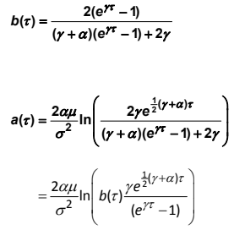

**#Hull White Vasicek**

1. Incorporates Mean Reversion
2. Arbitrage-Free
3. Time-Dependent Volatility
4. Allows Negative Interest Rates
5. Flexible and Accurate Calibration
6. Complex Implementation: More complex to implement than the Vasicek model due to time-dependent parameters.

The PDE and Solution is similar to the Vasicek model with following difference

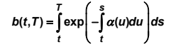 and 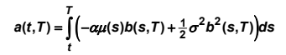

|  |  |  |  |
| --- | --- | --- | --- |
| **Model** | **SDE** | **rt > 0 ∀ t** | **Distribution of rt** |
| **Vasicek** | $$dr_{t}=α\left(μ-r_{t}\right)dt+σd{\tilde{W}}_{t}$$ | No | Normal |
| **CIR** | $$dr_{t}=α\left(μ-r_{t}\right)dt+σ\sqrt{r_{t}}d{\tilde{W}}_{t}$$ | Yes | Non-central Chi square |
| **Hull White Vasicek** | $$dr_{t}=α\left(μ_{t}-r_{t}\right)dt+σd{\tilde{W}}_{t}$$ | No | Normal |
| **Hull White CIR** | $$dr_{t}=α\left(μ_{t}-r_{t}\right)dt+σ\sqrt{r_{t}}d{\tilde{W}}_{t}$$ | Yes | Non-central chi square |

*Here, α > 0 determines the speed of mean reversion. If α is high, the reversion will be very quick.*

**Advantage of Hull White Vasicek over Vasicek** → μt can be chosen to reproduce as closely as possible, the exact yield curve, rather than restricted forms of the Vasicek model.

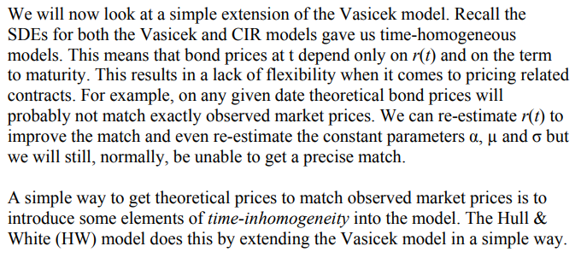

**Statistical Properties of all 3 models**

* In each case the short rate of interest rt is modelled as an Ito process.
* The process therefore operates in continuous time and has normally-distributed increments over short time intervals.
* The volatility parameter σ controls the size of the random movements.
* The coefficient of dt represents the expected annual drift under the risk neutral probability measure (since the increments dW̃t have zero mean under this measure). But under the real-world probability measure the drift will have a different value.
* All three models exhibit mean reversion.
* Under Vasicek and CIR the long-term “target” rate μ is constant, while in Hull White it is a function of the time t .
* With Vasicek and Hull White it is possible to get a negative value for rt , which is unrealistic.
* The inclusion of the √rt factor in CIR prevents rt taking negative values.
* Over longer periods the distribution of rt under CIR involves the non-central chi-square distribution, whereas the distribution under the other two models is normal.
* Hull White is easier to fit to past and current data than the other models due to the fact that there is more choice of parameters (since μ is time-dependent).

**Similarities of all 3 Models**

* All are one-factor models used for modelling short rate of interest rate rt.
* All 3 assume that rt has the dynamics of an ITO Process under the risk neutral probability measure Q
* All 3 models are mean reverting
* All 3 models generate arbitrage-free zero coupon bond prices
* All 3 models can be used to price simple options on zero coupon bonds
* They cannot be used to price derivatives whose payoff depends on more than one interest rate
* There will be positive correlation between bond prices of all durations, which is unrealistic.

**Differences of all 3 Models**

* Under Hull White, μt is time-dependent
* Hull white is easier to fit to past and current data than Vasicek and CIR due to the fact that there is more choice of parameters (since μ is time-dependent).
* CIR volatility parameter includes √ rt – preventing negative values of interest rates
* Over long periods, the distribution of rt under CIR involves the non-central chi square distribution, whereas, under Vasicek and CIR, the distribution is normal.

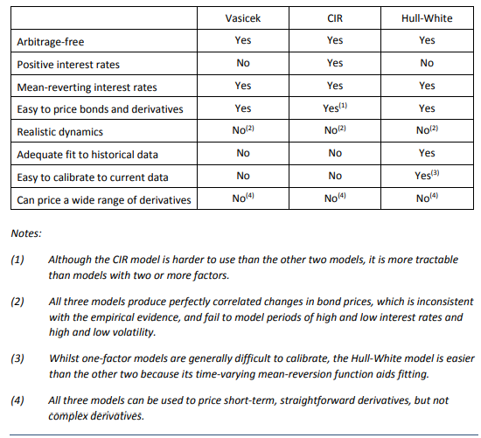

**Limitations of model : $dr_{t}=θdt+σd{\tilde{W}}_{t}$**

* Model 4 does not exhibit mean reversion.
* If θ is non-zero, the trend value of rt will increase or decrease steadily, which is unrealistic.
* The model allows negative interest rates, which is not necessarily realistic.
* The model involves only two parameters, θ and σ , and so may be difficult to calibrate to past and current data.
* Since this is a one-factor model: • it cannot be used to price derivatives whose payoffs depend on more than one interest rate. • there will be positive correlation between bond prices of all durations, which is unrealistic.

**Model : $dr_{t}=r_{t}\left(μ dt+σ dZ_{t}\right)$**

* **3 properties of this model – comment on desirability.**

This means short term interest rates would in the long term increase if > 0 geometrically. This is not desirable as it does not reflect reality.

The model also has the following properties: The change in rate is dependent on the current rate. This is undesirable as typical rates mean revert.

The model requires constant volatility over time. This is not desirable as volatility of short term interest rates changes over time.

(**Practise question 18.6) Why Super-martingale property is required?**

* Super-martingale property is expressed as $E_{P}\left(A_{T} | F_{t}\right)<A_{t} or E_{P}\left(\frac{A_{T}}{A_{t}} | F_{t}\right)<1$
* This matches with the bond price formula $P\left(t,T\right)= E_{P}\left(\frac{A_{T}}{A_{t}} | F_{t}\right)$. Thus, this property ensures that Bond Price is always < 1.
* Bond Price P(t, T) < 1 implies that the applicable interest rates are > 0 i.e. positive interest rates.

 Name given to the process At is **State Price Deflator**.

**Zero coupon bonds**

It is represented by B(t,T)

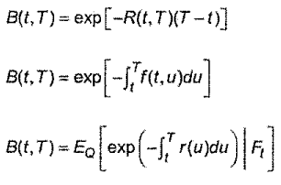

It shows the formulas for spot rate, forward rate and risk free rate.

## Ch 19: Credit Risk

**Credit events which might result in a failure to meet an obligation include –**

* Actions that are associated with bankruptcy or insolvency laws
* Downgrade by NSSROs (Nationally Recognised Statistical Rating Organisations) like Moody’s, S&P and Fitch
* Failure to pay
* Repudiation/ moratorium
* Restructuring – when the terms of obligation are altered so as to make the new terms less attractive to debt holder, such as a reduction in the interest rate, re-scheduling, change in principal, change in level of seniority.

**Default free bond** – if stream of payments due from the bond will definitely be paid in full and on time.

**Outcome of A Default** may be that the contracted payment steam is:

* Rescheduled
* Cancelled out by the payment of an amount which is less than the default-free value of the original contract
* Continued but at a reduced rate
* Totally wiped out

**Types of Credit Events –** a credit event is an event that will trigger the default of a bond and includes the following -

* Actions that are associated with bankruptcy or solvency laws
* Rating downgrade of the bond by a rating agency such as Standard & Poor’s or Moody’s
* Failure to pay
* Repudiation / moratorium
* Restricting – where the terms are changed to become less favourable to the bond holder.

**Structural Models** are used to represent a firm’s assets and liabilities and define a mechanism for default. Typically, default occurs when a stochastic or random variable hits a barrier representing default. Main example of model is Merton Model. These models deliver an explicit link between a firm’s default and the economic conditions and provide a sound basis for estimating default correlations amongst different firms. The disadvantage is identifying the correct model and estimating its parameters.

**Reduced Form Models** do not attempt to deliver a representation of a firm, like structural models do. Rather they are statistical models that use observed data ,both macro and micro, and so usually be fitted to data. The market statistics most commonly used are the credit rating issued by NNSROs. The credit rating agencies will have used detailed data specific to the issuing corporate entity when setting their rating. They will also regularly review the data to ensure that the rating remains appropriate and will re-rate bond either up or down as necessary. Default is no longer tied to the firm value falling below a threshold level. Rather, default occurs according to some exogenous hazard rate process.

**Intensity Based Model** is a particular type of continuous time reduced form model. It typically models the jumps between different states using transition intensities. The disadvantage is that they sometimes lack the clarity of structural models.

**Credit Spread = Bond Yield – Risk Free Rate**

**Merton Model**

* **How Merton Model can be used to value the debt issued by a company? OR Describe Merton Model.**
  + Merton’s model assumes that a corporate entity has issued both equity and debt such that ‘F(t)’ is the value of company at time t.
  + It is an example of a structural credit risk model
  + F(t) varies over time as a result of actions by the corporate entity which does not pay dividends on its equity or coupons on its bonds. Part of the corporate entity’s value is zero-coupon debt with a promised repayment amount of ‘L’ at a future time T. At time T the remainder of the value of the corporate entity will be distributed amongst the equity holders and the corporate entity will be wound up.
  + The corporate entity will default if the total value of its assets, F(T) is less than the promised debt repayment at time T i.e. F(T) < L. In this situation, the bond holders will receive F(T) instead of L and the equity holders will receive nothing.
  + This can be regarded as treating the equity holders of the corporate entity as having a European call option on the assets of the company with maturity T and a strike price equal to the value of debt.
 $Notations$

 + L = nominal value of zero coupon bond ( Debt)
  + Ft = value of assets/ current gross value of company
  + Et = market capitalisation of shares( Equity)

$Equity$

Value of Equity Et = max( FT - L , 0) 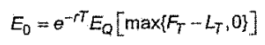

$$E_{t}= F_{t}Φ\left(d_{1}\right)-Le^{-r\left(T-t\right)}Φ\left(d_{2}\right)$$

$Zero Coupon Bonds$

Payoff of Bondholders = L – max( L – FT, 0 )

$$=F_{t}-E_{t}$$

$=Le^{-r\left(T-t\right)}-\left[Le^{-r\left(T-t\right)}Φ\left(-d_{2}\right)-F_{t}Φ\left(-d_{1}\right)\right]$ (in terms of put option)

* ***Use of Merton Model***

The Merton model can be used to estimate either the risk neutral probability that the company will default or the credit spread on the debt.

* **Risk Neutral Probability Of Default** = $1-Φ\left(d_{2}\right)$, where $d_{2}=\frac{\ln\left(\frac{F_{0}}{L}\right)+\left(r-0.5σ^{2}\right)T}{σ\sqrt{T}}$

In the standard Black-Scholes formula for the price of a call option, Φ(d2) represents the risk neutral probability that the option Φ(d2) will be exercised, or, equivalently, the risk neutral probability that the share price at expiry exceeds the strike price. Under the Merton model approach, the call option replicates the shareholders’ position and is exercised if the shareholders repay the bondholders in full.

So, is equal to the probability that the bondholders are repaid in full, or, equivalently, the probability that the company does not default. This means that the probability of default is: 1 − Φ(d2)

**#Derivation under 1st Principles of Risk Neutral Probability of Default**

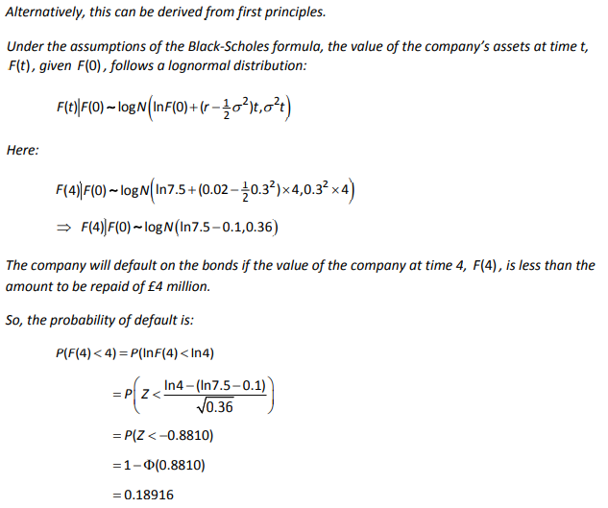

* **Proportion Of Assets Represented By Debt And Equity → Q27 Sept 2014**
* **(Sept 2018 q7) Why is fall in equity more than fall in debt?**
  + Share price fell from £1 to £0.5
  + Debt/ price of ZCB fell from £1.211 (per £1 nominal) to £0.5 (per £1 nominal).
  + Fall in debt will always be lower than fall in share price because : Debt ranks above equity on company default. Hence, debt holders have more secure investment, they will always receive something at maturity, and may receive the whole value. While, equity holders will receive nothing on default and might receive nearly nothing even if the company does not default.
* **(Oct 2016 q10) $Δ_{equity}=\frac{dE_{t}}{dF_{t}}=0.984$**  **Comment**
  + If Ft increases by £1 million, then Et changes by £0.984 million.
  + The remaining change of £ 0.016 million is due to change in bond price which increases by 1-0.984 = £0.016 per £100 nominal

**Relative Change in share and bond prices**

* + Given current gross value of company = 200 million while nominal value of ZCB is 100 million.
  + Delta of 0.984 indicates that major change in company assets is incorporated by a changes in share price rather than bond prices.
  + As the Assets are twice debt liability, any increase in asset value will directly increase share prices because there are high chances of debt being paid in full.
  + High value of delta shows that the share price moves almost in line with the value of the company.

**Relative Change in share and bond prices – if value of company was lower**

* + If the total value of company was lower, the risk of default on the bond, would increase.
  + Thus, any increase in the value of the company would have greater effect on price of bonds (asset cover↑ level of risk on bond↓) & smaller effect on share prices than above.
* **(Vega & Merton Model) Why is low Vega desirable in Merton Model? (Sept 2019)**

The volatility of a company’s value is not directly observable and is not easy to estimate.

It is therefore desirable to use a model where the output is relatively insensitive to the volatility figure because this will give a more accurate answer even if our estimate of the volatility is wrong.

**2-State Model**

* The model is a continuous time Markov with two states N and D {D: Previously Defaulted, N: Not Previously Defaulted}
* Two-state credit risk model has a constant transition intensity which is a ***subset of*** the Jarrow-Lando-Turnbull Model.
* Under this simple model it is assumed that the default-free interest rate term structure is deterministic with r(t)= r for all t.
* If the transition intensity, under real world measure P, from N to D at time t is denoted by λ(t), then the model is represented as

N → D (where, D is an absorbing state)

* We define, Xt : state of bondholder at time ‘t’ then, the transition intensity λ(t) is given by:

$P_{P}\left(X_{t+dt}=ND \right|X_{t}=ND)=1-λ_{t}dt+o(dt)$

$P_{P}\left(X_{t+dt}=D \right|X_{t}=ND) =λ_{t}dt+o(dt)$

Where dt → 0

* Payoff of at time t = 1 – (1- 𝛿)N(T)

Where, $N\left(T\right)= \left\{\begin{aligned}1 default \\ 0 no default\end{aligned}\right.$

$Fair price of Zero-Coupon Bond=e^{-r\left(T-t\right)}E_{Q}\left[X | F_{t}\right]=e^{-r(T-t)}\left[1-\left(1-δ\right)\left\{1-e^{-\int_{t}^{T}{λ\left(s\right)ds}} \right\}\right]$

Where, λ(s) i the deterministic risk neutral default intensity

* **Implied Risk Neutral Transition Intensity**
$${\tilde{λ}}_{t}=\frac{∂}{∂t}\left[\ln\left(e^{r\left(T-t\right)}P\left(t,T\right)-δ\right)\right] AND {\tilde{λ}}_{T}=\frac{∂}{∂T}\left[\ln\left(e^{r\left(T-t\right)}P\left(t,T\right)-δ\right)\right]$$

* **λt = 0.002t is too simplistic, comment?**
  1. It is a matter of concern because the fair price of the bond is dependent on an accurate assessment of the default transition intensity. If this assessment is incorrect then the bond could be mispriced.
  2. An alternative approach would be to assume that the transition intensity λ(t) is stochastic and depends on a separate state variable process X(t)
  3. By using a stochastic approach, λ(t) can be allowed to vary with company fortunes and other economic factors.
  4. For e.g. a rise in interest rates may default more likely and so X(t) could include appropriate allowance for changes in interest rates. This approach can be used to develop models for credit risk that combine the structural modelling and intensity-based approaches.
* **Incorporate Unforeseen Events**
  1. Unforeseen events can be considered as random and so a stochastic approach would be needed.
  2. By using a stochastic approach, λ (t) can be allowed to vary with company fortunes and other economic factors.
  3. This is done by introducing an additional stochastic process X(t) , which models a suitable economic indicator, such as interest rates.
  4. For example, a downturn in the economy may make default more likely and so λ(t) could include appropriate allowance for this possibility.
* **Explain how 2 state Model can be generalised to JLT Model?**
  1. Instead of the simple default / no default two-state model, a more general model has been developed by Jarrow, Lando and Turnbull, in which there are n states. The n states relate to n −1 possible credit ratings for a non-defaulted company, and one default state.
  2. Transitions are possible between all states, except for the default state, which is absorbing (i.e. once a company has entered the default state, it cannot leave it).

**Bond A is AA-rated and other is rated BBB. Implication of rating and possible reason for difference. (Mock)**

* AA-rated bonds are less likely to default or more likely to be repaid in full.
* This may be because the AA bondholders are paid out before the BBB bondholders if the company defaults.
* The BBB bond may have a longer maturity and so is exposed to greater risk of default.

**2 bonds A and B – Max probability of double default – (q17 April 2012)**

Max probability of double default is achieved when both default intensities are in perfect correlation. Thus, the max probability of double default = min(λA and λB).

Price of derivative (based on max probability of double default) = payoff*disc_factor*(1 – e – term *min(λA, λB)).

**Jarrow Lando Turnbull (JLT) Model**

Here, we deal with multiple states of credit rating and one absorbing state of default. JLT Model assumes that transition rate between states are deterministic. The state dynamics are represented by a time-homogenous Markov Chain.

$λ\left(t\right)={\left[λ_{ij}\left(t\right)\right]}_{i,j=1}^{n} \left(generator matrix\right)$

$q_{ij}\left(s, t\right)=P\left(X_{t}=j \right|X_{s}=i) ∀t>s (TPM)$

$Q\left(s, t\right)={\left[q_{ij}\left(s,t\right)\right]}_{i, j=1}=exp\left(\int_{s}^{t}{λ_{u}du}\right){ =e^{Λ(t-s)}}=Σe^{D\left(t-s\right)}Σ^{-1}$

* Where, $Λ=ΣDΣ^{-1}$, D is diagonal matrix of Eigen Values of Λ, Σ is matrix of Eigen Vectors of Λ. (Intuitive video on Eigen values)

Properties –

* λ ij ≥ 0 for i $≠$ j
$\sum_{j=1}^{n}{λ_{ij}=0}$

$λ_{nj}=0 (absorbing state)$

* State i+1 is always more risky than state i

Thus, $P\left(t, T, X_{t}\right)=e^{-y(T-t)}\left[1-\left(1-δ\right)P_{Q}\left(X_{T}=n | F_{t}\right) \right]$

**Multi Factor Credit Risk Model** - 

**Comment on downgrade trigger strategy – will it improve return on the portfolio (Practise Que 19.8)**

* The downgrade trigger strategy will reduce the expected number of defaults, as we have seen. (6.26 → 5.9)
* However, the return on the portfolio will also be a function of the yields on the debt. Companies rated B are likely to have bonds with a higher yield (because of the higher risk), so excluding these may in fact reduce the yield on the portfolio.
* Also, the actual number of defaults may not match the expected number. The return depends on the actual progress of the portfolio, rather than the expected outcome.

## Ch 20: Ruin Theory

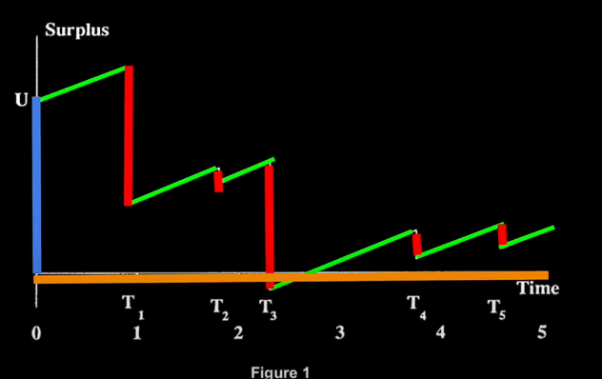

**INITIAL SURPLUS U(0)**

**CONTINOUS PREMIUM STREAM “c”**

**AGGREGATE CLAIM S(t)**

**Surplus Process U(t)** – the insurer’s surplus at time ‘t’ is given by → $U\left(t\right)=U+c*t-S(t)$

Where, c = (1+theta)*E(S) is the rate of premium income and S(t) is aggregate claims up to time ‘t’.

**Two Limitation Of This Surplus Process Model – (Sept 2020)**

* Premium income is assumed to be continuous.
* Premium income is assumed to be constant .
* There is no allowance for expenses . (if applicable)
* Claims are assumed to be settled as soon as they occur. There could be delays in settlement.
* There is no allowance for interest earned on the insurer’

|  |  |  |
| --- | --- | --- |
| **Parameter** | **Ultimate Ruin** | **Finite Time Ruin** |
| **Initial Surplus (U)** ↑ | ↓ | ↓ |
| **Timing of observation (t)** ↑ | - | **↑** |
| **Insurer’s Loading Factor (θI)** ↑ | ↓ | ↓ |
| **Reinsurer’s Loading Factor(θR)** ↑ | ↑ | ↑ |
| **Mean Claim (μ)** ↑ | ↑ | ↑ |
| **Claim Volatility (σ2)** ↑ | ↑ | ↑ |
| **Distribution of N (λ)** ↑ | - | ↑ |
| As λ increases, the premium rate and the claim rate both increase. This means that the process is effectively speeded up, so any ruin that occurs will occur earlier. Hence the finite time ruin probability ψ(U, t) increase as λ increases. However, the probability of ultimate ruin ψ(U) is not affected by the Poisson parameter. This is because we now are not interest in the time when ruin occurs – were only interested in the probability that ruin ever occurs. | | |
| **Frequency of observation (h)** ↑ **(discrete time)** | ↓ | ↓ |

**Lundberg’s Inequality $ψ\left(U\right)≤e^{-R*U}$** where U is initial surplus and ψ(U) is the probability of ultimate ruin. R is the parameter associated with a surplus process known as Adjustment Coefficient. Its value depends upon the distribution of aggregate claims and on the rate of premium income. In actuarial literature, exp{-RU}is often used as an approximation of ψ(U). It provides an upper bound on the probability of ruin in a surplus process over a certain time horizon.

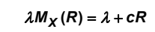

**R can be interpreted** as measuring risk.(It measures risk inversely) The larger the value of R, the smaller the upper bound for ψ(U). R is an increasing function of **θ.**

**Effect of XOL on Insurer (q3 ST3 Sept 2008)**

* Generally, the Overall claim volatility falls => probability of ruin falls. Higher the retention limit, greater the reduction.
* Usually reduces insurer’s expected overall profit (because reinsurer needs to cover its own expense and profit requirements, which will increase the insurer’s probability of ruin. The higher the reinsurer’s profit loading, the greater the probability of ruin.
* Hence, there is a trade-off between profit and ruin.

**What is meant by $ψ\left(U\right) and ψ\left(U, t\right)$?**

* Ruin is defined as when an insurer’s assets fall to (or below) zero. This will be the smallest value of t ≥ 0 when the surplus process U(t) ≤ 0.
* $ψ\left(U\right)$ is the probability of ultimate ruin given initial surplus U.

Probability that the insurer’s surplus becomes negative at any time, given that the insurer has a surplus of U at time 0.

$$ψ\left(U\right)=P\left(U\left(t\right)<0\right) for some t, 0<t<∞$$

Where, U(t) = U + c*t – S(t)

Here, S(t) is the surplus process, c is the rate of premium income

* $ψ\left(U,t\right)$ is the probability of ruin within time ‘t’ given initial surplus U.

Probability that the insurer’s surplus becomes negative at any time in the interval (0,t], given that the insurer has a surplus of U at time 0.

$$ψ\left(U,t\right)=P\left(U\left(τ\right)<0\right) for some τ, 0<τ≤t$$

This holds for Continuous Time.

* $ψ_{h}\left(U\right)$ is the probability of ultimate ruin given initial surplus U.

$$ψ_{h}\left(U\right)=P\left(U\left(τ\right)<0\right) for some τ, τ=h, 2h, 3h, …, ∞$$

Where, U(t) = U + c*t – S(t)

Here, S(t) is the surplus process, c is the rate of premium income

* $ψ_{h}\left(U,t\right)$ is the probability of ruin within time ‘t’ given initial surplus U.

$$ψ_{h}\left(U,t\right)=P\left(U\left(τ\right)<0\right) for some τ, τ=h, 2h, 3h, …, t$$

This holds for Discrete Time.

**Explain why $\frac{dR}{dα}=0$ and solving for α will give optimal value for α, where ‘α’ is the retained proportional?**

* Given: $\left(120α-5\right)\frac{dR}{dα}+120R=\left(100R+100α\frac{dR}{dα}\right)e^{100αR}$
* $\frac{dR}{dα}=0$ and solving for α gives us the value of α for which R is maximum.
* Lundberg’s Inequality for $ψ\left(U\right)$, the probability of ultimate ruin given an initial surplus U, states that: $ψ\left(U\right)≤e^{-RU}$.
* Maximising R minimizes the upper bound for the probability, so makes ruin less likely.
* Hence the value of alpha for drt/dα = 0 is an optimal value in this sense.

**X ~ Gamma(2, 0.01) -vs- X = 200 (fixed). Comment on value of adjustment coefficient R. (q12 October 2011)**

* For X ~ Gamma (2, 0.01), R = 0.0021
* For X = 200 (fixed), R = 0.0035
* Fixed claims leads to lower variability thus R increases and P(Ruin) falls.

**X ~ Exp (1) for Catastrophe insurance – Problems with this model (April 2021)**

* There are many issues with the modelling approach the insurer is proposing:
  1. **Choice of Exponential Distribution** - The insurer specialises in catastrophe insurance - so the Exponential distribution may not be appropriate for this business for example (a) because it does not have the high kurtosis/’fat tails’ commonly seen in catastrophe events (b) because catastrophe events tend to be ‘low frequency, high impact’, so modelling them with a continuous distribution may not even be appropriate in the first place
  2. **Independent Claims Assumption** - The insurer is also assuming that net claims are independent in each annual period. In practice this is unlikely to be true because the number/size of claims are likely to be highly correlated to the previous year’s
  3. **Initial Surplus** - The insurer has also assumed its initial surplus is constant in practice it could invest these funds to generate return at e.g. the risk-free rate.
  4. **Solvency & Ruin Occurrence** - Solvency is only assessed on an annual basis, but ruin can occur in reality at any time.

**Comment on choice of Exponential and Log Normal distribution for financial modelling. (Sept 2021)**

* Mean and variance of Exp (λ = 2) and logN(-1.04, 0.8332) are the same.
* 99th percentile are different – this shows us that we have to consider the tail behaviour of the distribution and not just the 1st two moments.

**Comment P(ruin in 1st year) < P(ultimate ruin) (q14 booklet)**

* Probability of ruin in 1st year (finite time ruin) = 0.0107 (much smaller)
* Probability of ultimate ruin = 0.33287
* Reason : (a) either upper bound provided by Lundberg’s Inequality is not very tight (b) or there is significant chance of ruin after the 1st year because there is a big difference whether ruin ever happens and whether it happens before time 1.

**Adjustment Coefficient R is higher under XOL compared to Proportional Reinsurance (q15 booklet)**

* Under XOL, R = 0.13 (approx.)
* Under Proportional, R = 0.0956 (approx.) (lower)
* Lundberg’s inequality gives the upper bound for probability of ruin as $ψ\left(U\right)≤e^{-RU}$ where U is the initial surplus and R is the adjustment coefficient.
* Because Under XOL, R is higher it implies that the upper bound of probability of ultimate ruin will be lower than under proportional
* Given that the Reinsure Premium is same, the insurer should opt for XOL Arrangement.

**(q20 booklet) Comment on Arrangement Options – (a) No reinsurance (b) Proportional and (c) XOL**

|  |  |  |
| --- | --- | --- |
| **Under (a) no** | **Under (b) Proportional** | **Under (c) XOL** |
| Insurer Premium = 33.15*λ  Average claim amount = 25.5*λ  R = 0.0138 (approx.) | Reinsurer premium loading factor = 20%  Reinsurance premium paid = 9.18*λ  Net premium income = 23.97*λ  R = 0.0226 (approx.) | Reinsurance premium loading factor = 40%  Reinsurance premium paid = 2.1*λ  Net premium income = 31.05*λ  R = 0.01658 (approx.) |

* Option B -vs- A
  1. Reinsurance loading factor is lower than insurer’s (30% compared to 20%)
  2. Adjustment coef R is higher under (b) thus, (b) offers a lower upper limit for P(ultimate ruin)
  3. Thus, (b) is better than (a)
* Option C -vs- A
  1. Even though reinsurer’s premium loading is higher under (c) (40% compared to 30%), adjustment coefficient R is higher under (c) thus, (c) offers a lower upper limit for P(ultimate ruin)
  2. Thus, (c) is better than (a)
* Option B -vs- C
  1. Under (b) reinsurer is involved for 30% claims while under (c) reinsurer is involved for only 5% of the claims.
  2. Premium loading factor under (b) is lower than (c) (20% compared to 40%)
  3. Adjustment coef R is higher under (b) thus, (b) offers a lower upper limit for P(ultimate ruin)
  4. Net premium income is lower OR reinsurance premium paid is higher - in case of (b) but there is compensation in form of lower upper limit as mentioned above.
  5. Under (b), on average, insurer deals with lower claim amounts as E(Y), under (b) is 17.85 while under (c) is 24.

**Impact On Ultimate Probability Of Ruin – if more policies are issued on the same terms (April 2019)**

* Expected payment after 1st exam = 0.25*500 = 125 and premium = 50.
* Thus if more policies are issued, there is higher chances of ruin in 1st year.
* So he should issue more policies if he can arrange enough initial reserves to cover the claim costs.
* The volatility of the insurer’s portfolio will also reduce.

**How Probability Of Ruin Changes After t=1 ? (Sept 2020)**

* Probability of ruin increases

The probability of ruin never decreases as time increases so the probability of ruin in infinite time will always be greater than or equal to the probability in finite time. And in this case it increases with time if we write more policies.

* Probability of ruin decreases

If we update the surplus each year then, the monthly premium income is £5,000 and the monthly expected claims are £2,500. So the insurer should expect its assets to increase over time. And the probability of ruin will decrease with time.

* Probability of ruin constant

Or arguably, the question says we have written a series of one-year insurance policies and doesn’t say we will write anymore, so the probability of ruin could be constant after time t=1.

## Ch 21: Run off Triangles

Run off triangles (delay triangles) usually arise in types of insurance where it may take some time after a loss until the full extent of the claims which have to be paid are known. It is important that the claims are attributed to the year in which the policy was written.

The number of years until a payment is made is called the delay, or *developmental period*.

**Types of Reserves**

* **IBNR claims reserve –** is required in respect of claims that have been incurred but not reported, i.e. the claim event has occurred, but the claim has not yet been reported to the insurer.
* **Outstanding reported claims reserve –** is required in respect of claims that have been reported, but have not yet been closed.

**Methods of grouping claims:**

* **Accident year basis** – where the claims development is clustered by the year an accident has occurred. In this respect, such data would include ‘incurred but not yet reported’ (IBNR) claims.
* **Underwriting year basis** – here we group claims by the time policies were written rather than when they occurred.
* **Reporting year basis** – here we group claims by the time of being reported to the insurance company by the policyholder.

E.g. claim on an event occurring on 1st December 2017 for an insurance policy written on 21st December 2016. This was reported by policyholder on 15th January 2018 and settled in July 2018.

Here, development year 1 for 2017 under an accident year basis, development year 2 for 2016 under an underwriting basis and development year 0 for 2018 under a reporting year basis.

**Link Ratios or Developmental Factors** – the ratios that are used to project future claims are known as developmental factors. They are either calculated directly from the data, or set using expert knowledge, are always used in the same way to estimate outstanding claim payments.

**Note** – it is possible to adjust the calculated development factors in light of other information. This method which uses prior knowledge can take a formal approach, but is more often an ***ad-hoc adjustment***.

**Reason To Change Development Factor –** e.g. changes in accounting methods OR claims administration which alter the speed of claim settlement. This gives rise to changes in development factors and it would be sensible to reflect this in the estimate of future claim payments.

**Completely Run Off** – no projection can be done for the 1st accident year because it is not possible to project beyond the highest development year. It is therefore assumed that all claims from this cohort have completely run off.

$$Loss Ratio=\frac{claims incurred}{premiums earned}$$

**General Statistical Model For The Run-Off Triangle Claim Data**

The general statistical model is : $C_{ij}=r_{j}s_{i}x_{i+j}+e_{ij}$ where:

* ‘i’ is the accident year
* ‘j’ is the development year
* ‘Cij’ is the incremental claims amount
* ‘rj’ is the developmental factor for year ‘j’ representing the proportion of claims paid by development year ‘j’
* ‘si’ is a parameter representing the exposure (for e.g. the number of claims incurred)
* ‘xi+j’ is a parameter varying by calendar year (for e.g. representing inflation)
* ‘eij’ is an error term

**Statistical Model assumed for projecting outstanding claims under basic chain ladder and inflation adjusted chain ladder**

|  |  |  |  |  |  |
| --- | --- | --- | --- | --- | --- |
| **Method** | **Model** | **Data Items** | **Assumed Values** | **Estimated Values** | **Not required** |
| Basic chain ladder | $$C_{ij}=s_{i}r_{j}+e_{ij}$$ | Cij |  | Si, rj | eij |
| Inflation adjusted chain ladder | $$C_{ij}=s_{i}r_{j}x_{i+j}+e_{ij}$$ | Cij | xi+j | Si, rj | eij |

* si = is a measure of the volume of claims relating to origin year j.
* rj = is a factor for development year j, representing the proportion of claims paid in that development year
* xi+j = is an adjustment factor relating to calendar years. An index of the cost of claims paid in calendar year i+j.
* eij = is a random statistical error with mean zero that represents the difference between actual and expected results.

**Why Insurance Companies Make Use Of Run-Off Triangles?**

When insured event occurs, it may take some time before the full extent of the claim is known and paid. Run off triangles allow insurance companies to analyse these delays and hence estimate the reserves that need to be held to meet future claims.

**Purpose of Run off Triangles →** General insurer needs to be able to estimate the ultimate cost of claims – (a) to know the full cost of paying claims in order to set future premium rates and (b) set up reserves to cover their liabilities.

**Assumptions Of The Basic Chain Ladder Method**

* payments from each origin year will develop in the same way in monetary terms
* weighted average past inflation will be repeated in the future
* the first year is fully run off

**Assumptions Of The Inflation-Adjusted Chain Ladder Method**

* payments from each origin year will develop in the same way in real terms
* rates of past and future inflation are appropriate
* the first year is fully run-off

**Assumptions of the Bornhuetter-Ferguson Method**

* Payments from each accident year will develop in the same way
* Weighted average past inflation will be repeated in the future
* The 1st policy year is fully run-off
* The estimated loss ratio is appropriate for other policy years.

**Assumptions of the Average Cost Per Claim Method**

* For each origin year, the number of claims in each development year is a constant proportion of the total number of claims from that origin year.
* For each origin year, the average incurred cost per claim in monetary terms in each development year, is a constant proportion of the total claims incurred in monetary terns for that origin year.
* Inflation can be ignored.
* The first year is fully run off

**CT6 October 2011 – Largest development factor -vs- average development factor comment**

* the student uses the largest development factor observed for each year.

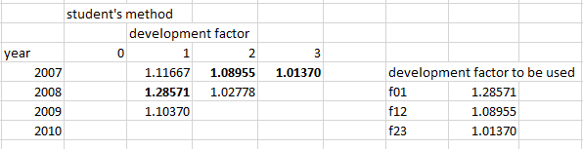

* this means that the student is considering the worst case scenario for the cost of claims. This will end up in holding higher reserves than essential.
* Under the average development factors approach, we hold £ 47.6 while under the maximum developmental factors approach, we hold £ 76.067. There is a substantial difference of £ 28.46.
* Perhaps we can divert some of the funds to other uses and hold lower reserves. However, the student’s way can provide some sort of an upper bound by considering the worst case scenario.
* It seems more sensible to use a weighted average of the individual development factors unless there is some reason to suggest that the development factors are likely to increase from this average in the future.

**Reasons why basic chain ladder method may not be appropriate**

* The first year may not be fully run off
* The development ratios may not be constant for each origin year.
* if the total payments are relatively small, there may not be enough policies for statistical model to apply, since the figures may be dominated by the random errors eij.
* The basic chain ladder does not explicitly model inflation but assumes that a weighted average of past inflation will apply in the future. If inflation for calendar years 2012 to 2015 has varied significantly, a chain ladder calculation will not give reliable results. The figures in the table are too erratic to judge whether this is the case.

**#April 2021 -**

**Similarities between Basic Chain Ladder and Inflation-Adjusted Chain Ladder Method**

* Both methods are based on the same assumption that payments from each accident year will develop in the same way.
* Or in effect, the same development factors are used to project outstanding claims for each accident year
* Changes in the rate at which claims emerge can only be incorporated by adjusting those development factors
* Both methods assume that the first year is fully run off

**Difference between** **Basic Chain Ladder and Inflation-Adjusted Chain Ladder Method**

* The basic chain ladder method assumes that weighted average past inflation will be repeated in the future
* The inflation-adjusted approach does not do this and instead modifies historic claims to be consistent (in real terms) with one another
* It does this with the use of historic inflation rates, which are a key input to the model
* However, the method does not automatically allow for future inflation
* And this is normally given as an input for inflation-adjusted chain ladder

**More appropriate to use Inflation-adjusted chain ladder over Basic**

* The advantages of inflation-adjusted chain ladder are its ability to make all history consistent in real terms
* This will be most useful when inflation has historically been large so that the adjustment will be bigger
* For example if inflation has historically been 0.5% for several years and is expected to stay at that rate for the foreseeable future, there may be very little reason to use inflation-adjusted chain ladder over basic chain ladder

**Neither Method May Be Appropriate**

* Both methods assume that all years behave and develop identically
* So they should not be used in situations where this is less likely to be true
* For example if the business entity has changed from start-up to major market player…
* Or one year experienced particularly severe claims due to a catastrophe

# Basic Cheat Sheet

**Variance**

Population Variance (σ^2): σ^2 = Var(X) = E[(X - μ)^2]

Sample Variance (s^2): s^2 = (1/(n-1)) * Σ(Xi - X̄)^2

**Covariance**

Population Covariance (Cov(X, Y)): Cov(X, Y) = E[(X - μX)(Y - μY)]

Sample Covariance (sXY): sXY = (1/(n-1)) * Σ(Xi - X̄)(Yi - Ȳ)

**Correlation**

Population Correlation Coefficient (ρ): ρXY = Cov(X, Y) / (σX σY)

Sample Correlation Coefficient (r): rXY = sXY / (sX sY)

**Properties and Relationships**

Variance of the Sum of Two Random Variables: Var(X + Y) = Var(X) + Var(Y) + 2 * Cov(X, Y)

Variance of the Difference of Two Random Variables: Var(X - Y) = Var(X) + Var(Y) - 2 * Cov(X, Y)

If X and Y are independent: Cov(X, Y) = 0 and Var(X + Y) = Var(X) + Var(Y)

Scaling Property: Cov(aX, bY) = ab * Cov(X, Y)

Specifically: Cov(X, aX) = a * Cov(X, X) = a * Var(X)

Var(aX) = a^2 * Var(X)

Correlation Bounds: -1 ≤ ρXY ≤ 1

Perfect Correlation: ρXY = 1 or ρXY = -1

Zero Correlation: ρXY = 0 (indicates no linear relationship, but not necessarily independence)

Standard Deviation (σ): σ = sqrt(Var(X))

Sample Standard Deviation (s): s = sqrt(s^2)

The **generalized formula for the variance of accumulated inflation over *n* years** is:

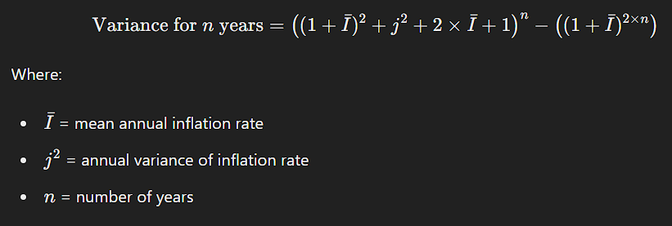

**Normal and Lognormal Distributions.**

**Normal Distribution**

Probability Density Function (PDF):  
f(x) = (1 / sqrt(2πσ^2)) * exp(-(x - μ)^2 / (2σ^2))  
where μ is the mean and σ^2 is the variance.

Properties:  
- Symmetrical around the mean μ.  
- Mean (μ), median, and mode are all equal.  
- About 68% of the data falls within 1 standard deviation (σ) of the mean.  
- About 95% falls within 2 standard deviations.  
- About 99.7% falls within 3 standard deviations.

Standard Normal Distribution:  
- Mean μ = 0  
- Variance σ^2 = 1  
- Z-score transformation:  
Z = (X - μ) / σ

**Lognormal Distribution**

Probability Density Function (PDF):  
f(x) = (1 / (xσsqrt(2π))) * exp(-(ln(x) - μ)^2 / (2σ^2))  
where μ and σ are the mean and standard deviation of the variable's natural logarithm.

Properties:  
- Positively skewed (tail on the right side).  
- Mean, median, and mode are not equal.  
- If Y = ln(X), where X is lognormally distributed, then Y is normally distributed.

Relationships:  
- If Y is normally distributed with mean μ and variance σ^2, then X = e^Y is lognormally distributed.  
- Mean of lognormal X:  
E[X] = e^(μ + σ^2 / 2)  
- Variance of lognormal X:  
Var(X) = (e^σ^2 - 1)e^(2μ + σ^2)

**Relationships Between Normal and Lognormal Distributions**

- If X is lognormally distributed, then ln(X) is normally distributed.  
- If Y is normally distributed, then e^Y is lognormally distributed.

**Operations on Distributions**

Addition of Normally Distributed Variables:  
- If X ~ N(μ_X, σ_X^2) and Y ~ N(μ_Y, σ_Y^2), then Z = X + Y is normally distributed:  
Z ~ N(μ_X + μ_Y, σ_X^2 + σ_Y^2)

Scaling of Normally Distributed Variables:  
- If X ~ N(μ, σ^2) and a is a constant, then Y = aX is normally distributed:  
Y ~ N(aμ, a^2σ^2)

Multiplication of Lognormally Distributed Variables:  
- If X and Y are independent lognormal variables, Z = XY is lognormally distributed.

Scaling of Lognormally Distributed Variables:  
- If X ~ LogNormal(μ, σ^2) and a is a positive constant, then Y = aX is lognormally distributed:  
Y ~ LogNormal(ln(a) + μ, σ^2)

**Poisson, Exponential, and Gamma Distributions**

**Poisson Distribution**

Probability Mass Function (PMF):  
P(X = k) = (λ^k e^(-λ)) / k!  
where λ is the average rate (mean) of occurrence.

Properties:  
- Mean (μ) = λ  
- Variance (σ^2) = λ  
- The sum of two independent Poisson random variables with parameters λ1 and λ2 is also a Poisson random variable with parameter λ1 + λ2.

**Exponential Distribution**

Probability Density Function (PDF):  
f(x) = λ e^(-λ x), x ≥ 0  
where λ is the rate parameter.

Properties:  
- Mean (μ) = 1 / λ  
- Variance (σ^2) = 1 / λ^2  
- Memoryless property: P(X > s + t | X > t) = P(X > s)  
- The sum of n independent Exponential(λ) random variables follows a Gamma distribution with shape parameter n and rate parameter λ.

**Gamma Distribution**

Probability Density Function (PDF):  
f(x; α, β) = (β^α x^(α - 1) e^(-β x)) / Γ(α), x > 0  
where α is the shape parameter and β is the rate parameter.

Properties:  
- Mean (μ) = α / β  
- Variance (σ^2) = α / β^2  
- If X ~ Gamma(α1, β) and Y ~ Gamma(α2, β), then X + Y ~ Gamma(α1 + α2, β).

**Relationships Between Distributions**

- Poisson and Exponential:  
 - The time between events in a Poisson process follows an Exponential distribution.  
 - If X ~ Poisson(λ t), then the time T until the first event is Exponential(λ).

- Exponential and Gamma:  
 - The Exponential distribution is a special case of the Gamma distribution with α = 1.

**Operations on Distributions**

Addition of Poisson Distributed Variables:  
- If X ~ Poisson(λ1) and Y ~ Poisson(λ2), then Z = X + Y ~ Poisson(λ1 + λ2).

Scaling of Exponential Distributed Variables:  
- If X ~ Exponential(λ) and a is a positive constant, then Y = aX is still Exponential with parameter λ / a.

Addition of Gamma Distributed Variables:  
- If X ~ Gamma(α1, β) and Y ~ Gamma(α2, β), then Z = X + Y ~ Gamma(α1 + α2, β).

Scaling of Gamma Distributed Variables:  
- If X ~ Gamma(α, β) and a is a positive constant, then Y = aX is Gamma(α, β / a).

**Poison Process**

**Definition**

A Poisson process is a stochastic process that models a sequence of events occurring randomly over time or space.  
- Events occur independently.  
- The average rate (number of events per unit time) is constant.  
- Two events cannot occur at the same time.

**Poisson Process Properties**

Rate Parameter (λ):  
λ = average number of events per unit time

Inter-arrival Time:  
The time between consecutive events in a Poisson process follows an Exponential distribution with parameter λ:  
P(T > t) = e^{-λt}

Number of Events in Time Interval:  
The number of events in a time interval of length t follows a Poisson distribution with mean λt:  
P(N(t) = k) = (λt)^k e^{-λt} / k!

**Probability of First Claim**

Probability that the first claim occurs within time t:  
P(T ≤ t) = 1 - e^{-λt}  
where T is the time until the first claim.

Probability that the first claim occurs after time t:  
P(T > t) = e^{-λt}

**Time Between Claims**

Distribution of the inter-arrival time T (time between consecutive events):  
T ~ Exponential(λ)

**Number of Claims in a Time Interval**

Probability of k claims in a time interval of length t:  
P(N(t) = k) = (λt)^k e^{-λt} / k!  
where N(t) is the number of claims in time t.

**Expected Values and Variances**

Expected number of claims in a time interval of length t:  
E[N(t)] = λt

Variance of the number of claims in a time interval of length t:  
Var(N(t)) = λt

**Combined Poisson Processes**

If N1(t) and N2(t) are independent Poisson processes with rates λ1 and λ2:  
N(t) = N1(t) + N2(t) ~ Poisson(λ1 + λ2)

**Key Formulas**

Probability Mass Function (PMF) of Poisson Distribution:  
P(N(t) = k) = (λt)^k e^{-λt} / k!  
where k is the number of events, λ is the rate, and t is the time interval.

Cumulative Distribution Function (CDF) of Exponential Distribution:  
F(t) = 1 - e^{-λt}

This is also same for the probability of first claim.  
where t is the inter-arrival time.

**Properties of Poisson Process**

Additivity:  
The sum of two independent Poisson processes with rates λ1 and λ2 is a Poisson process with rate λ1 + λ2.

Stationarity:  
The process has stationary increments, meaning the number of events in any time interval depends only on the length of the interval, not on its position.

Memorylessness:  
The Poisson process has no memory. The probability of an event occurring in the future is independent of the past.

**Related Concepts**

Homogeneous Poisson Process:  
The rate λ is constant over time.

Non-Homogeneous Poisson Process:  
The rate λ(t) varies with time.

Inter-arrival Times:  
The time between consecutive events in a Poisson process follows an Exponential distribution:  
P(T > t) = e^{-λt}

**Splitting:**  
If each event of a Poisson process is classified as type I with probability p and type II with probability 1 - p, then the number of type I events forms a Poisson process with rate λp, and the number of type II events forms a Poisson process with rate λ(1 - p).

Superposition:  
If you have multiple Poisson processes with different rates, their superposition (sum) is also a Poisson process with a rate equal to the sum of the individual rates.